**Top 100 JavaScript Interview Question**

1. **What is JavaScript? What is the role of JS Engine? [v. imp.]**

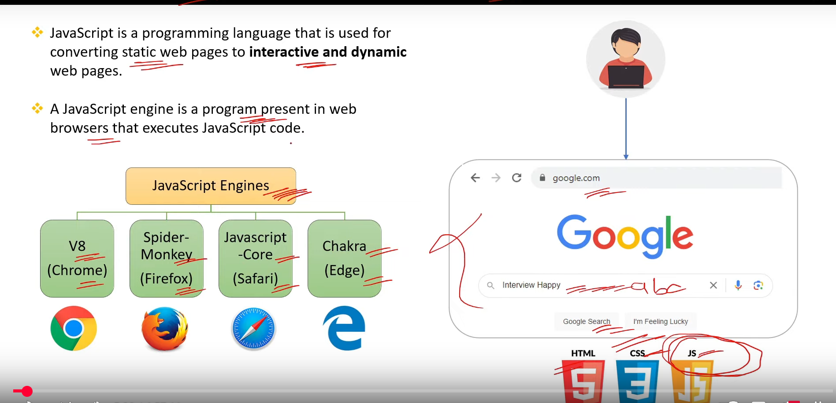

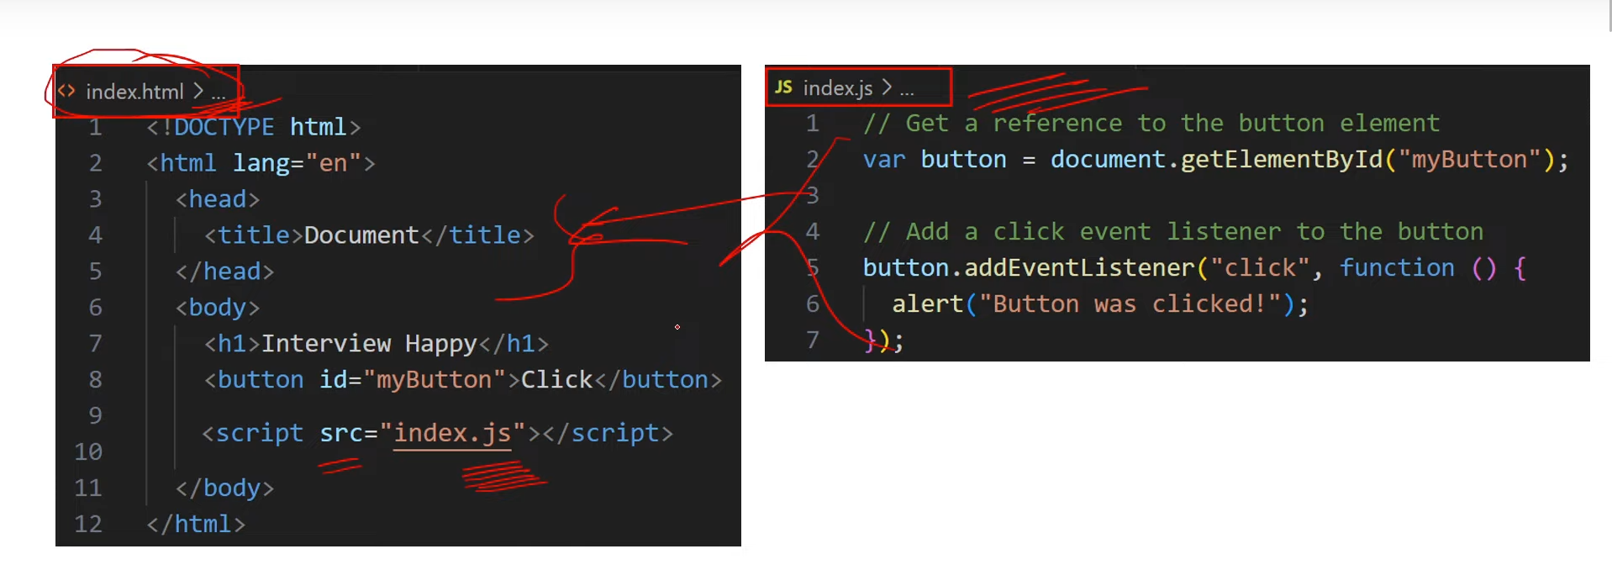

1. **What Are Client side and Server Side? [v. imp.]** 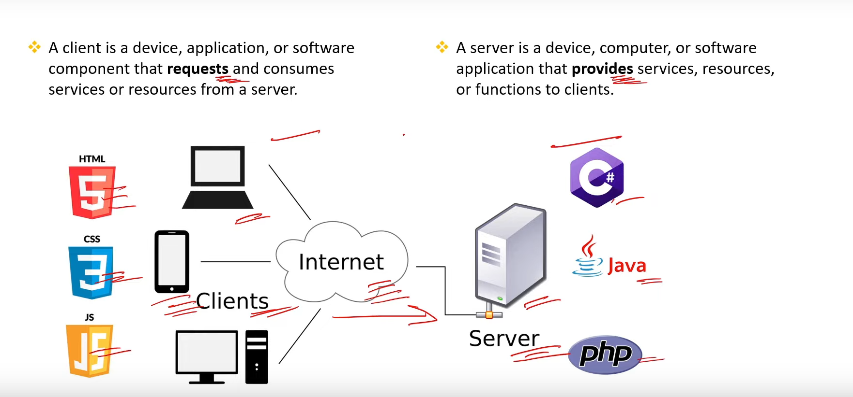
2. **What are Variable? What is the diff btw var,let and const? [v. imp.]**

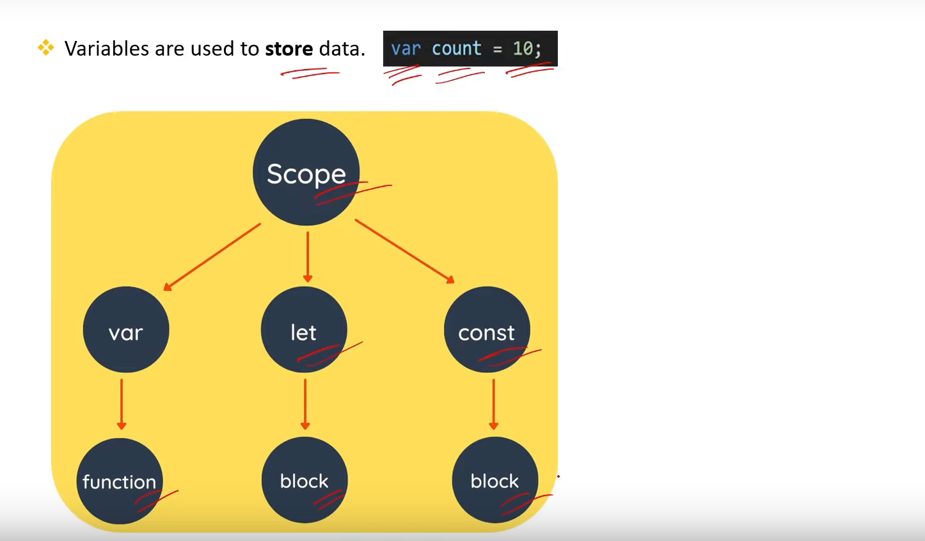

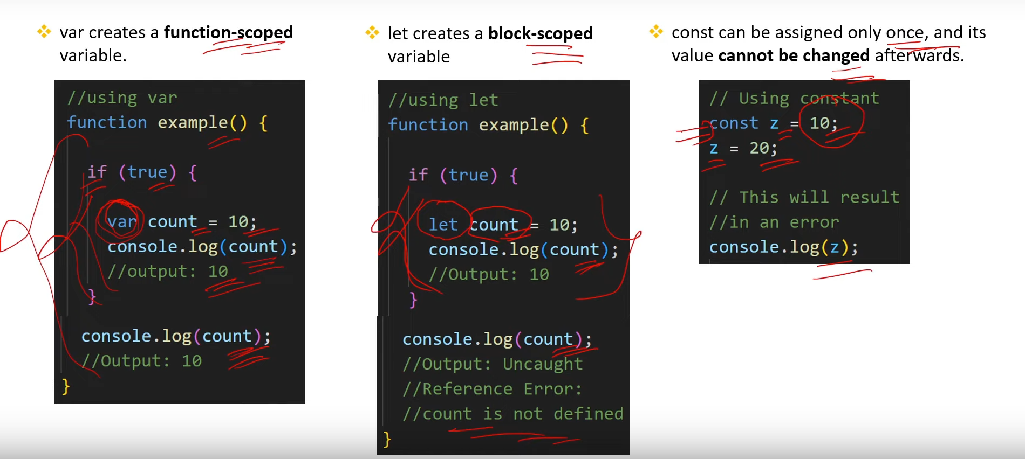

1. **What are the important string operation in JS?**

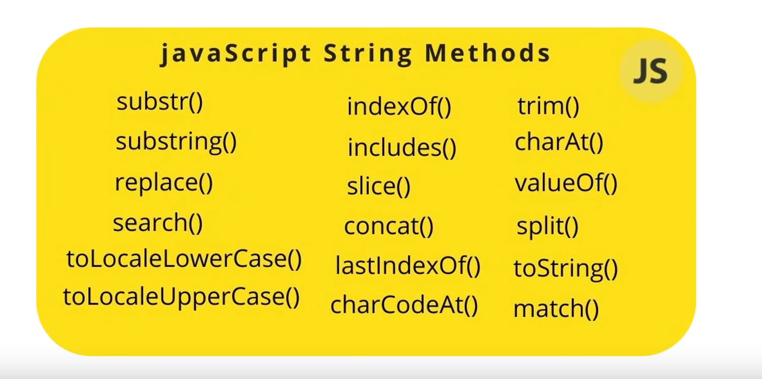

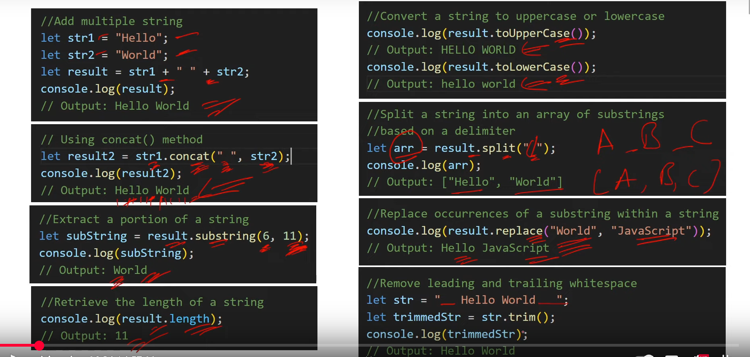

1. **What is Dom? What is the diff btw HTML and DOM? [v. imp.]**

* **DOM is like an Interface that are used to make our web Page dynamic with the help of JS.**

**“OR”**

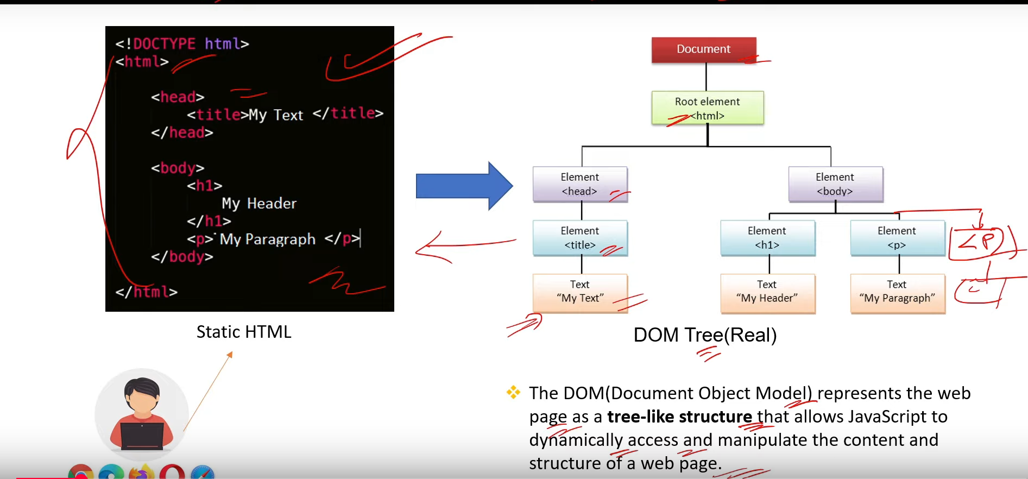

1. **What is Selectors in JavaScript? [v. imp.]**

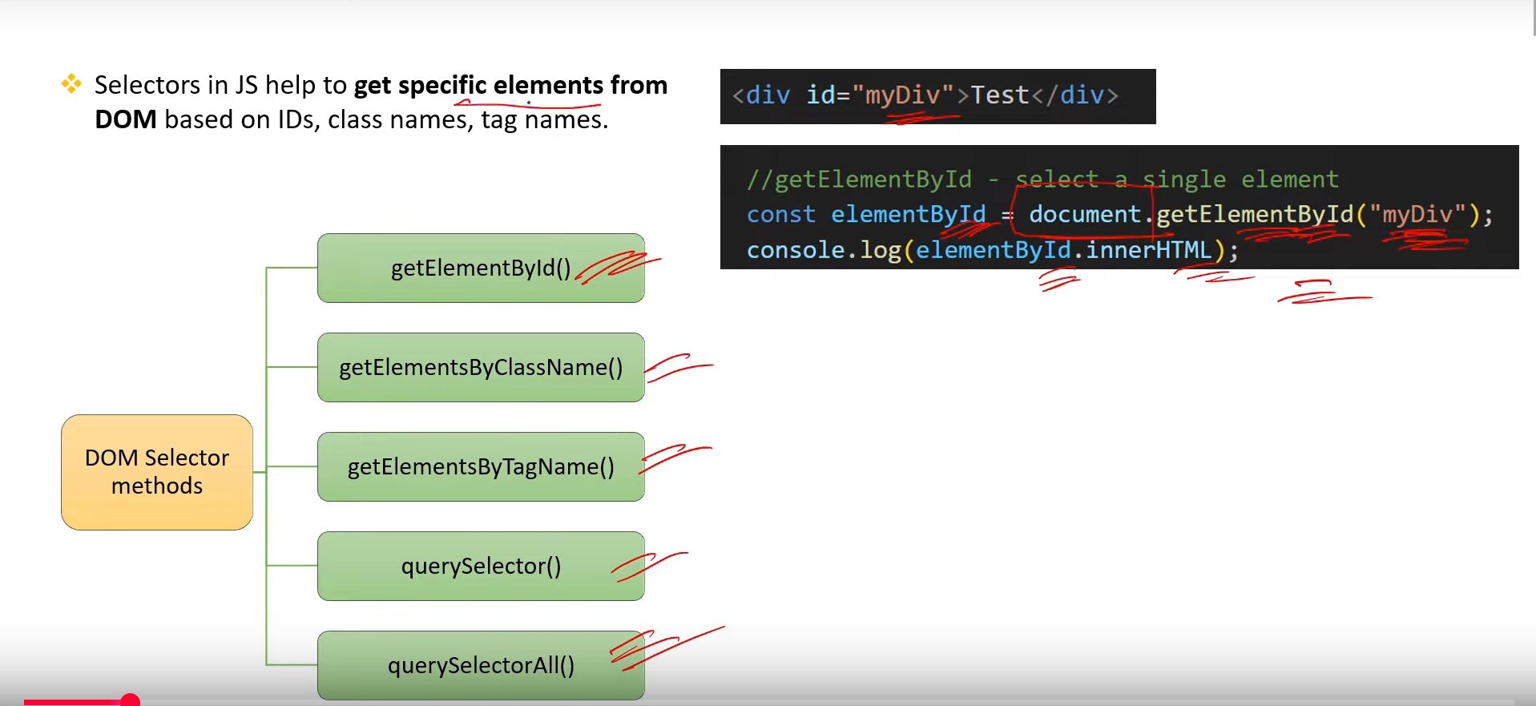

1. **What is the diff btw getElementById, getElementsByClassName and getElementsByTagName? [v. imp.]**

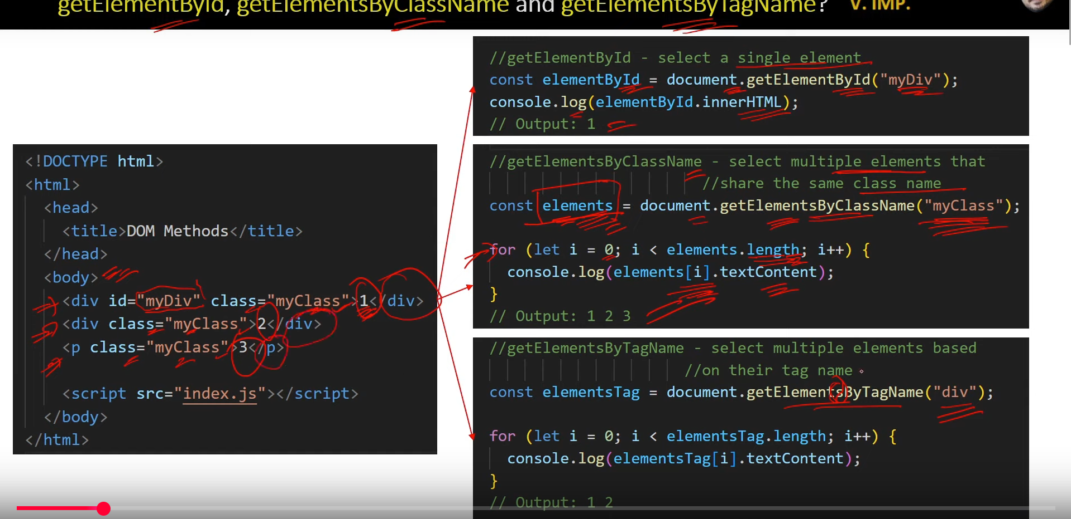

1. **What Are data types in js?**

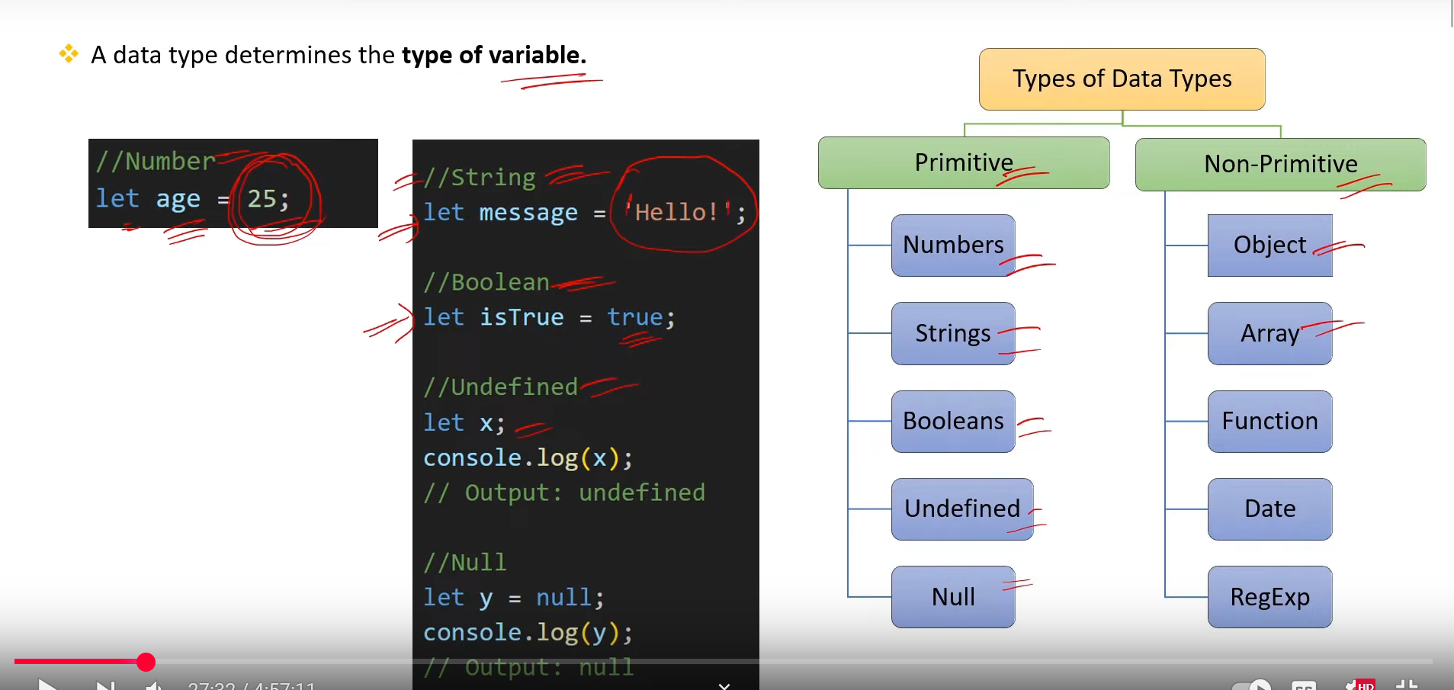

1. **What Are Operators? What are the types of Operators in JS? [v. imp.]**

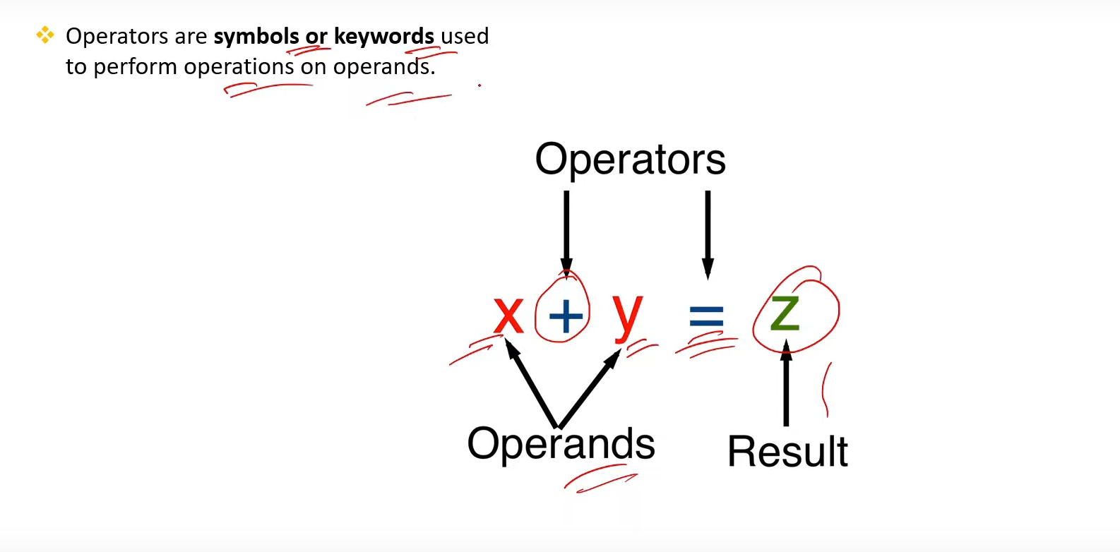

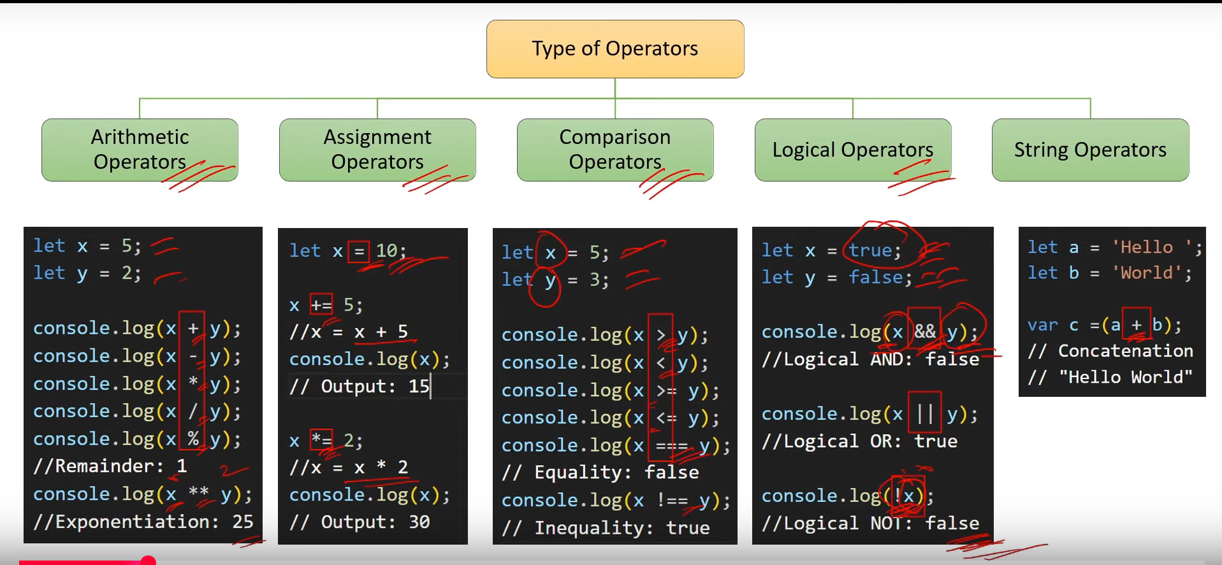

1. **What are the types of conditions statement in js? [v. imp.]**

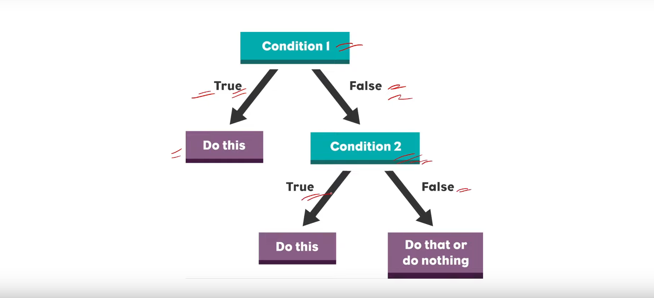

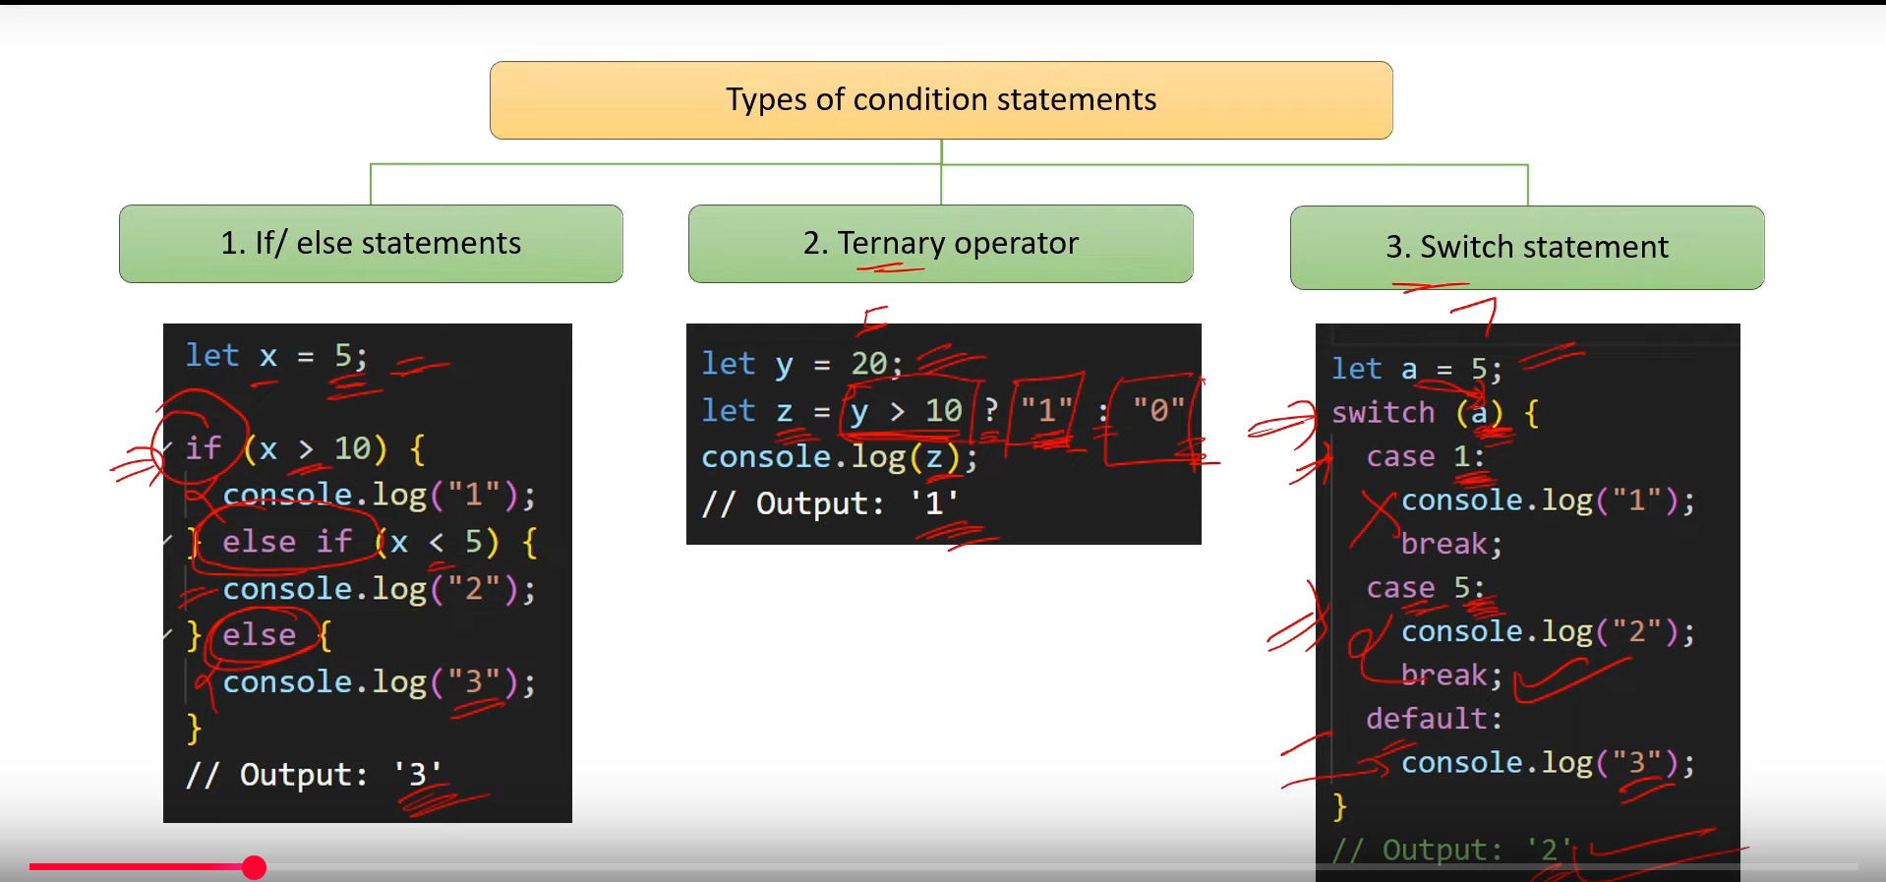

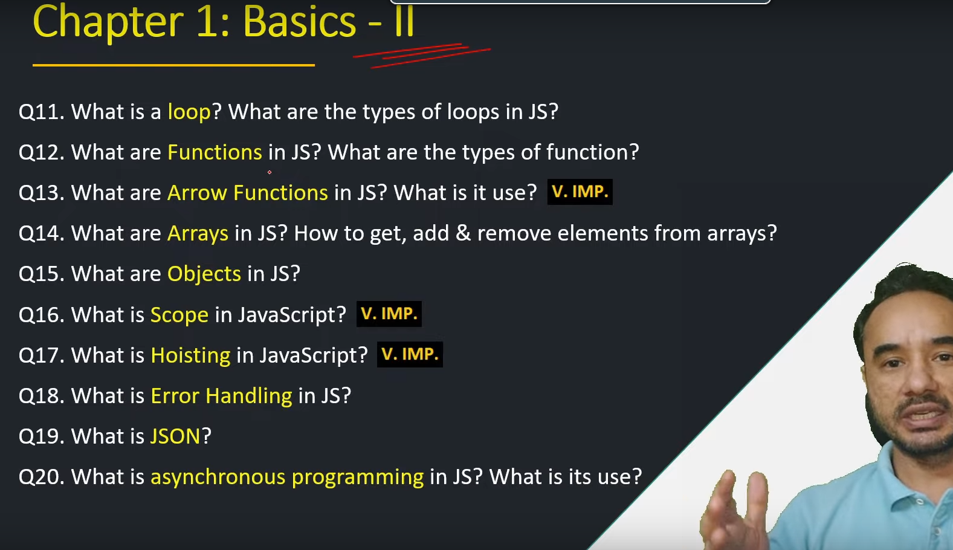

1. **What is a loop? What are the types of loops in JS? [v. imp.]**

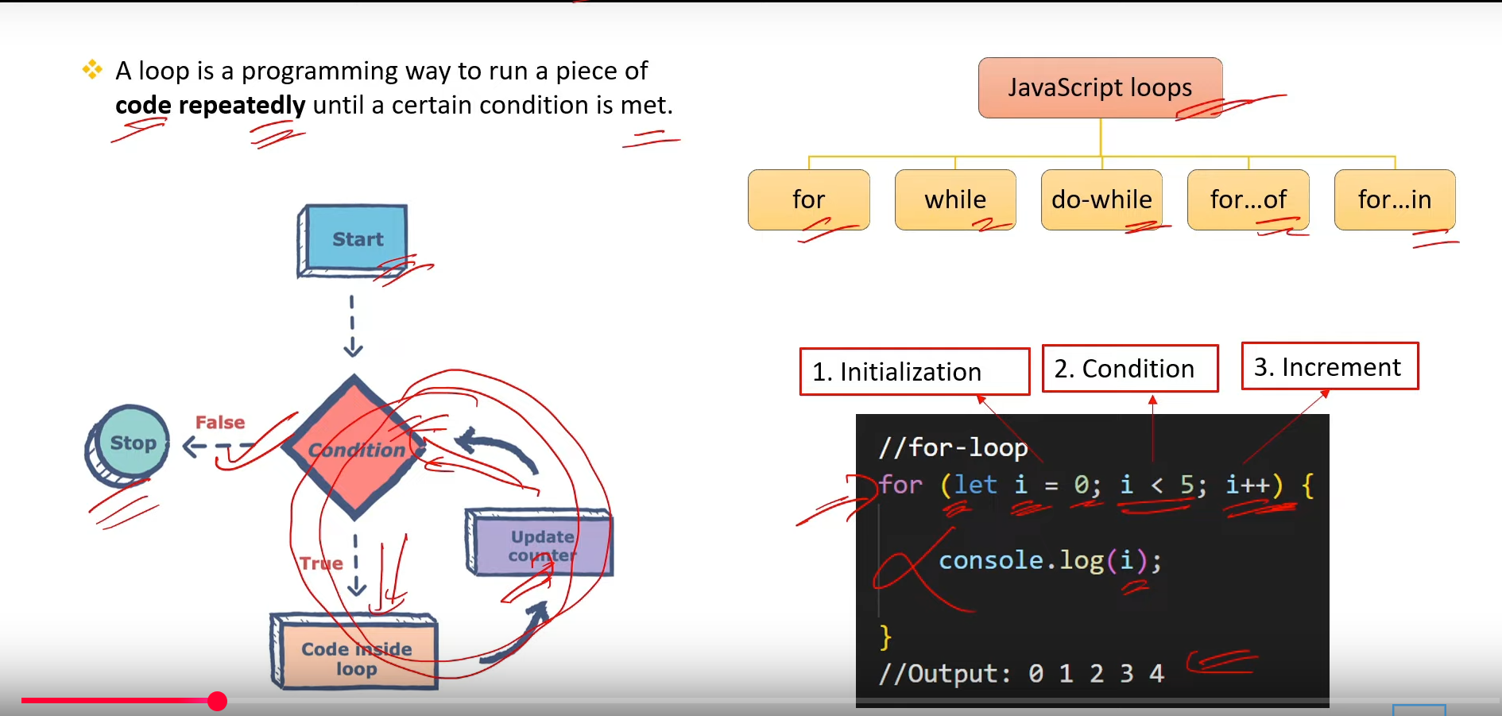

1. **What are Functions in JS? What are the type of functions? [v.imp.]**

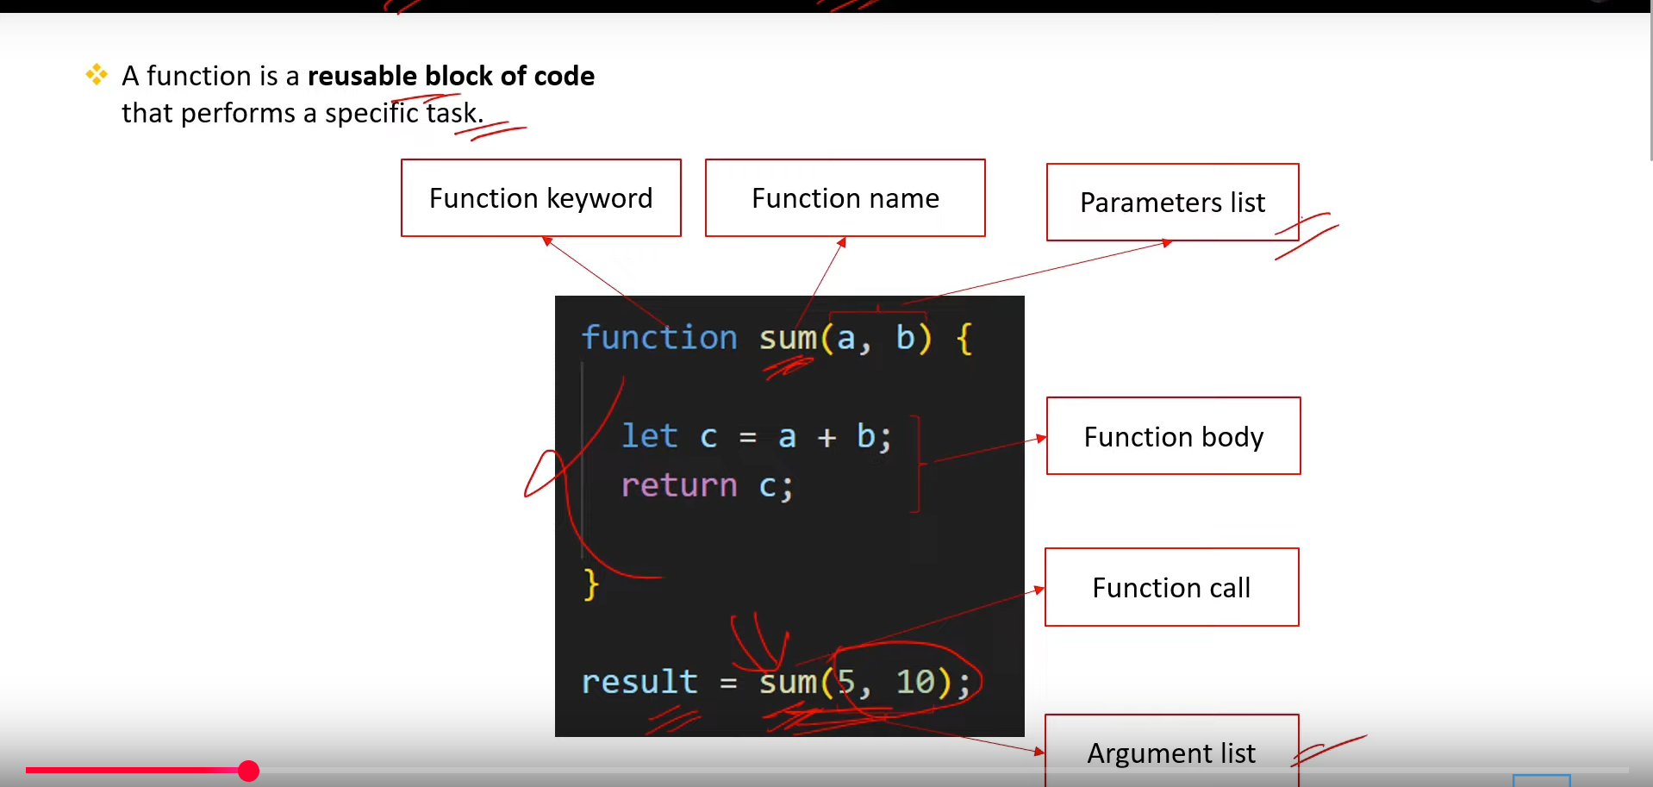

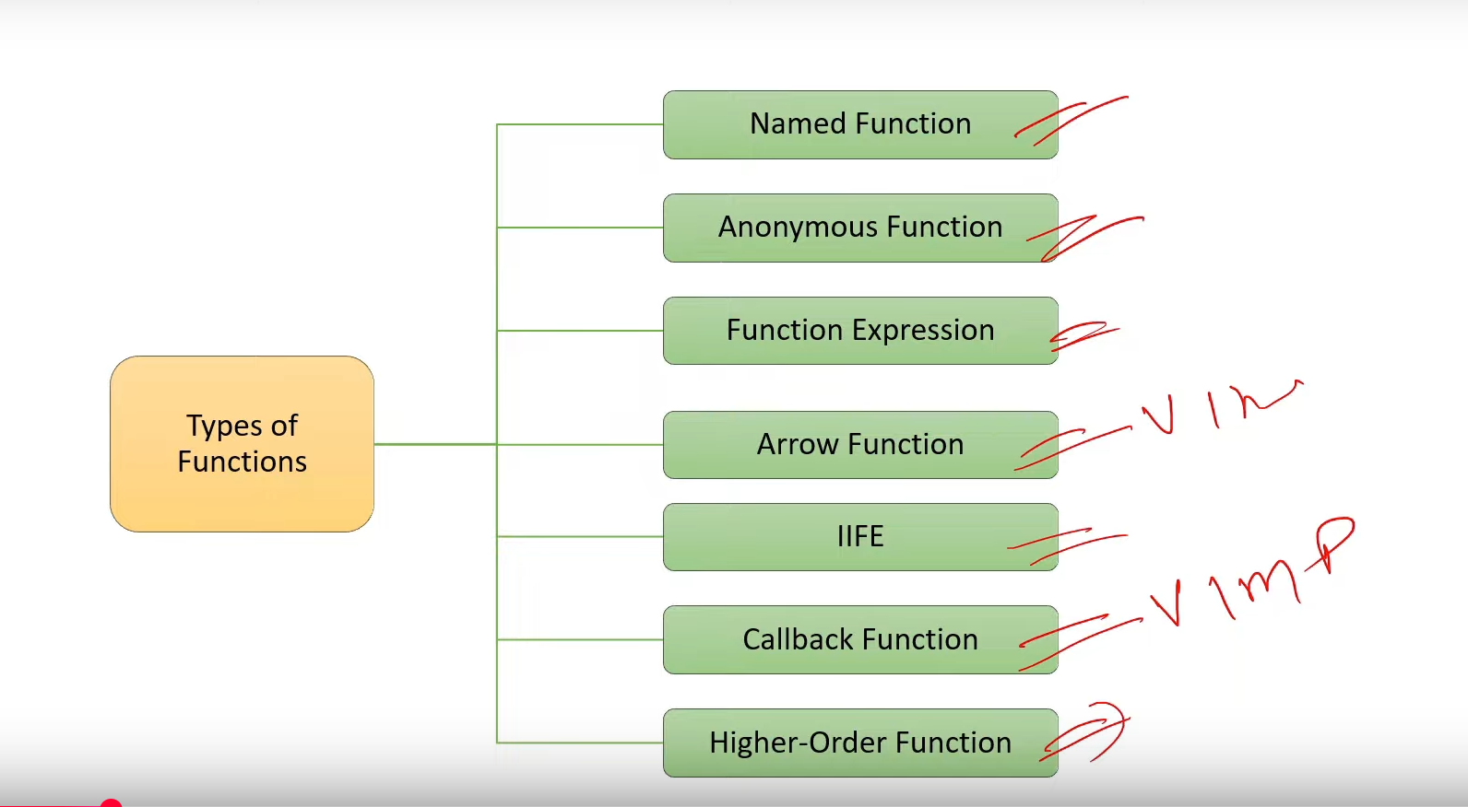

1. **What is Arrow Function in JS? What is it use? [v.imp.]**

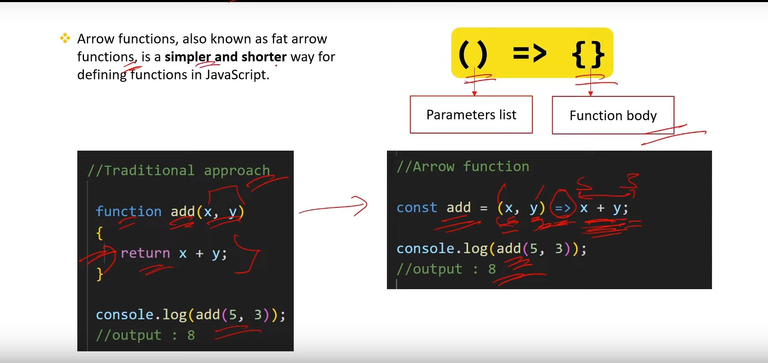

1. **What are arrays in JS? How to get, add and remove elements from array? [v.imp.]**

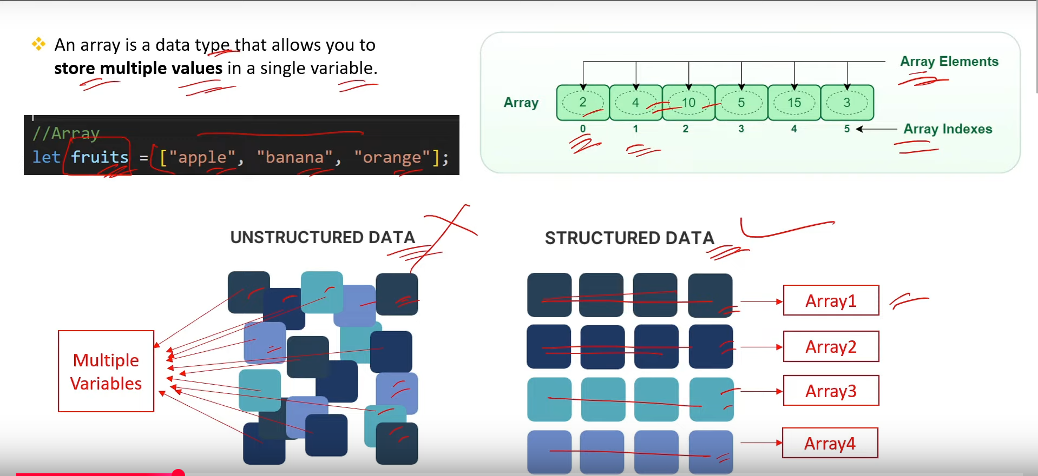

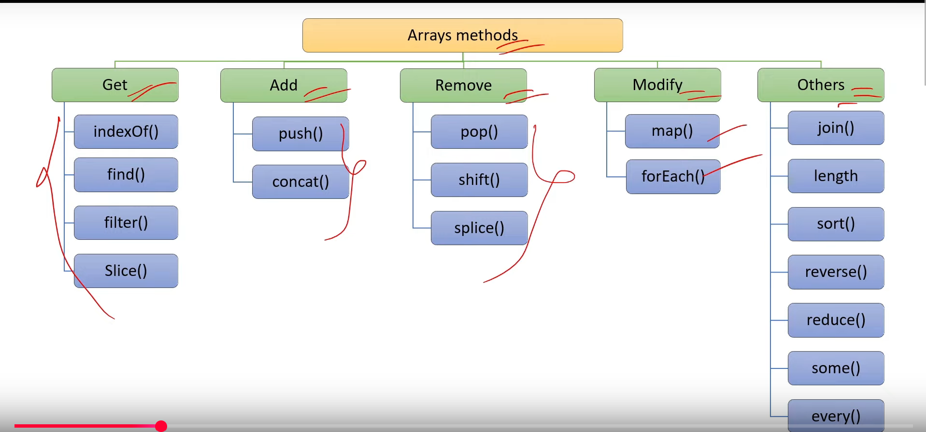

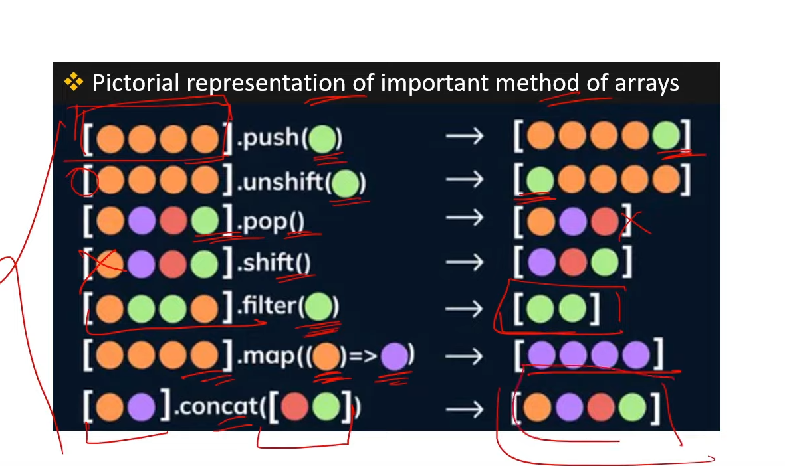

1. **What are Objects in JS? [v.imp.]**

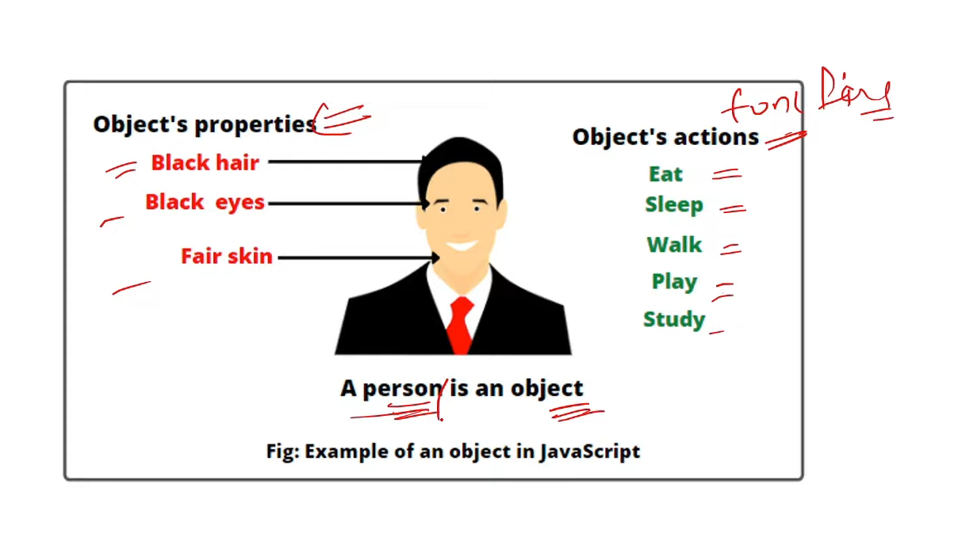

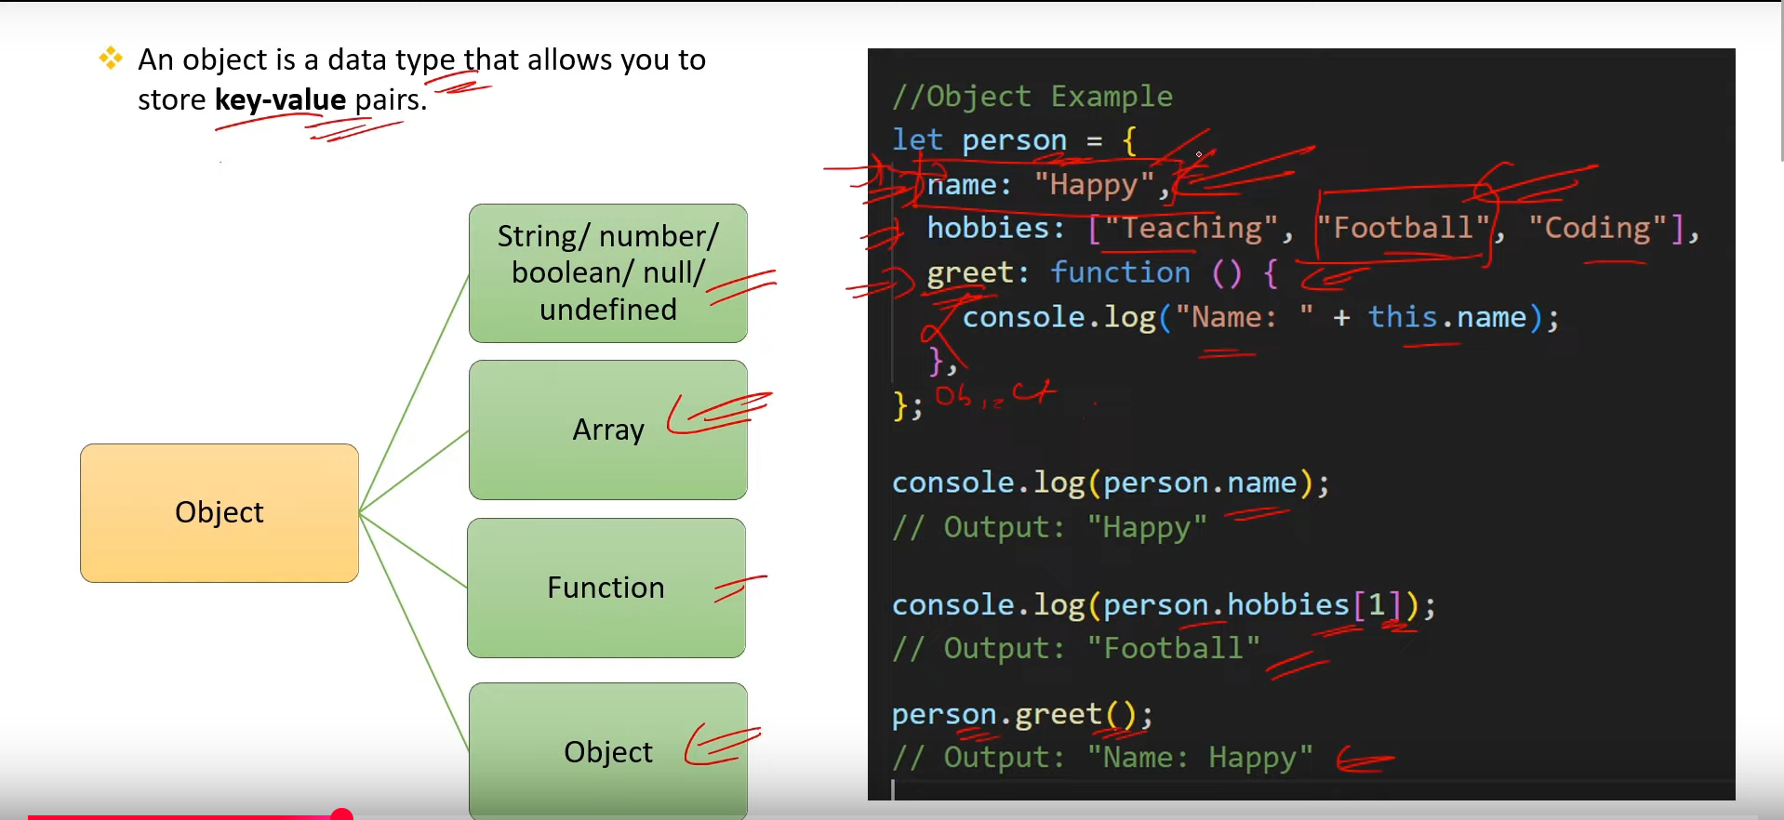

1. **What is Scope in JS? [v. imp.]**

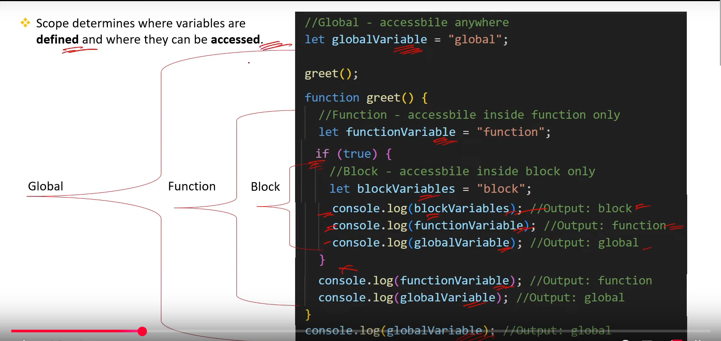

1. **What is Hoisting in JS? [v. imp.]**

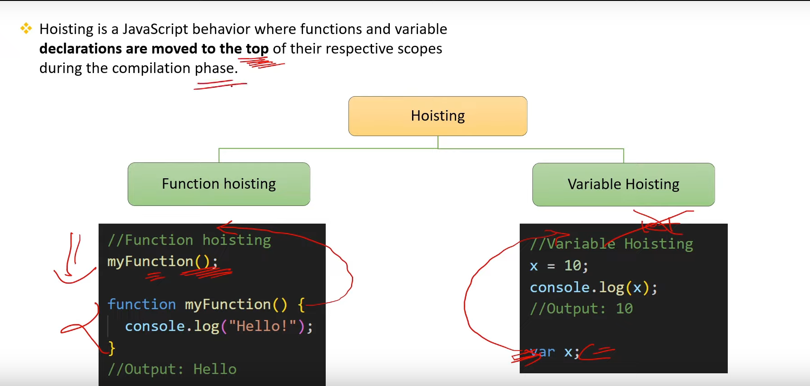

1. **What is Error Handling In JS? [v.imp.]**

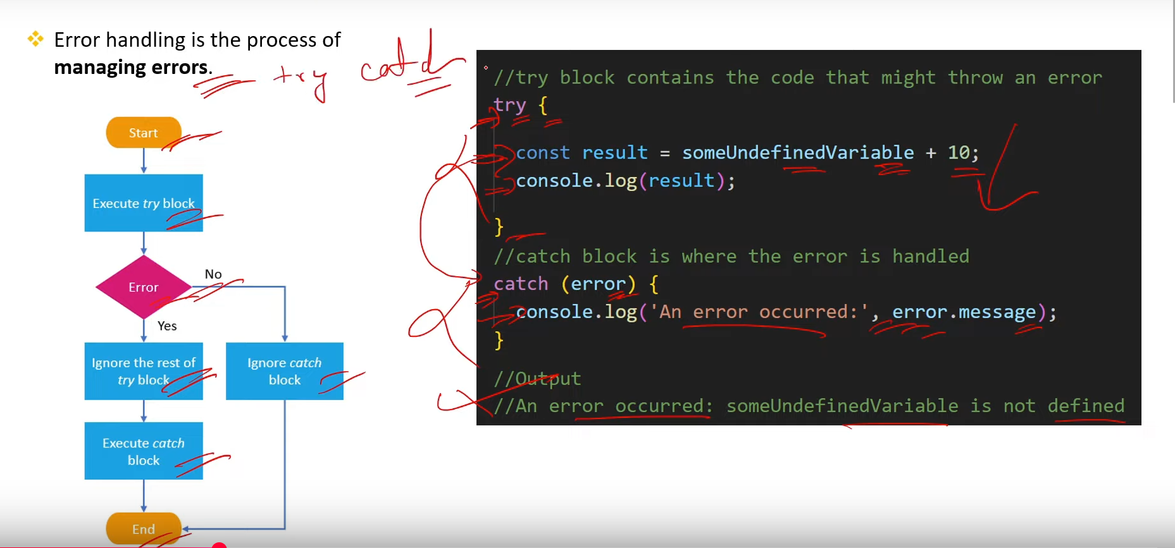

1. **What is Asynchronous Programing in JS? What is its Use? [v.imp.]**

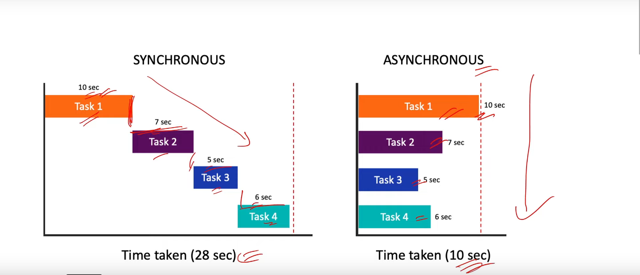

**JS is single threaded Language, but the help of event loop it acchive the asynchronous programing.**

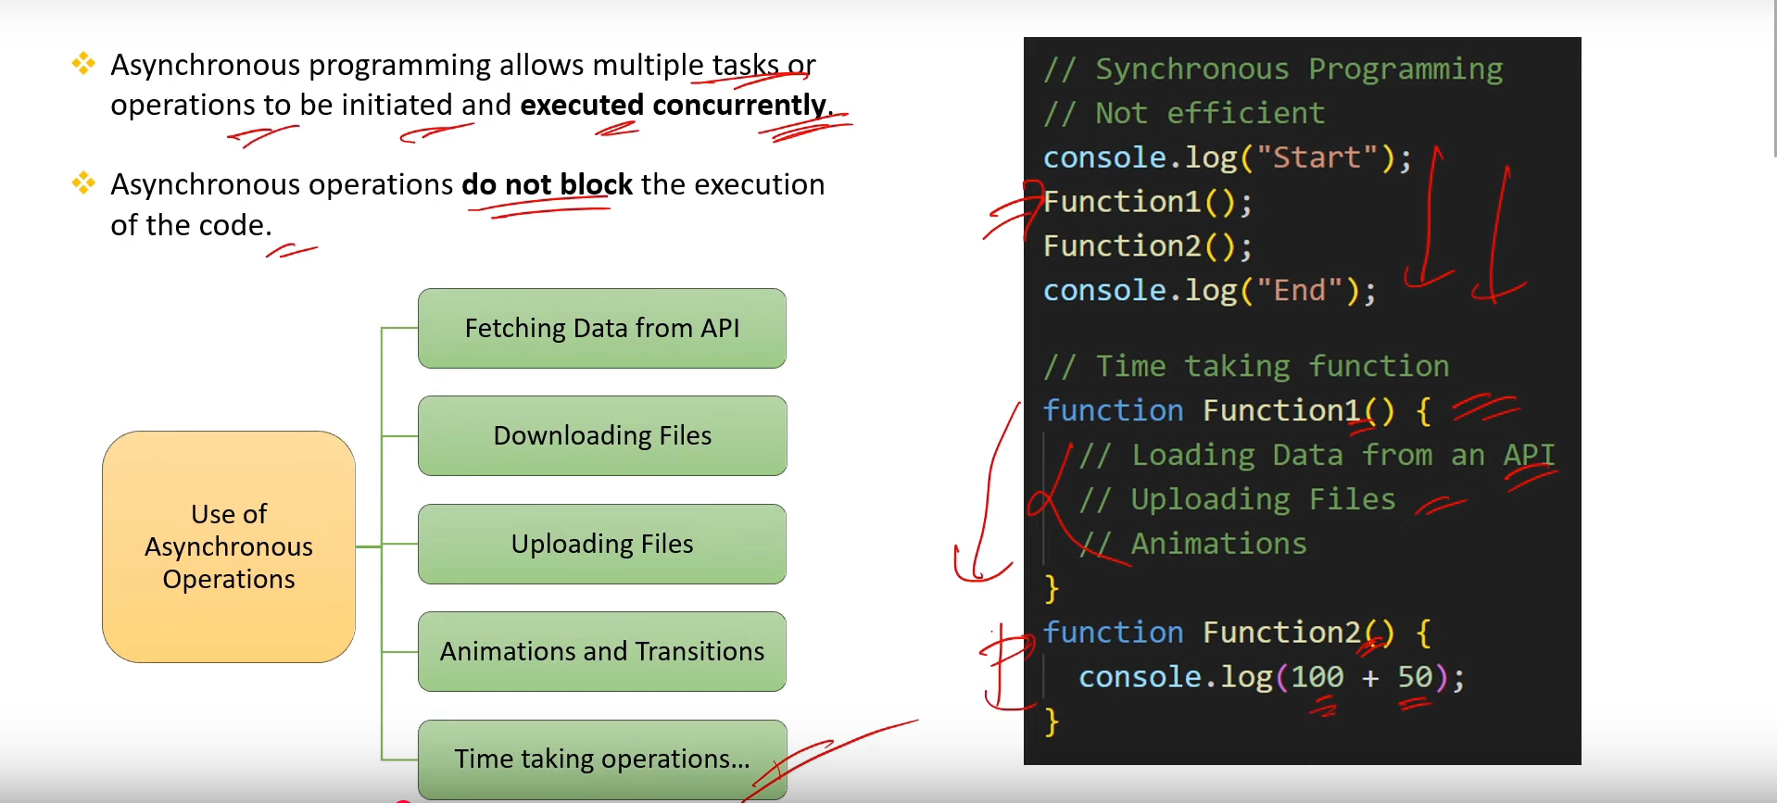

1. **What is JSON? [v. imp.]**

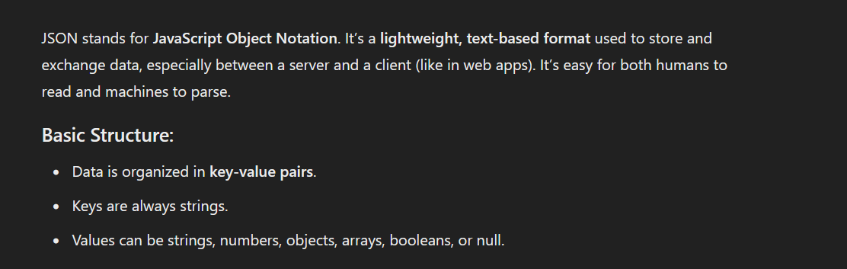

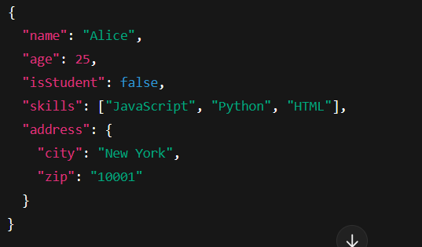

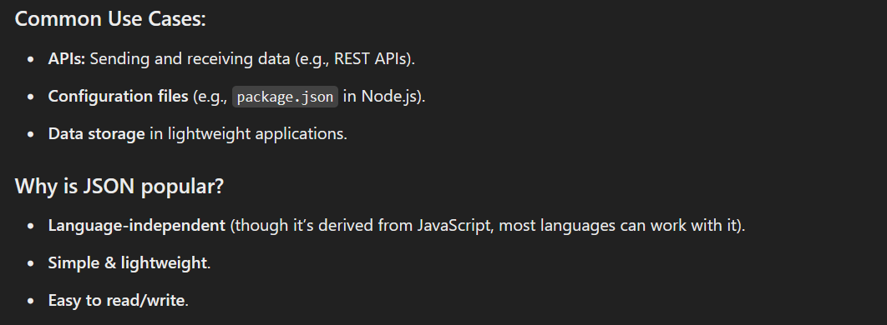

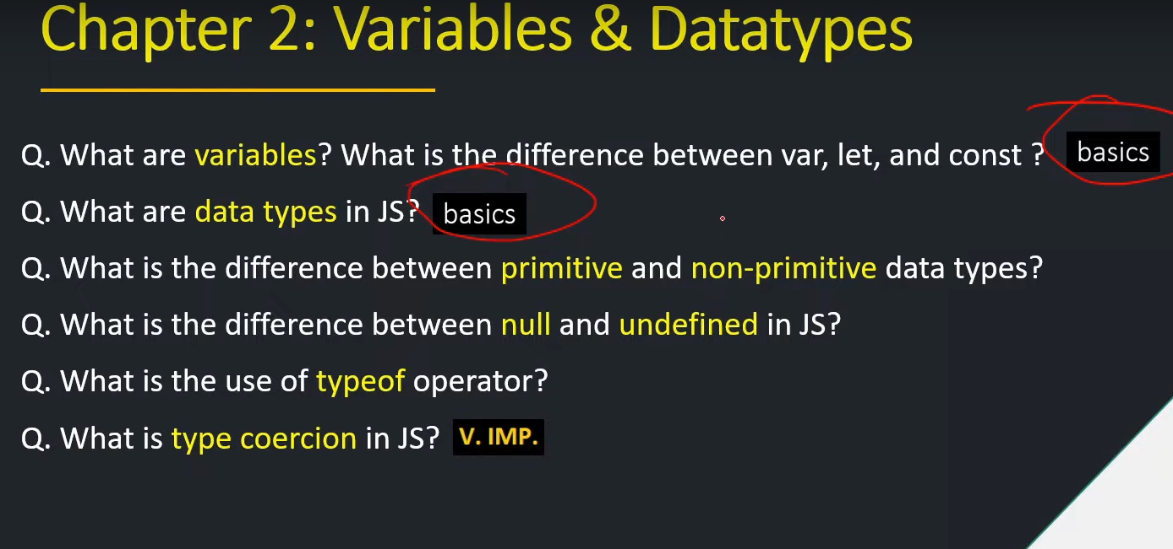

1. **What are the variables? What are the diff btw var, let and const?**

**Variable is like a container that are used to store the data.**

1. **What are the Data Types in JS?**

**Data types is use to determine the type of variable.**

1. **What is the diff btw Primitive and non-Primitive data types?**

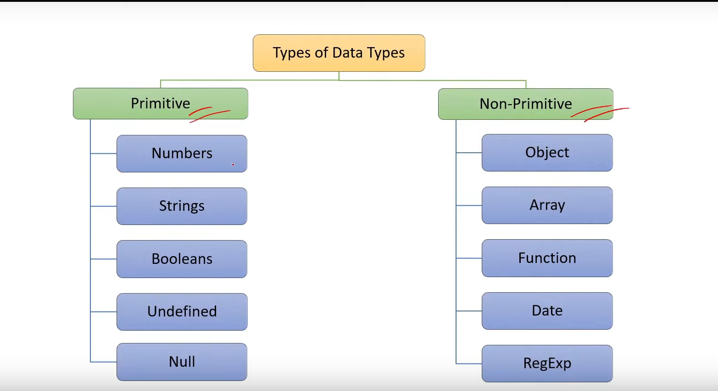

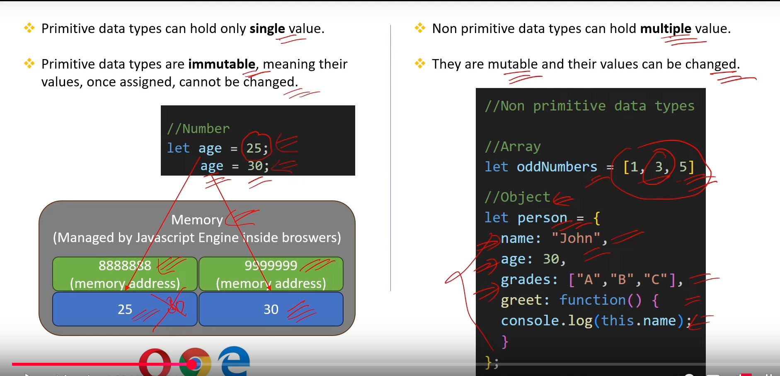

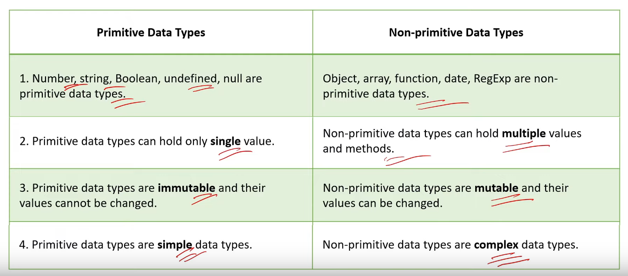

1. **What is the diff btw null and undefined in JS?**

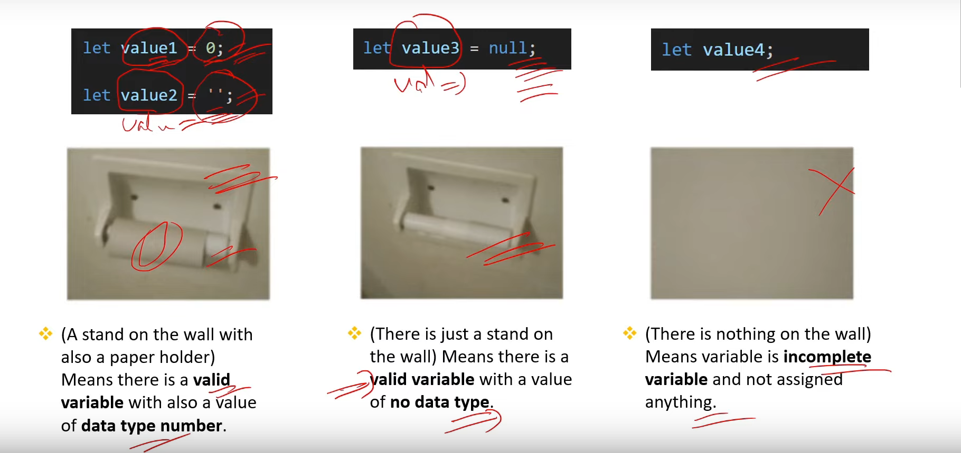

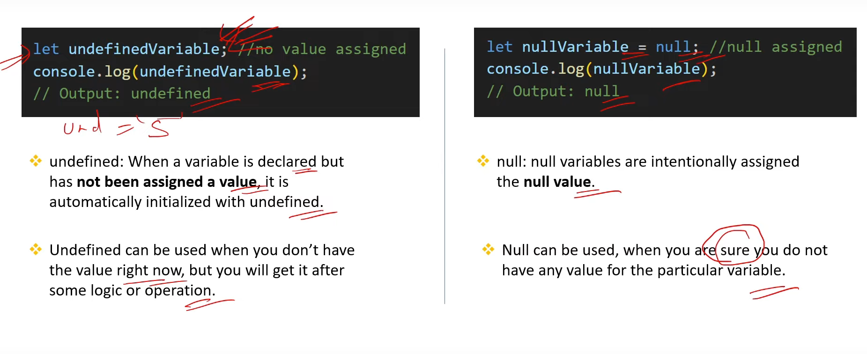

1. **What is the use of typeOf operator?**

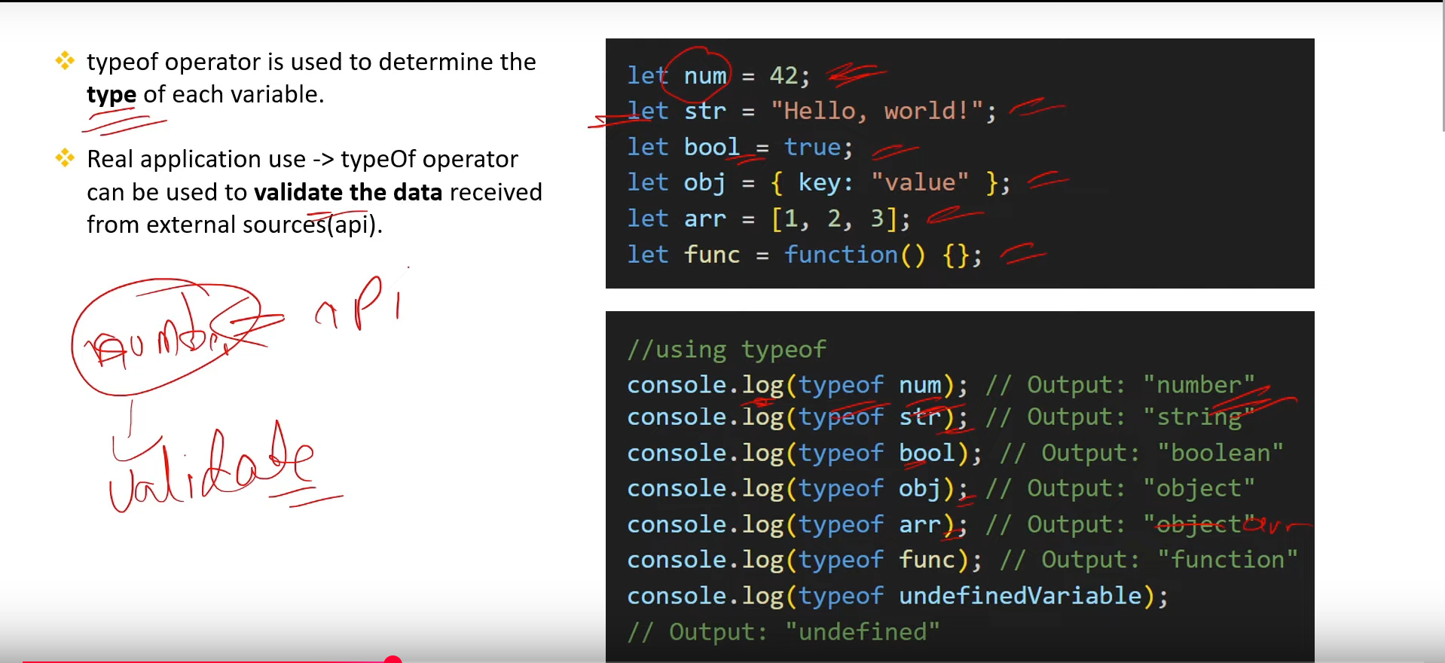

1. **What is type coercion in JS? [v.imp.]**

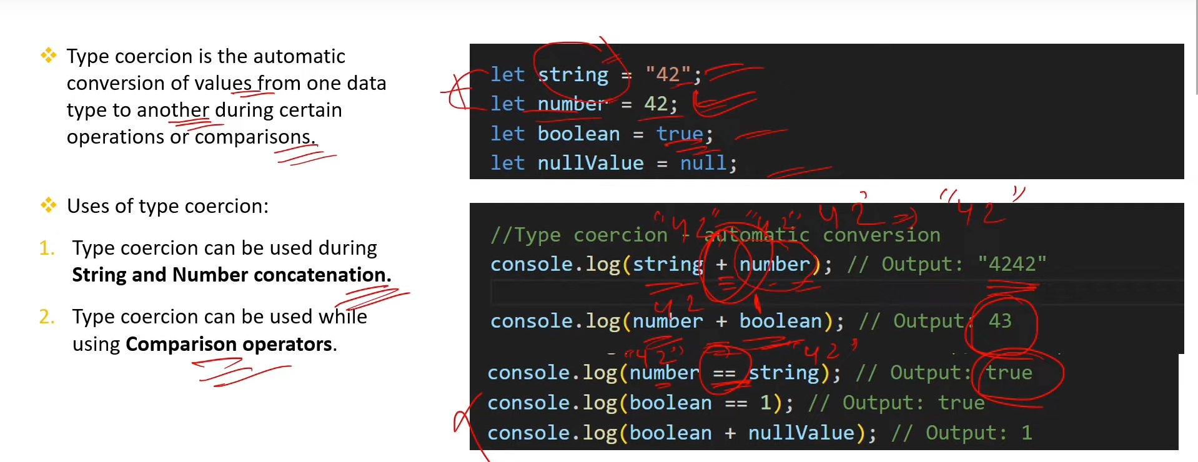

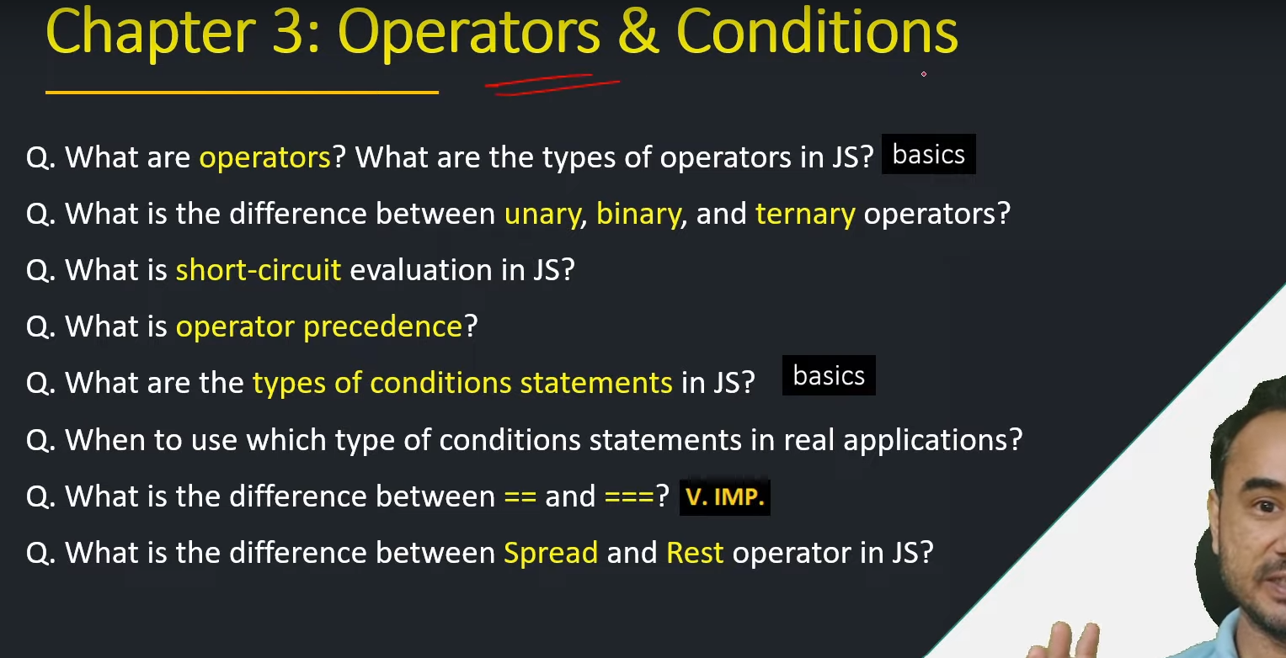

1. **What are operators? What are the types of operators in JS? [BASIC]**

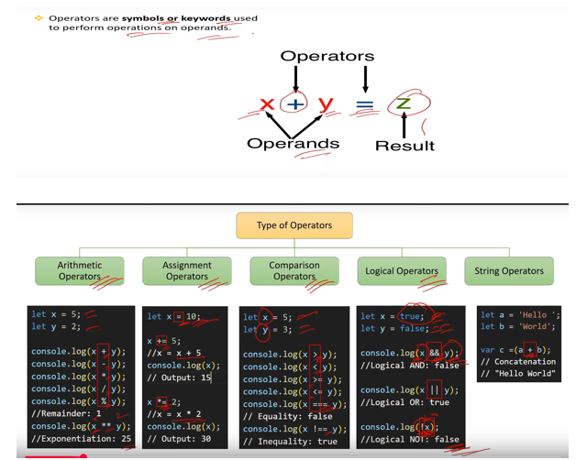

1. **What is the diff btw unary, binary, and ternary operators?**

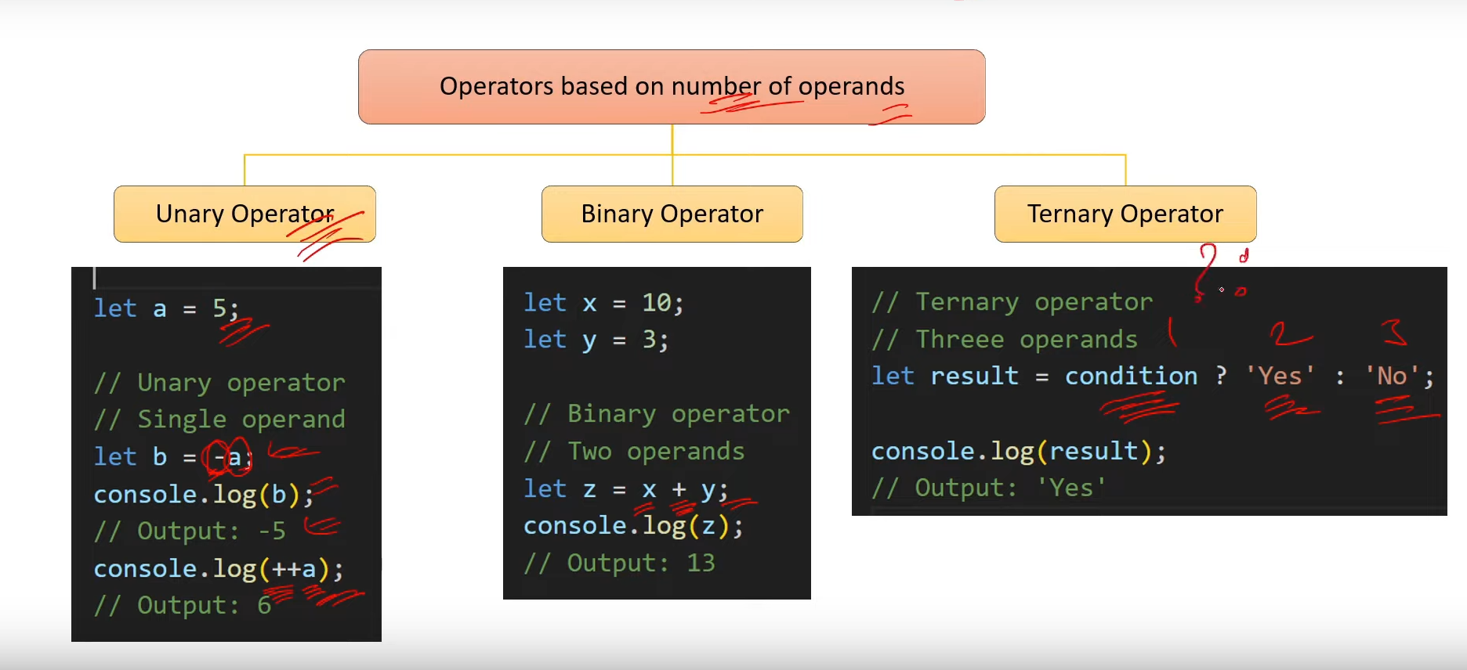

1. **What is Short-circuit evaluation in JS?**

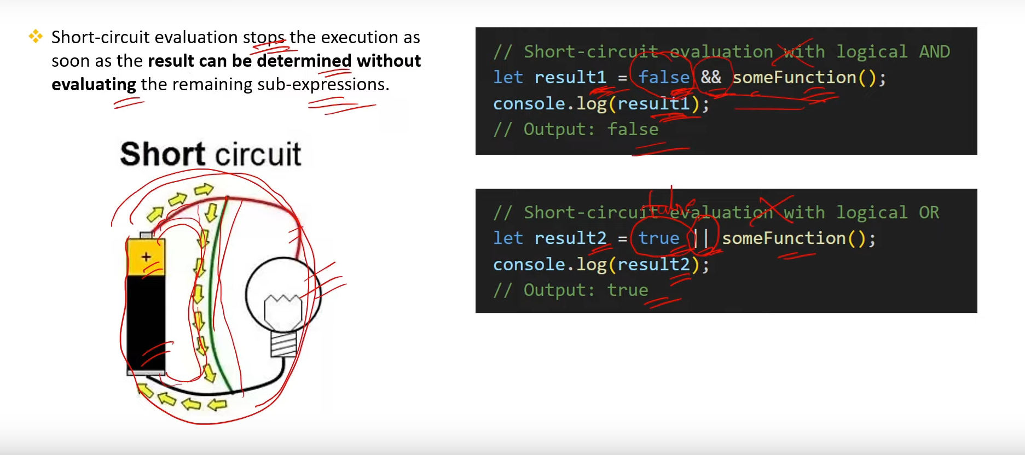

1. **What is operator precedence?**

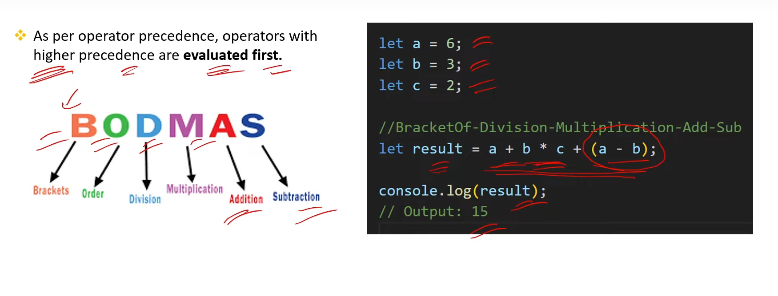

1. **What are the types of conditions statements in JS?[Basic]**

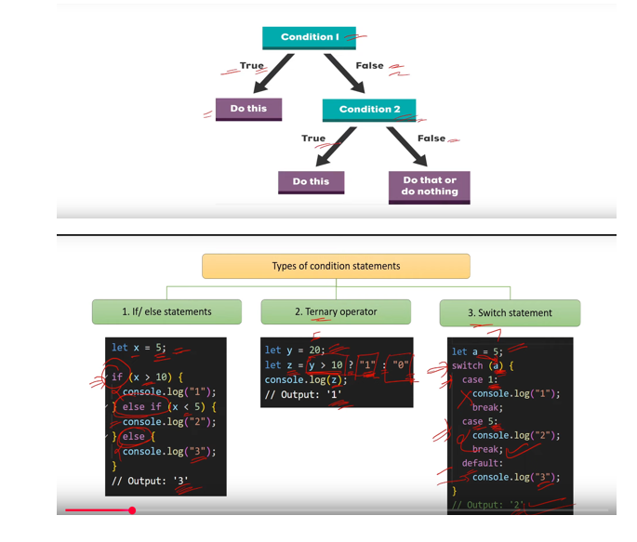

1. **When to use which type of conditions statements in real applications?**

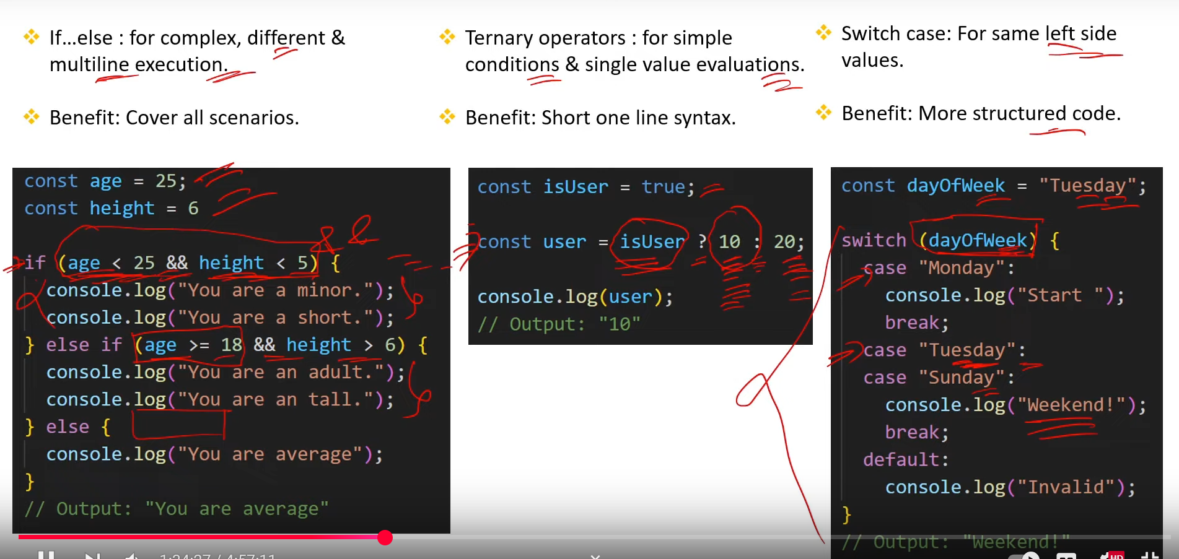

1. **What is the difference between == and ===? [V.IMP.]**

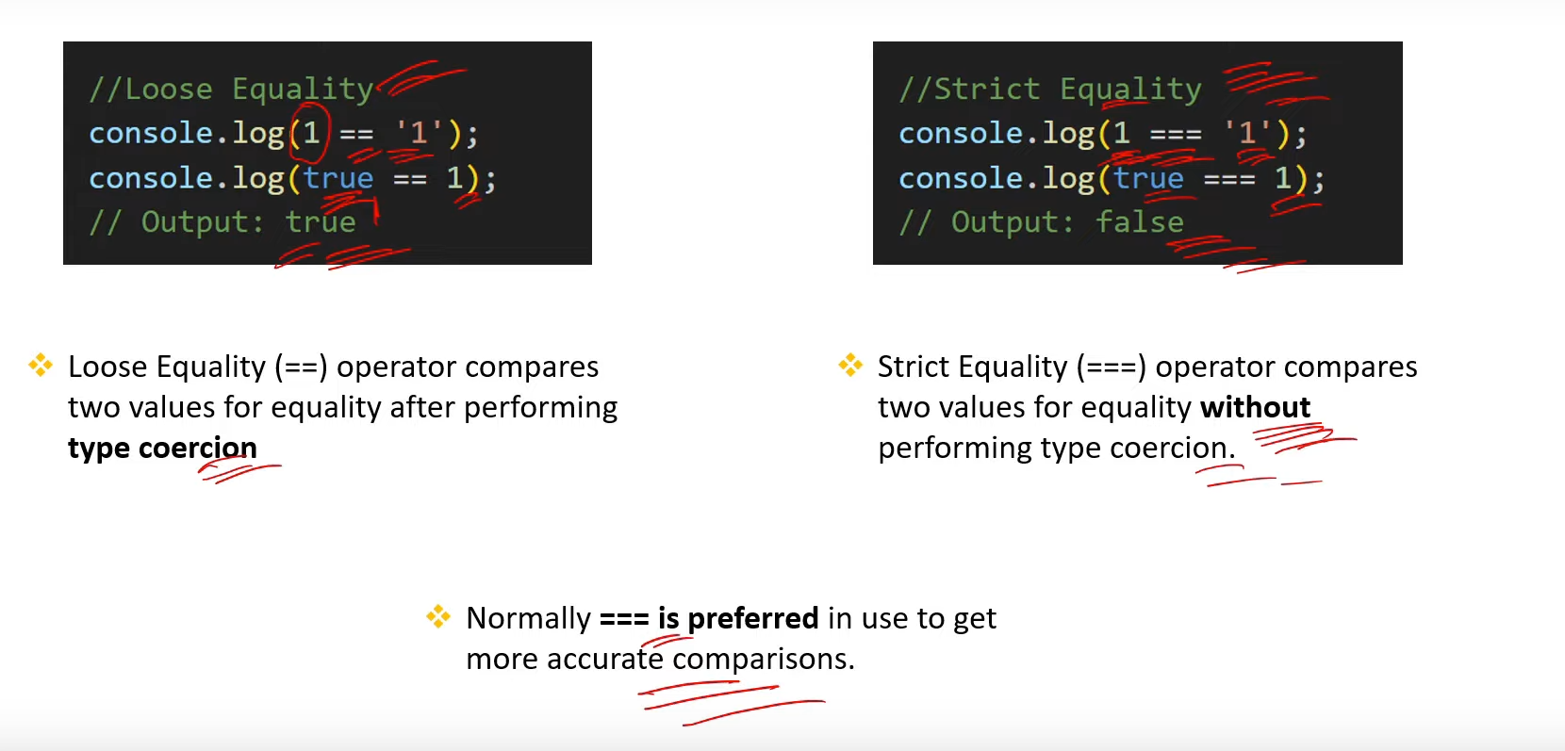

1. **What is the difference between Spread and Rest operator in JS?**

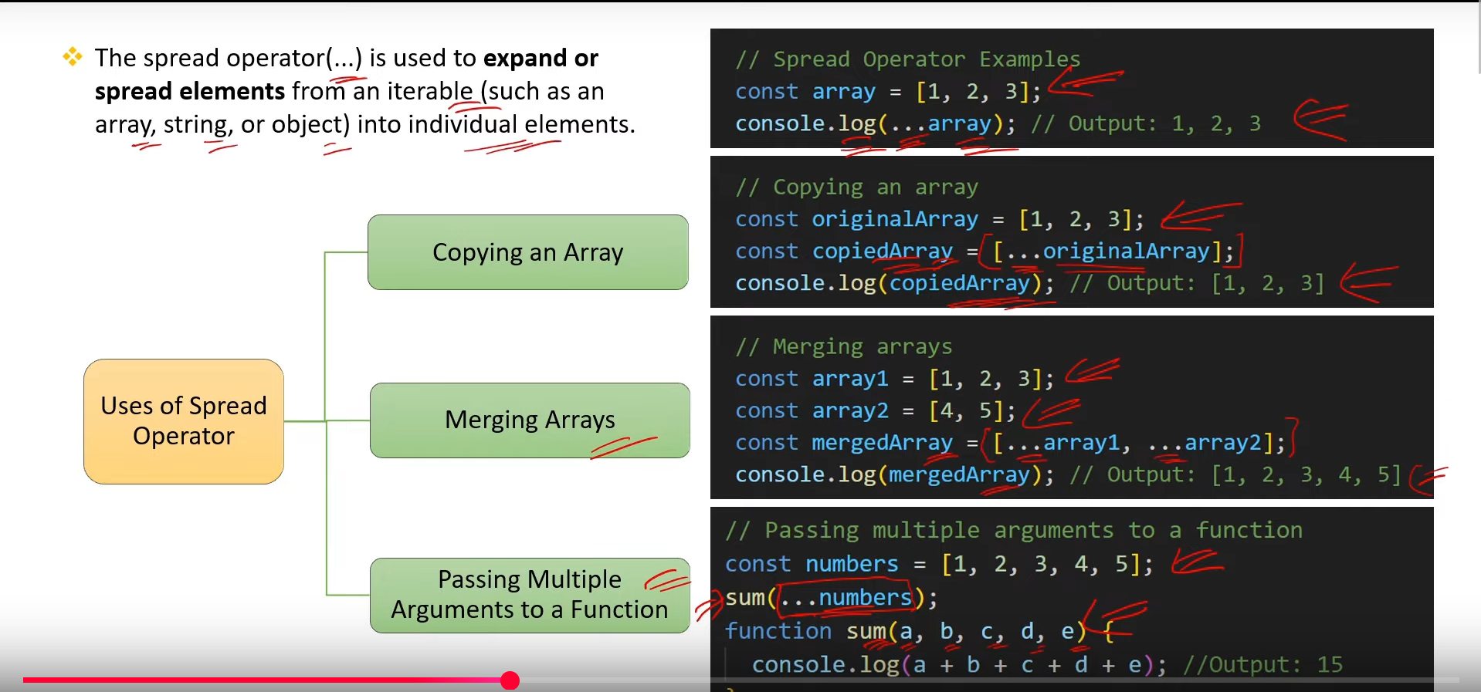

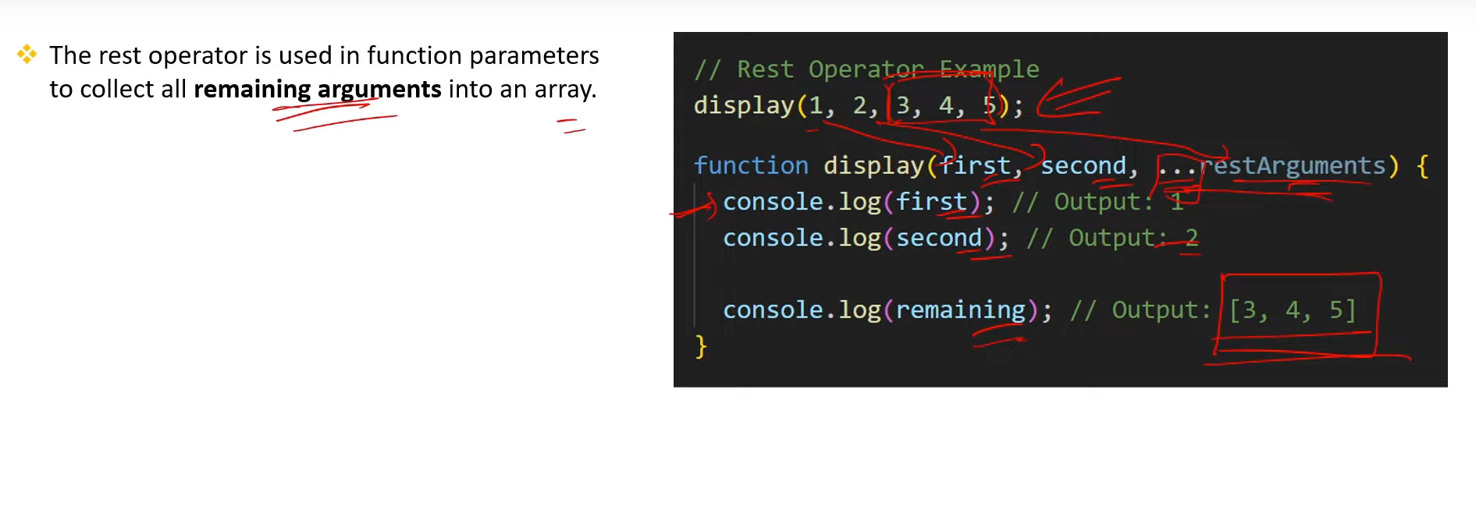

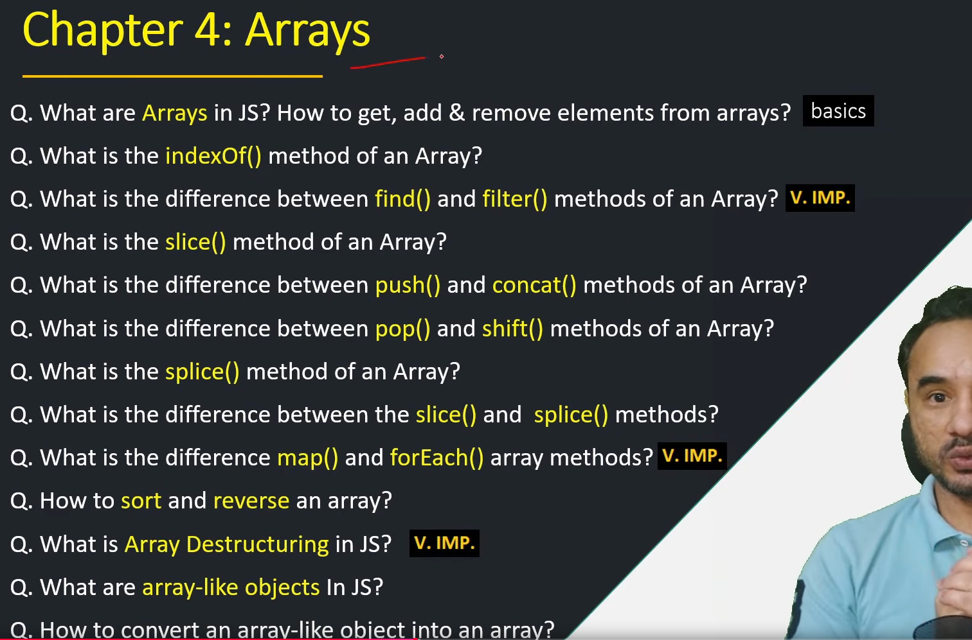

1. **What are Arrays in JS? How to get, add & remove elements from arrays? [Basics]**

1. **What is the indexof() method of an Array?**

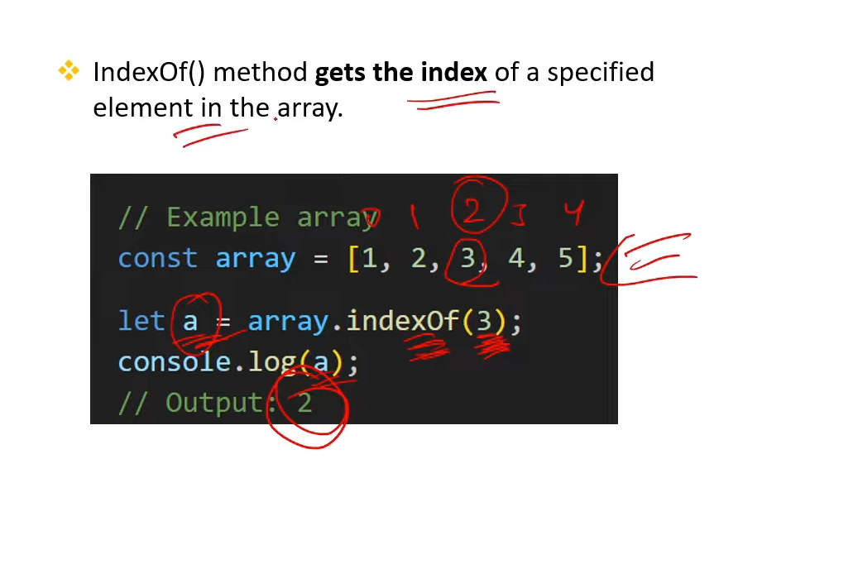

1. **What is the difference between find() and filter() methods of an Array? [V.IMP.]**

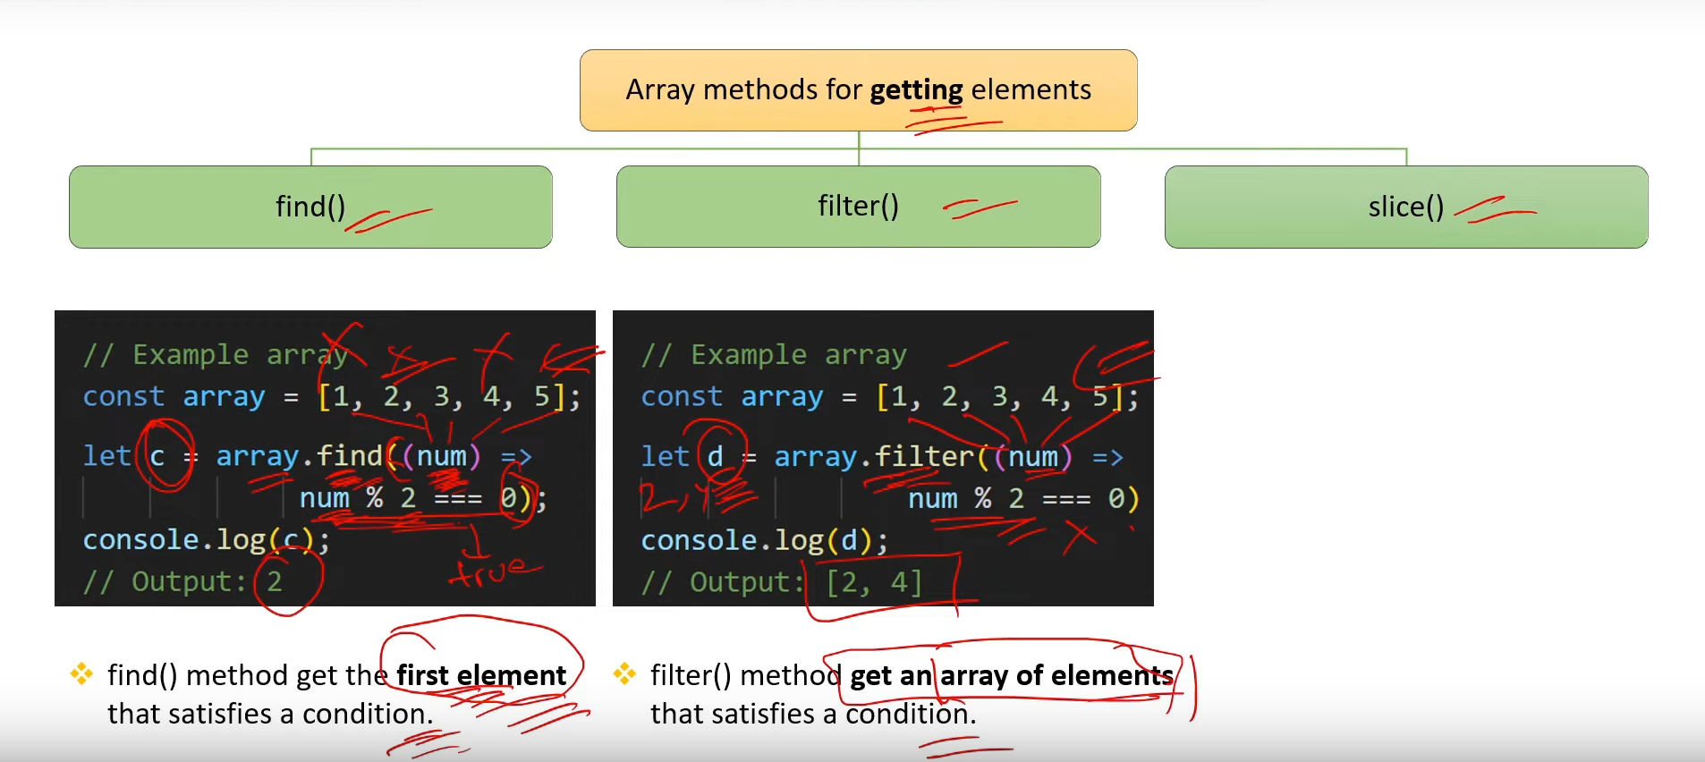

1. **What is the slice() method of an Array?**

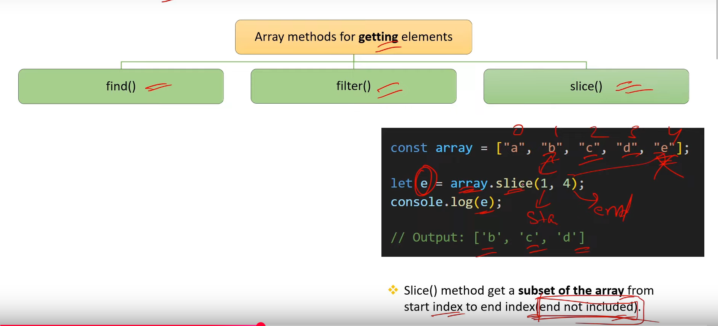

1. **What is the difference between push() and concat() methods of an Array?**

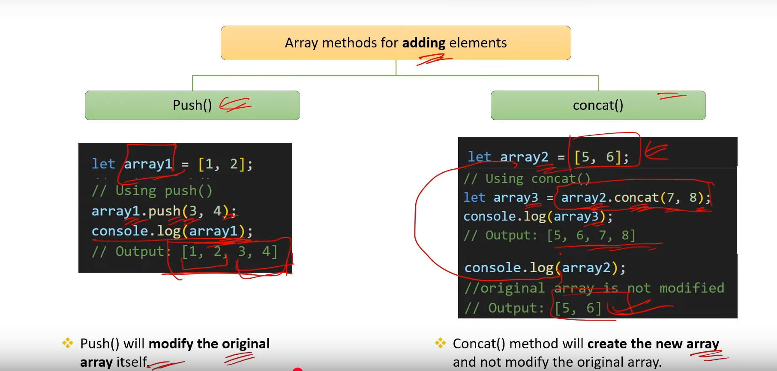

1. **What is the diference between popl) and shit() methods of an Array?**

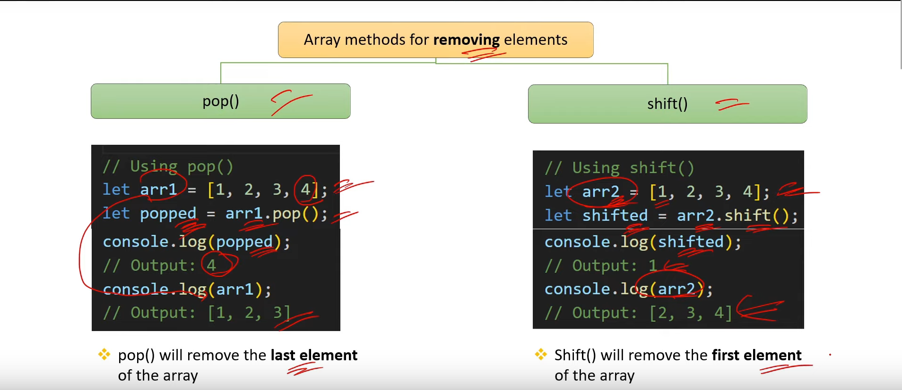

1. **What is the splice() method of an Array?**

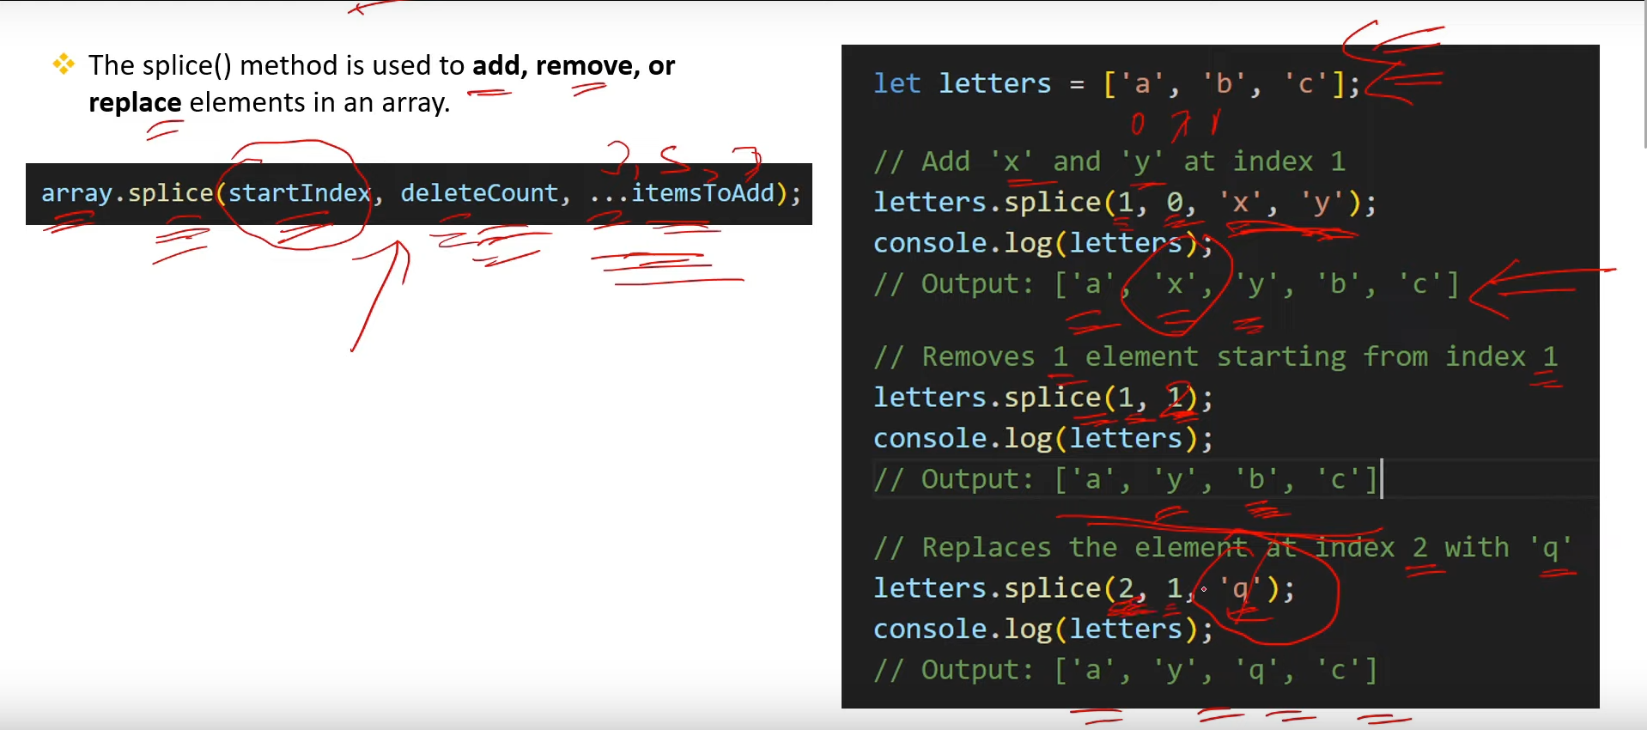

1. **What is the difference between the slice() and splicel() methods?**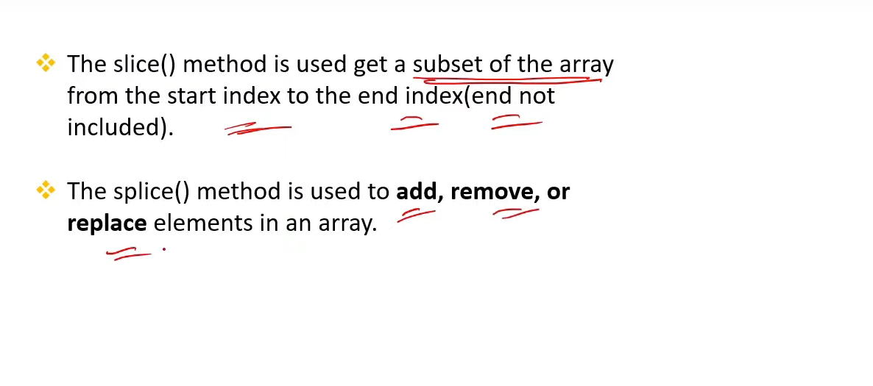
2. **. What is the difference mapl() and forEach() aray methods? [V.MP]**

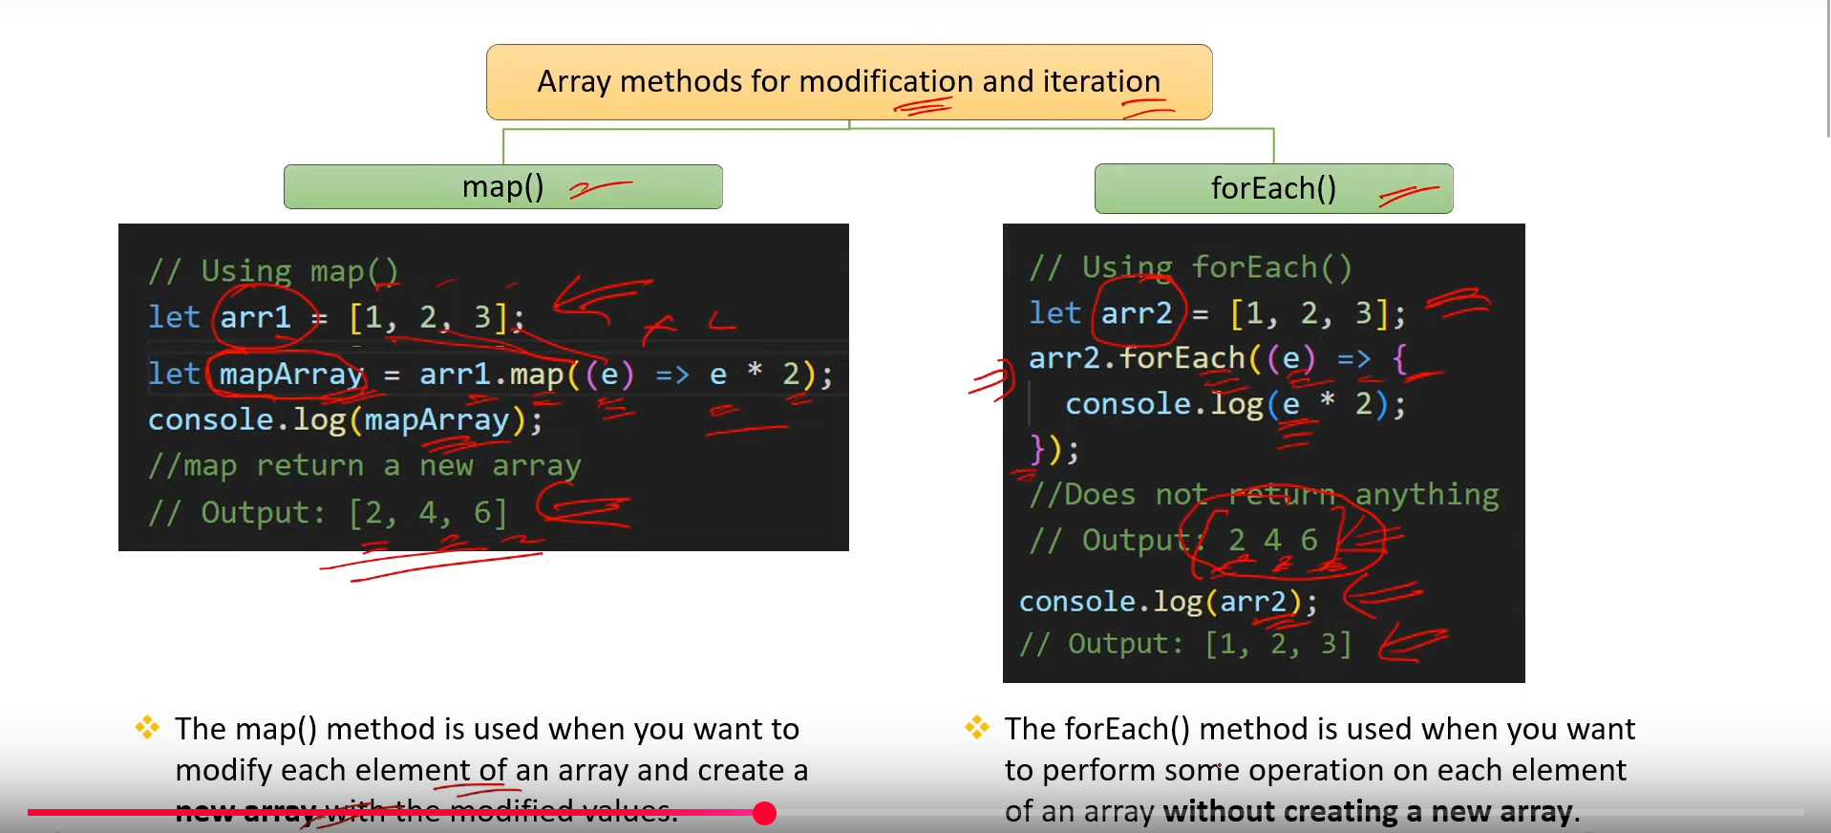

1. **How to sort and reverse an array?**

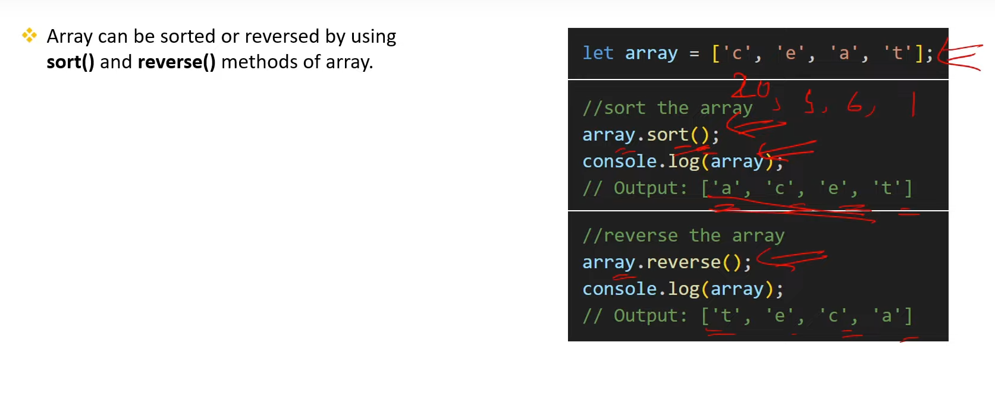

1. **What is Array Destructuring in JS?[V.IMP.]**

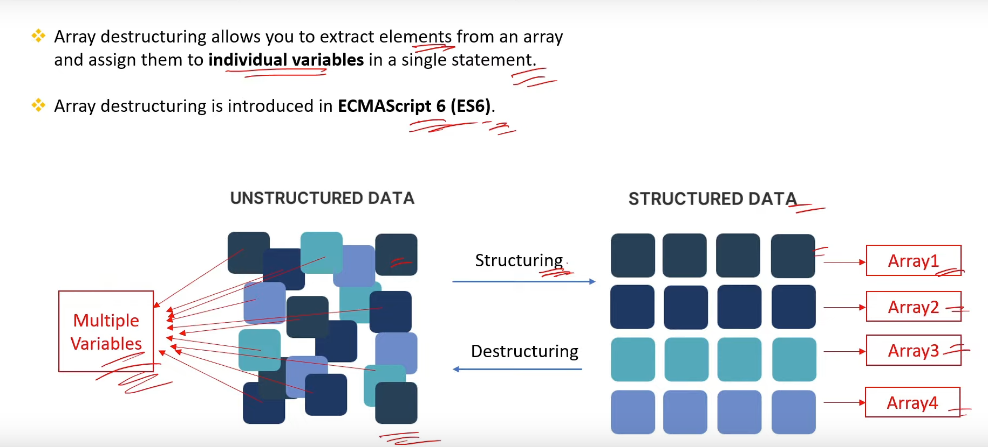

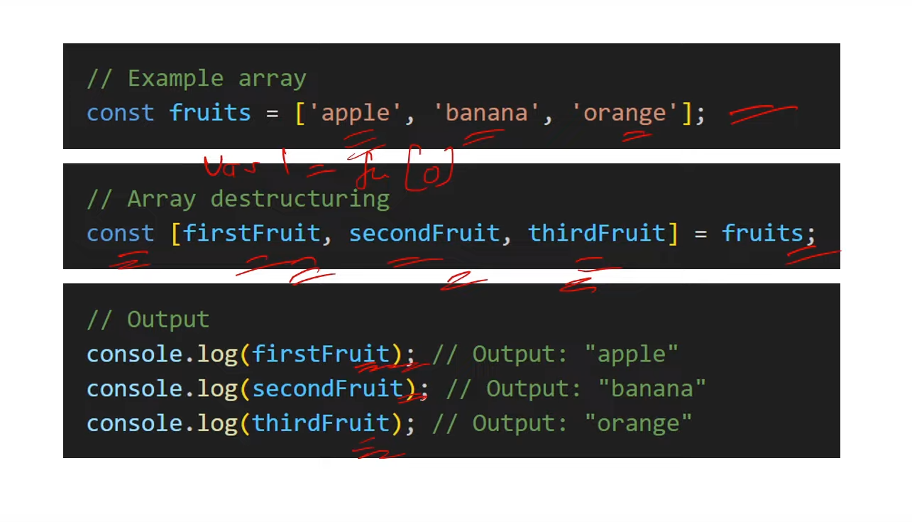

1. **What are array-like objects In JS?**

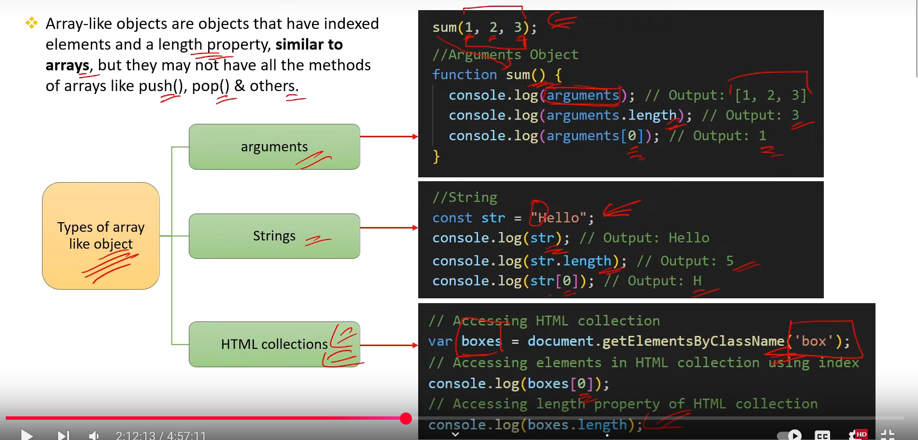

1. **How to convert an array-like obiect into an array?**

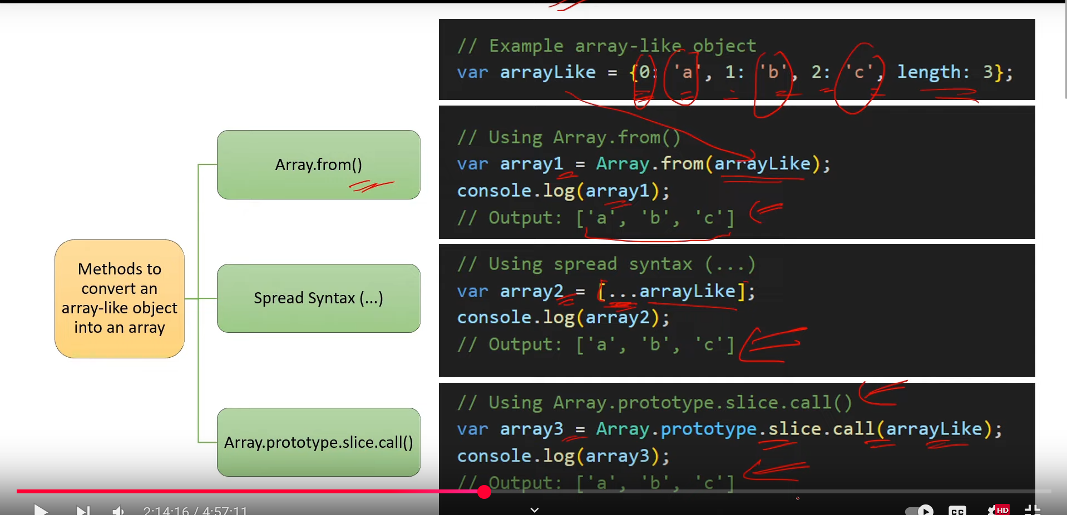

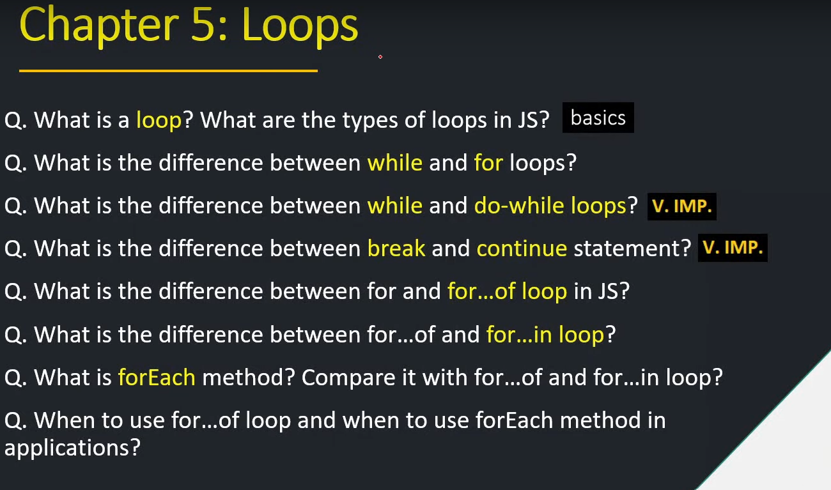

1. **What is a loop? What are the types of loops in JS? [basics]**
2. **What is the difference between while and for loops?**

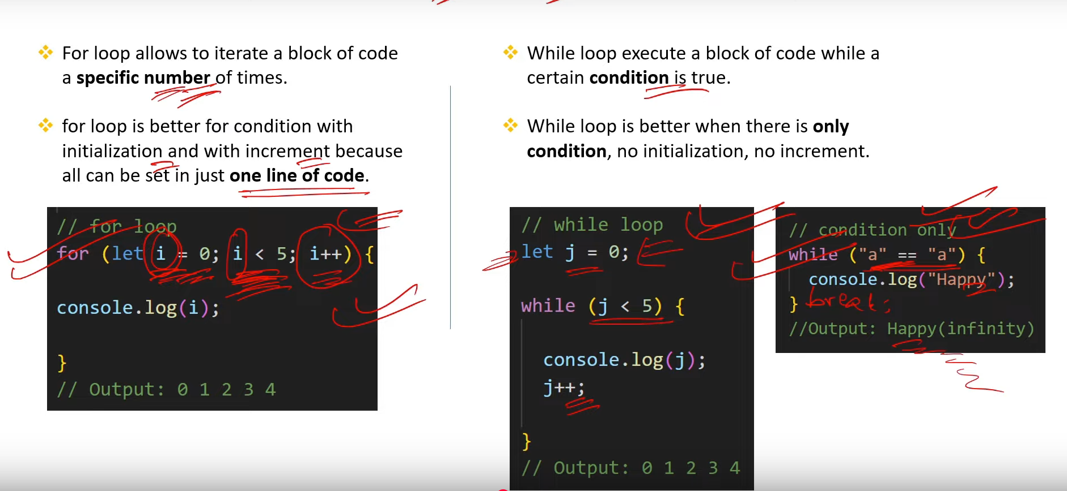

1. **What is the difference between while and do-while loops? [V.IMP.]**

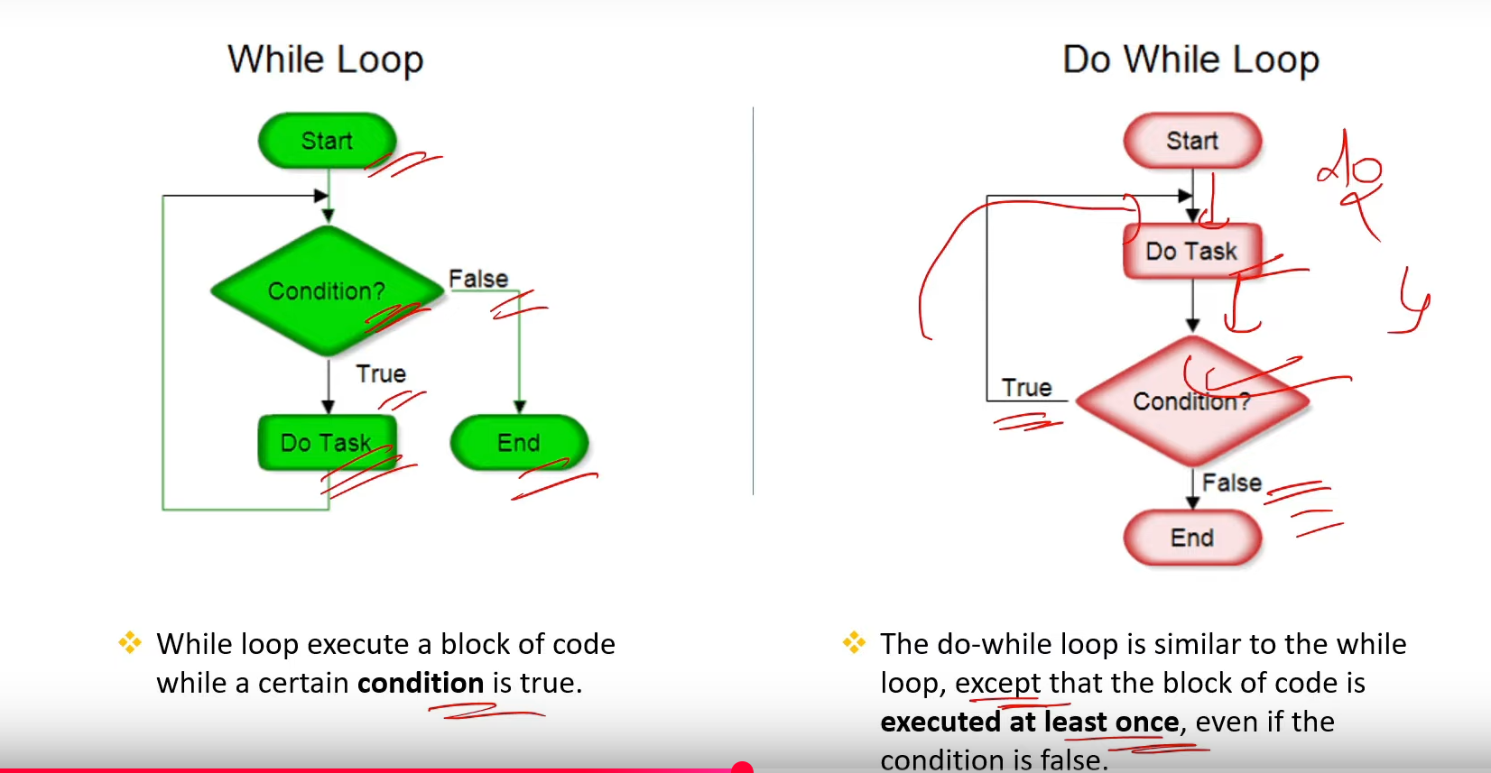

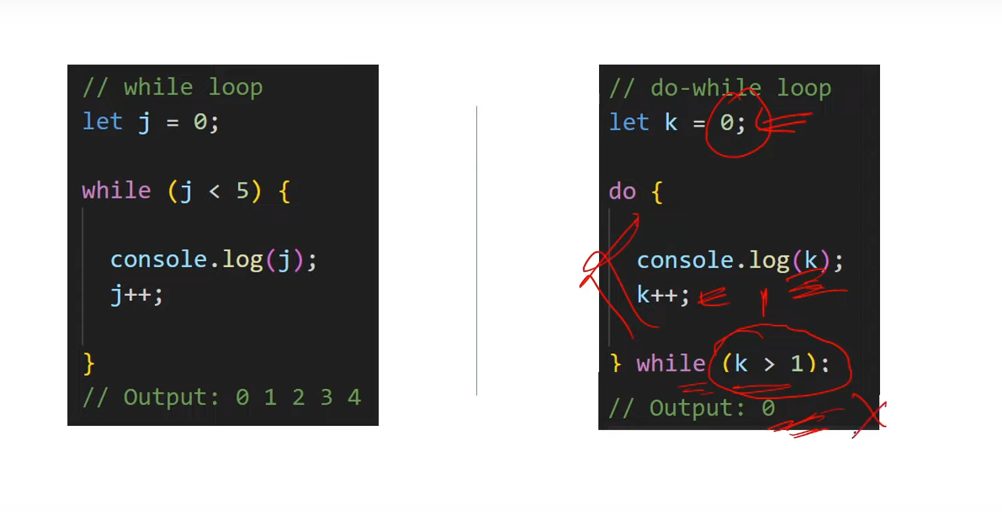

1. **What is the difference between break and continue statement?[ V.IMP.]**

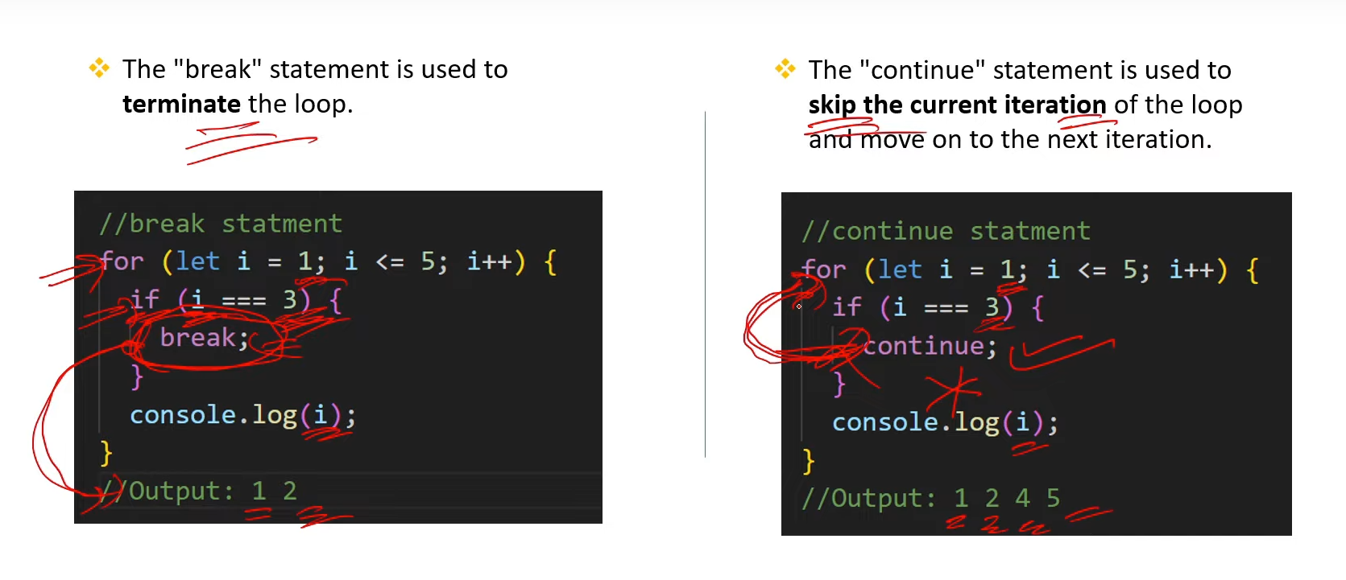

1. **What is the difference between for and for...of loop in JS?** 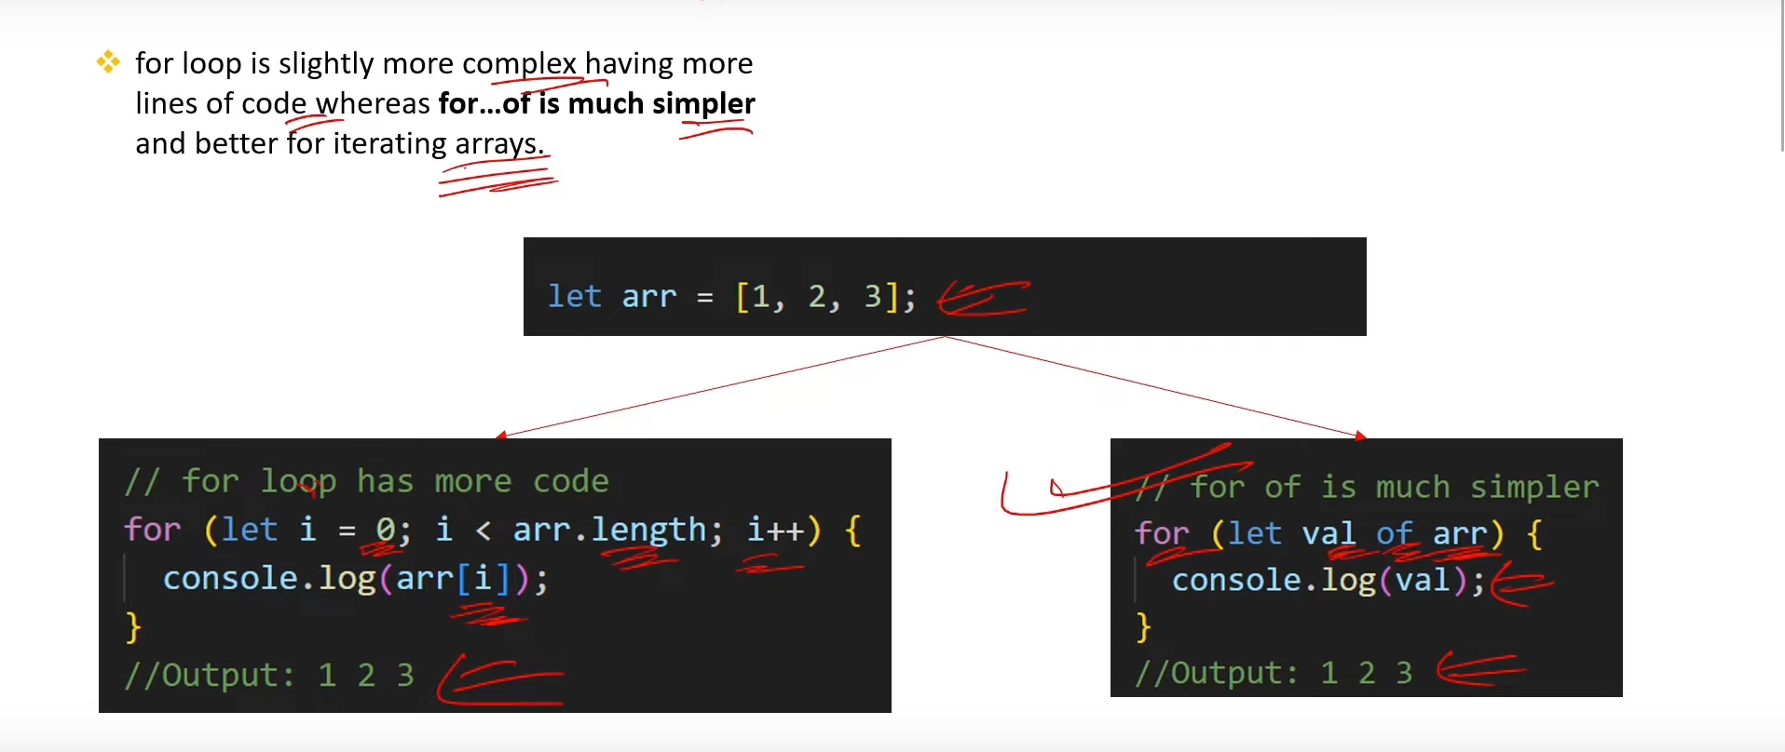
2. **What is the difference between for...of and for..in loop?**

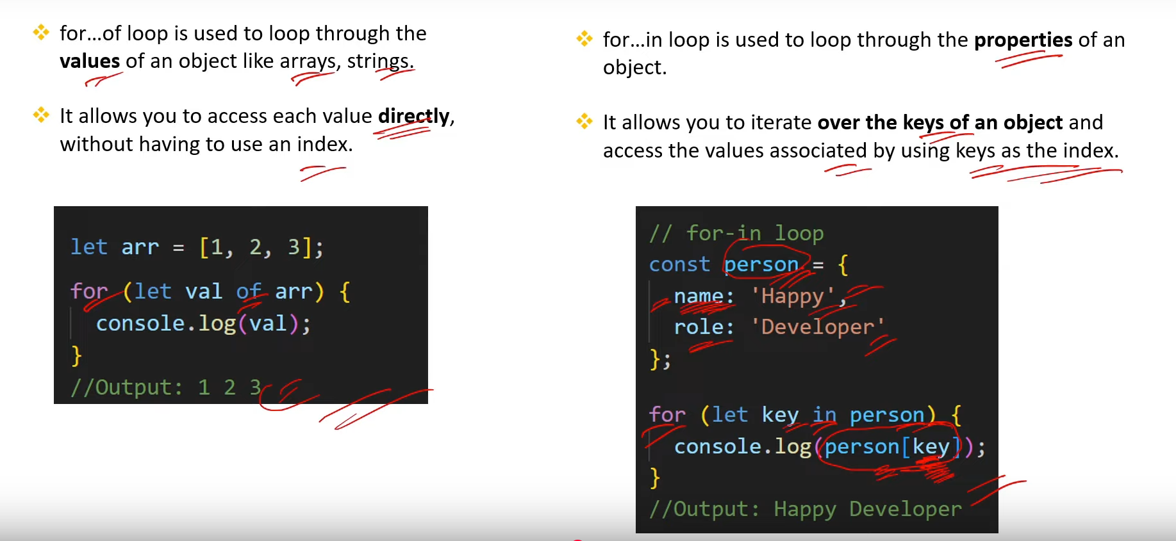

1. **What is forEach method? Compare it with for...of and for...in loop?**

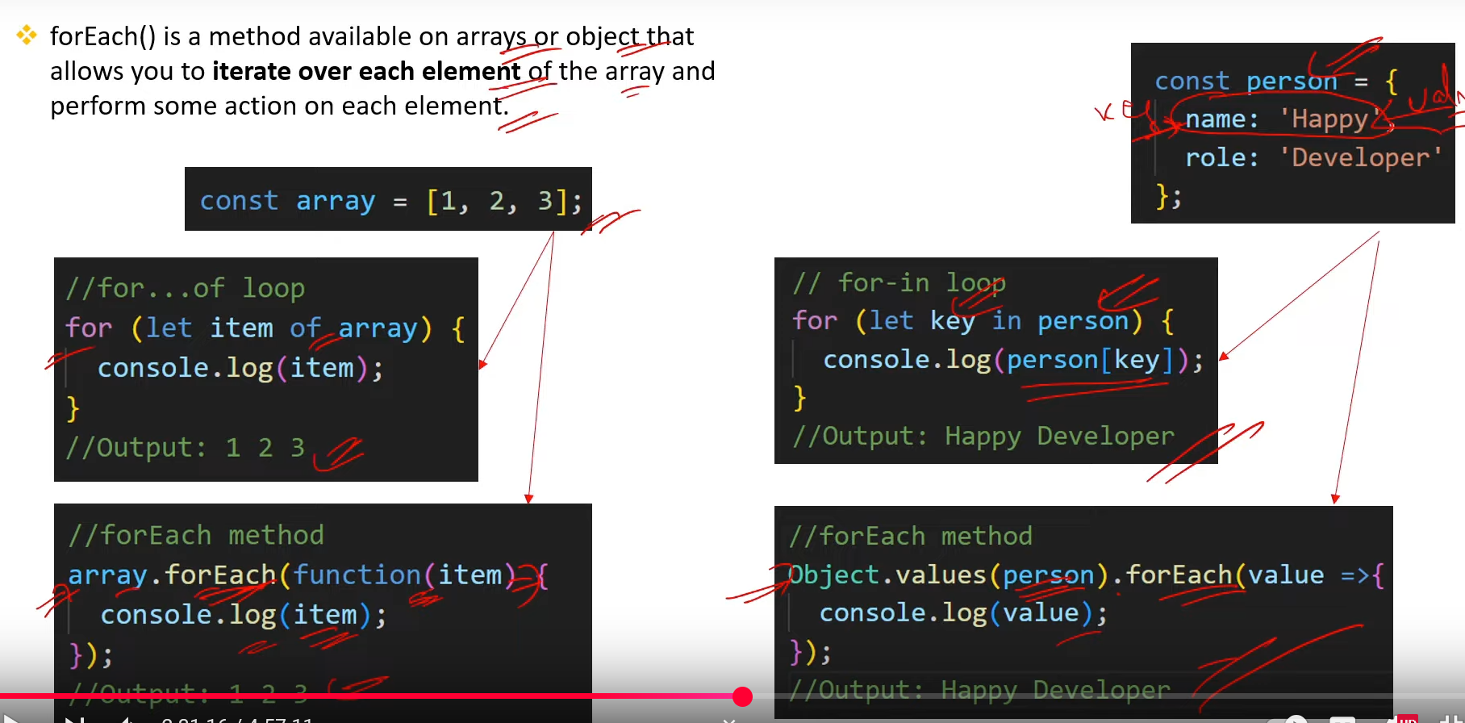

1. **When to use for...of loop and when to use forEach method in applications?**

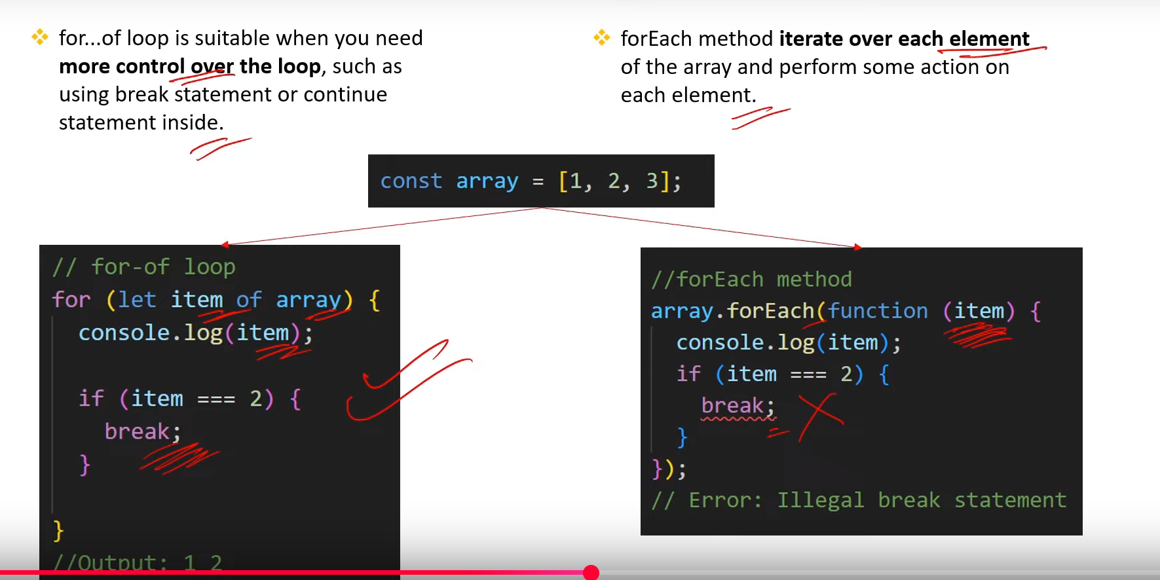

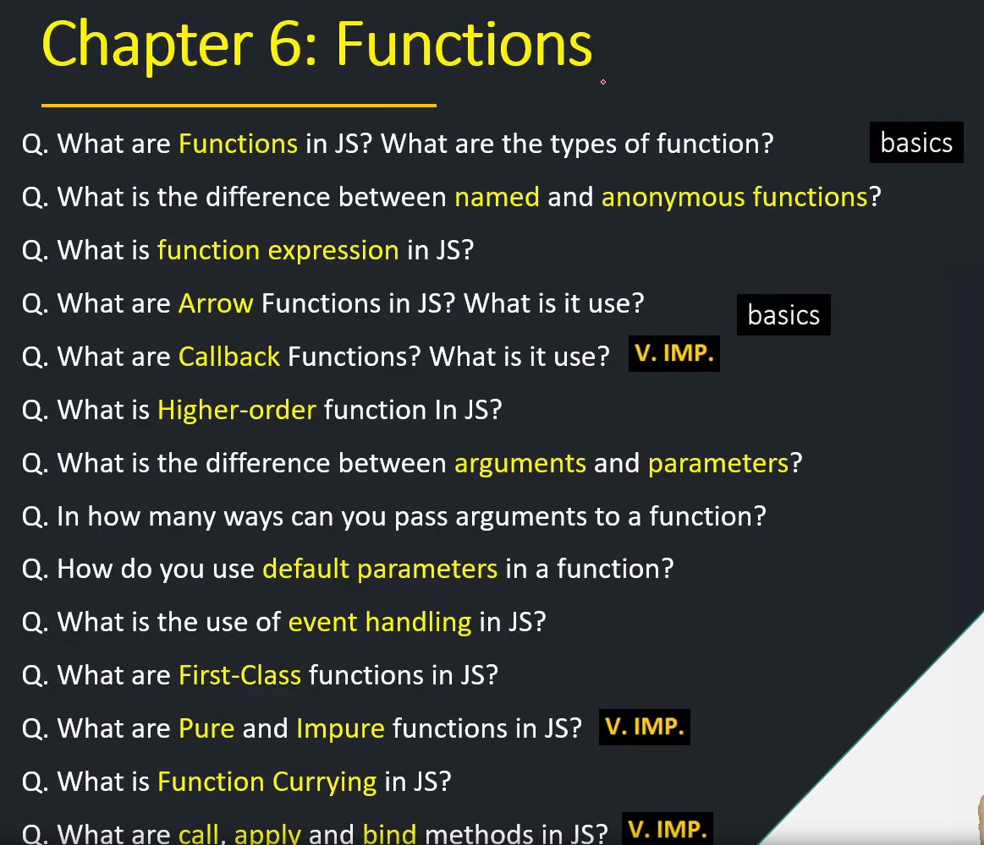

1. **What are Functions in JS? What are the types of function? [basics]**

* **Function is a Reuseable block of code that perform some specific task when we call the function, function can take argument for operation. We can Reuseable the function also.**

1. **What is the difference between named and anonymous functions?**

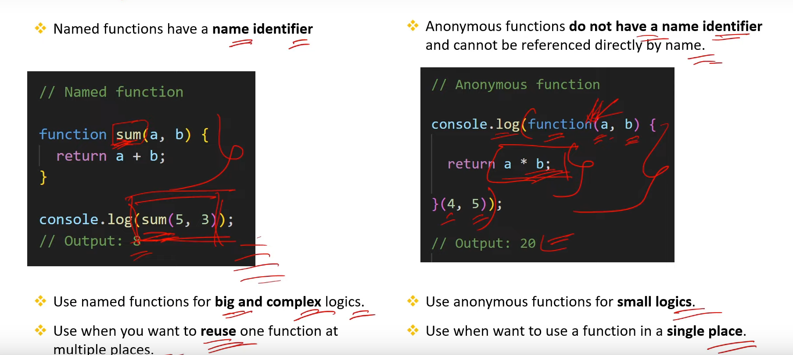

1. **What is function expression in JS?**

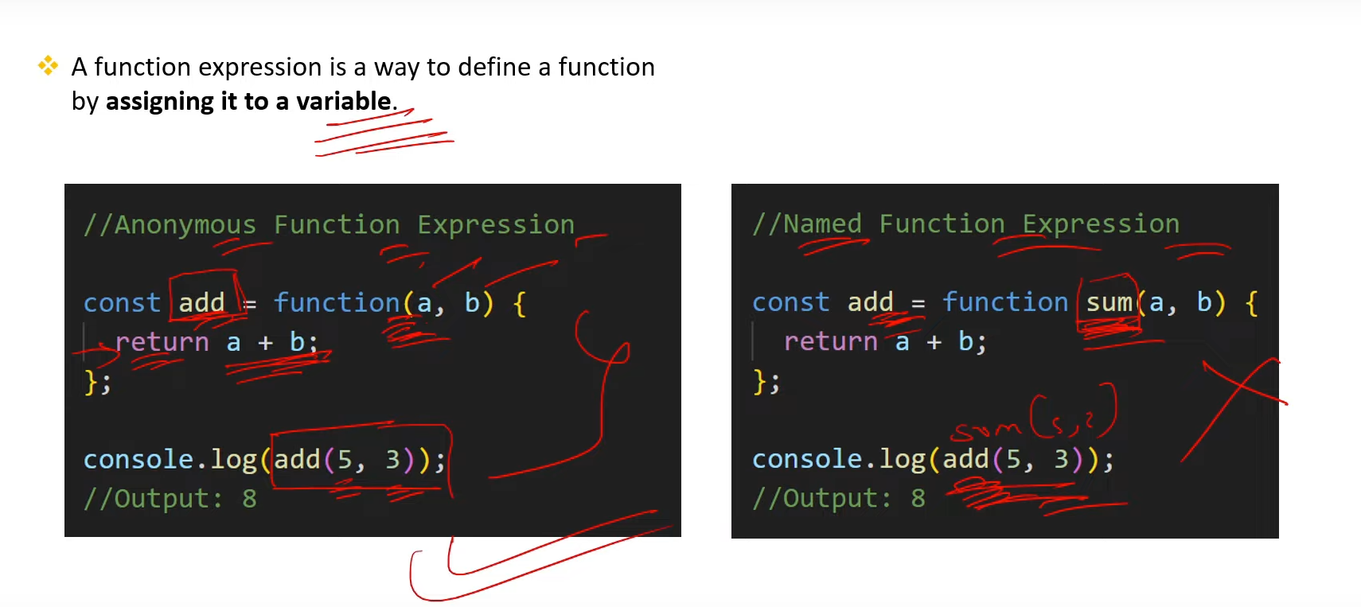

1. **What are Arrow Functions in JS? What is it use? [Basic]**

**->Arrow function is the easy and modern way to define the function, its syntax is very easy and readable , and also in arrow function the this keyword is point to the windows object.**

1. **What are Callback Functions? What is it use? [V.IMP.]**

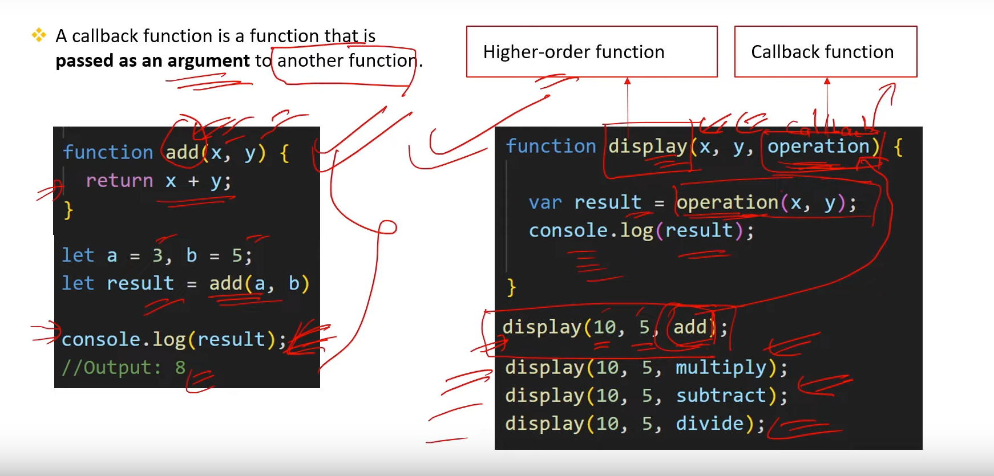

1. **What is Higher-order function In JS?**

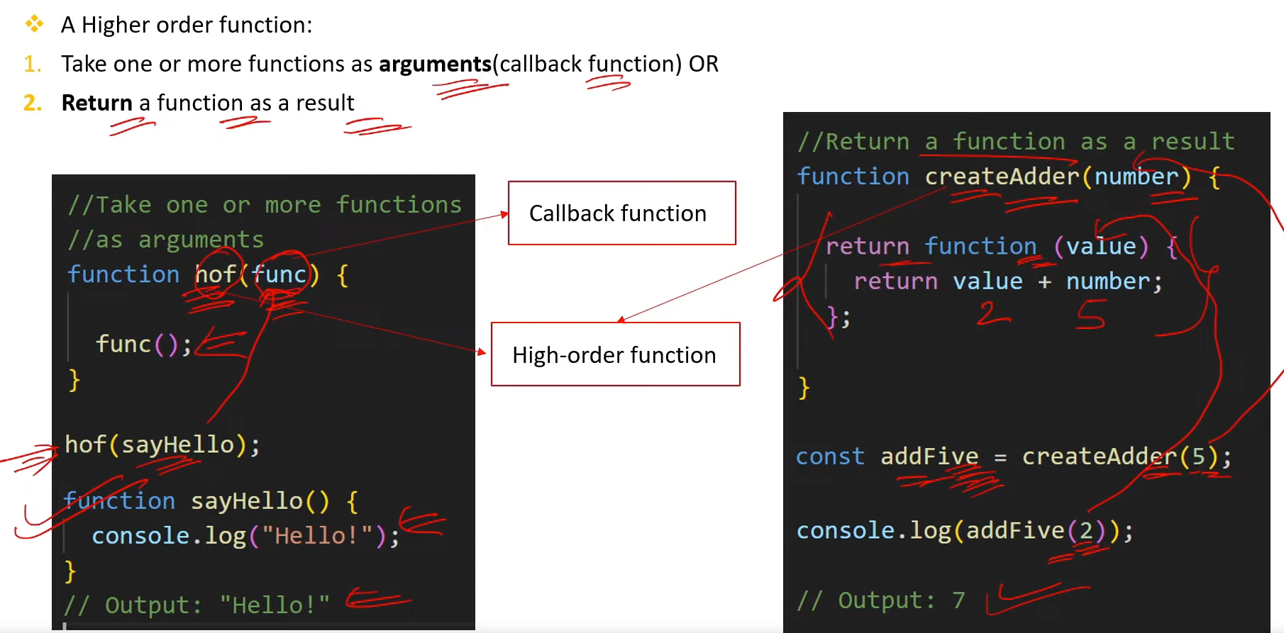

1. **What is the difference between arguments and parameters?**

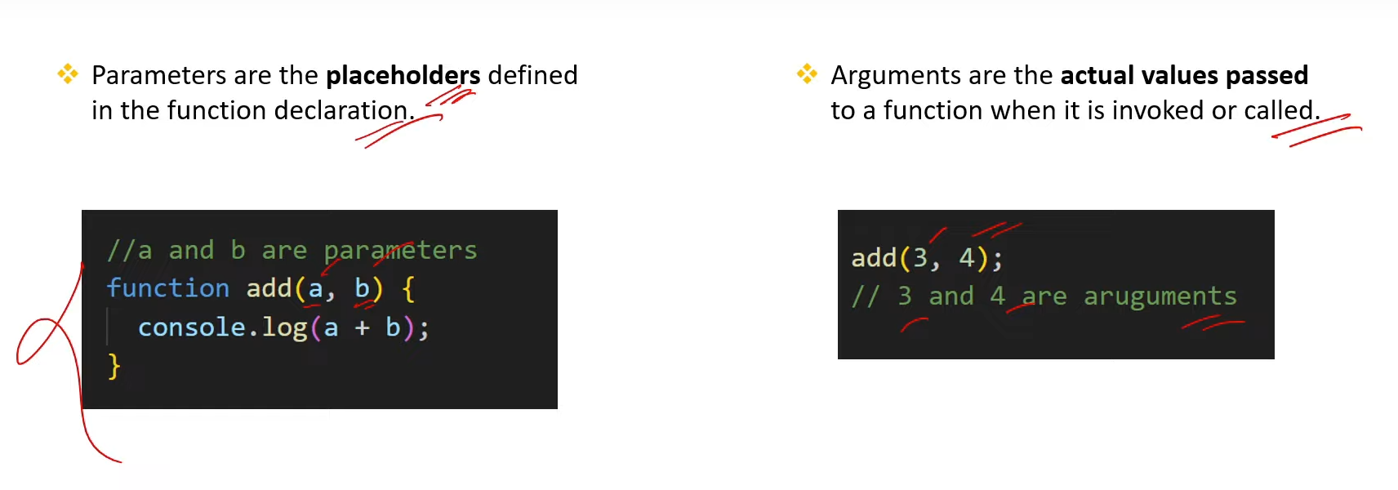

1. **In how many ways can you pass arguments to a function?**

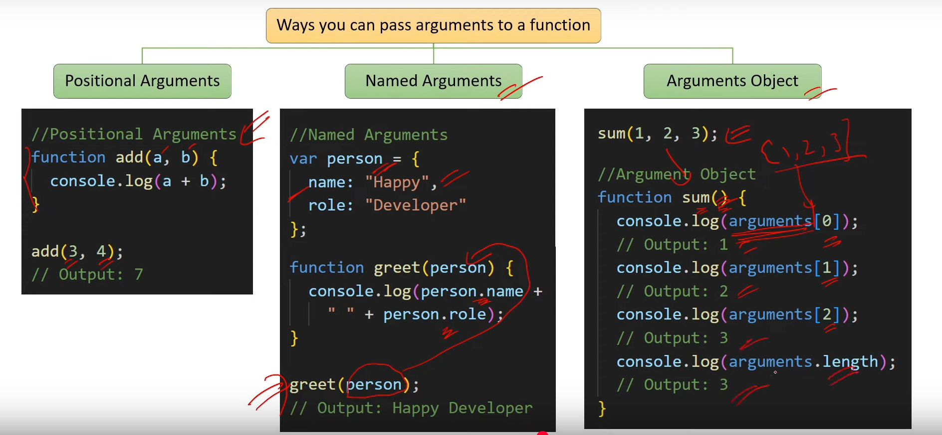

1. **How do you use default parameters in a function?**

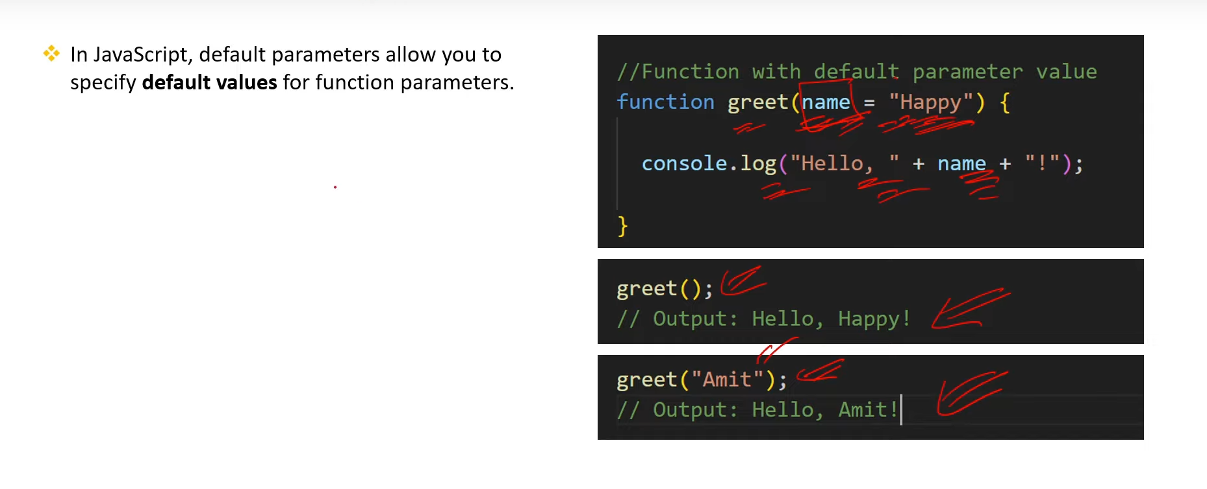

1. **What is the use of event handling in JS?**

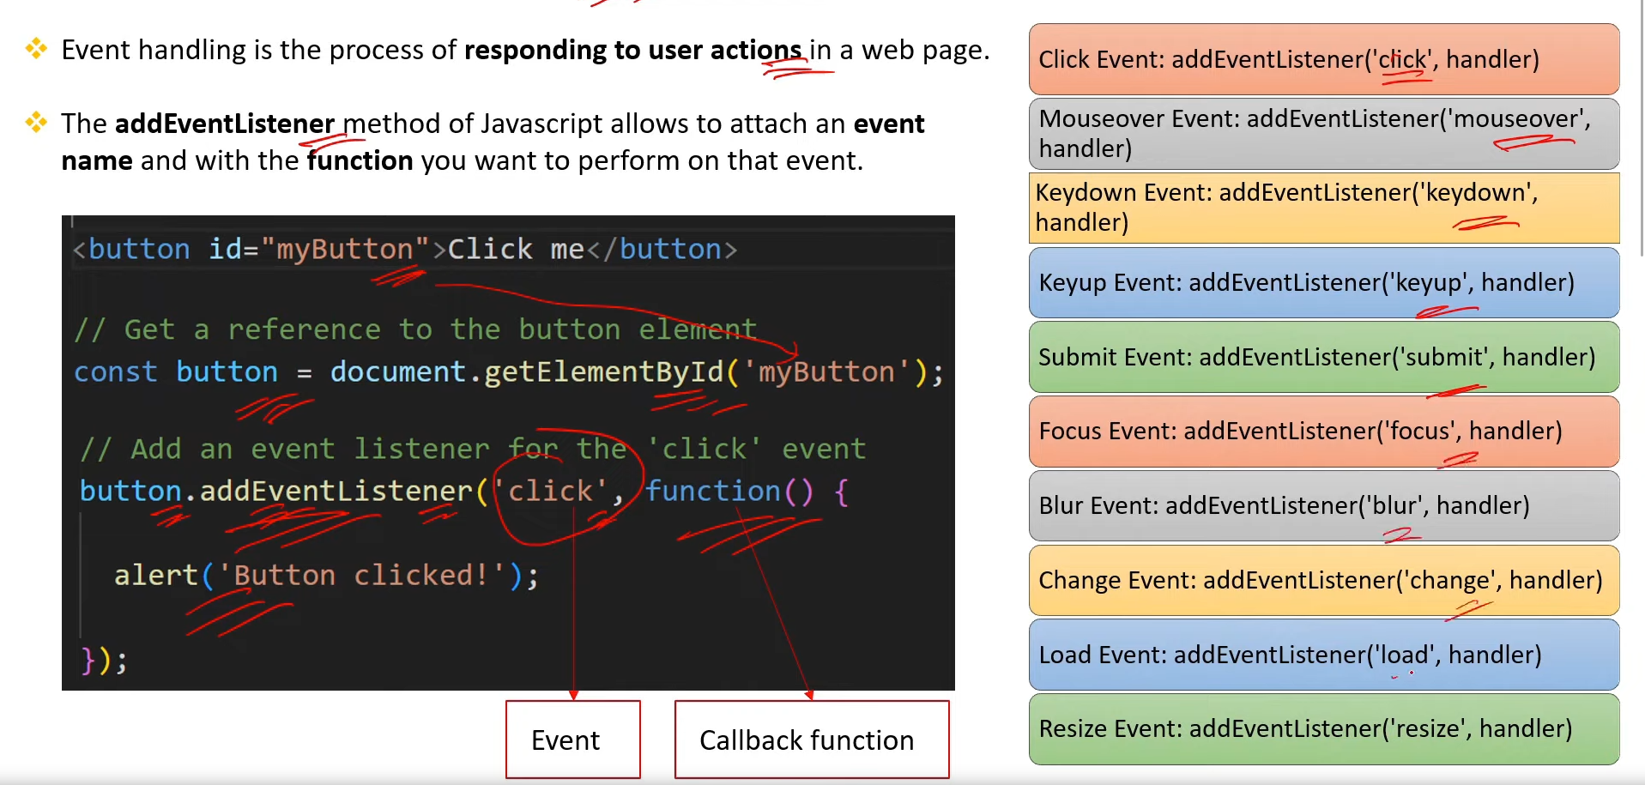

1. **What are First-Class functions in JS?**

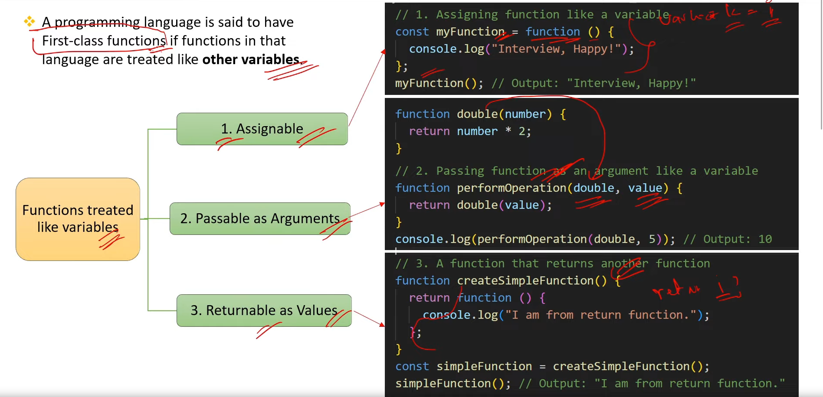

1. **What are Pure and Impure functions in JS? [V.IMP.]**

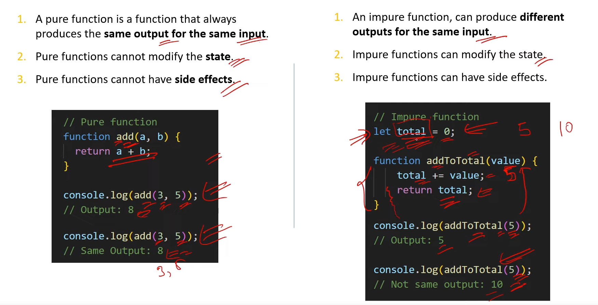

1. **What is Function Currying in JS?**

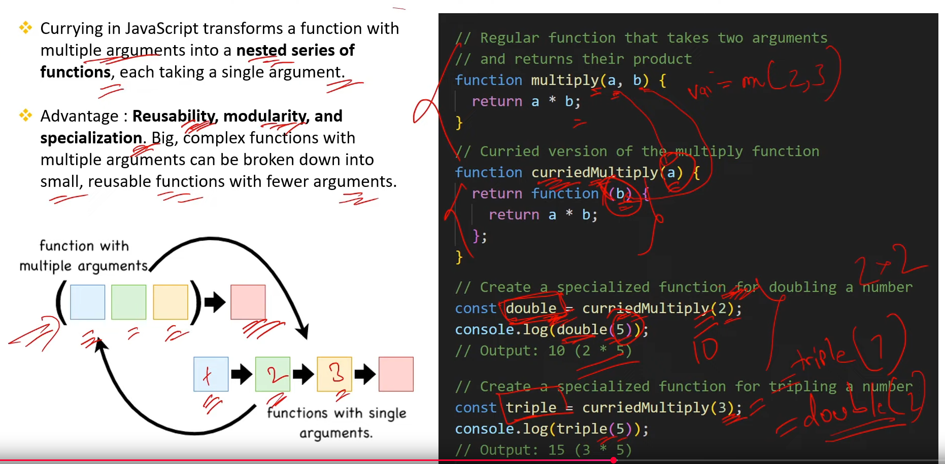

1. **What are call apply and bind methods in IS? [V.IMP]**

* **It is the way of invoke any function in JS. With the context and arguments**

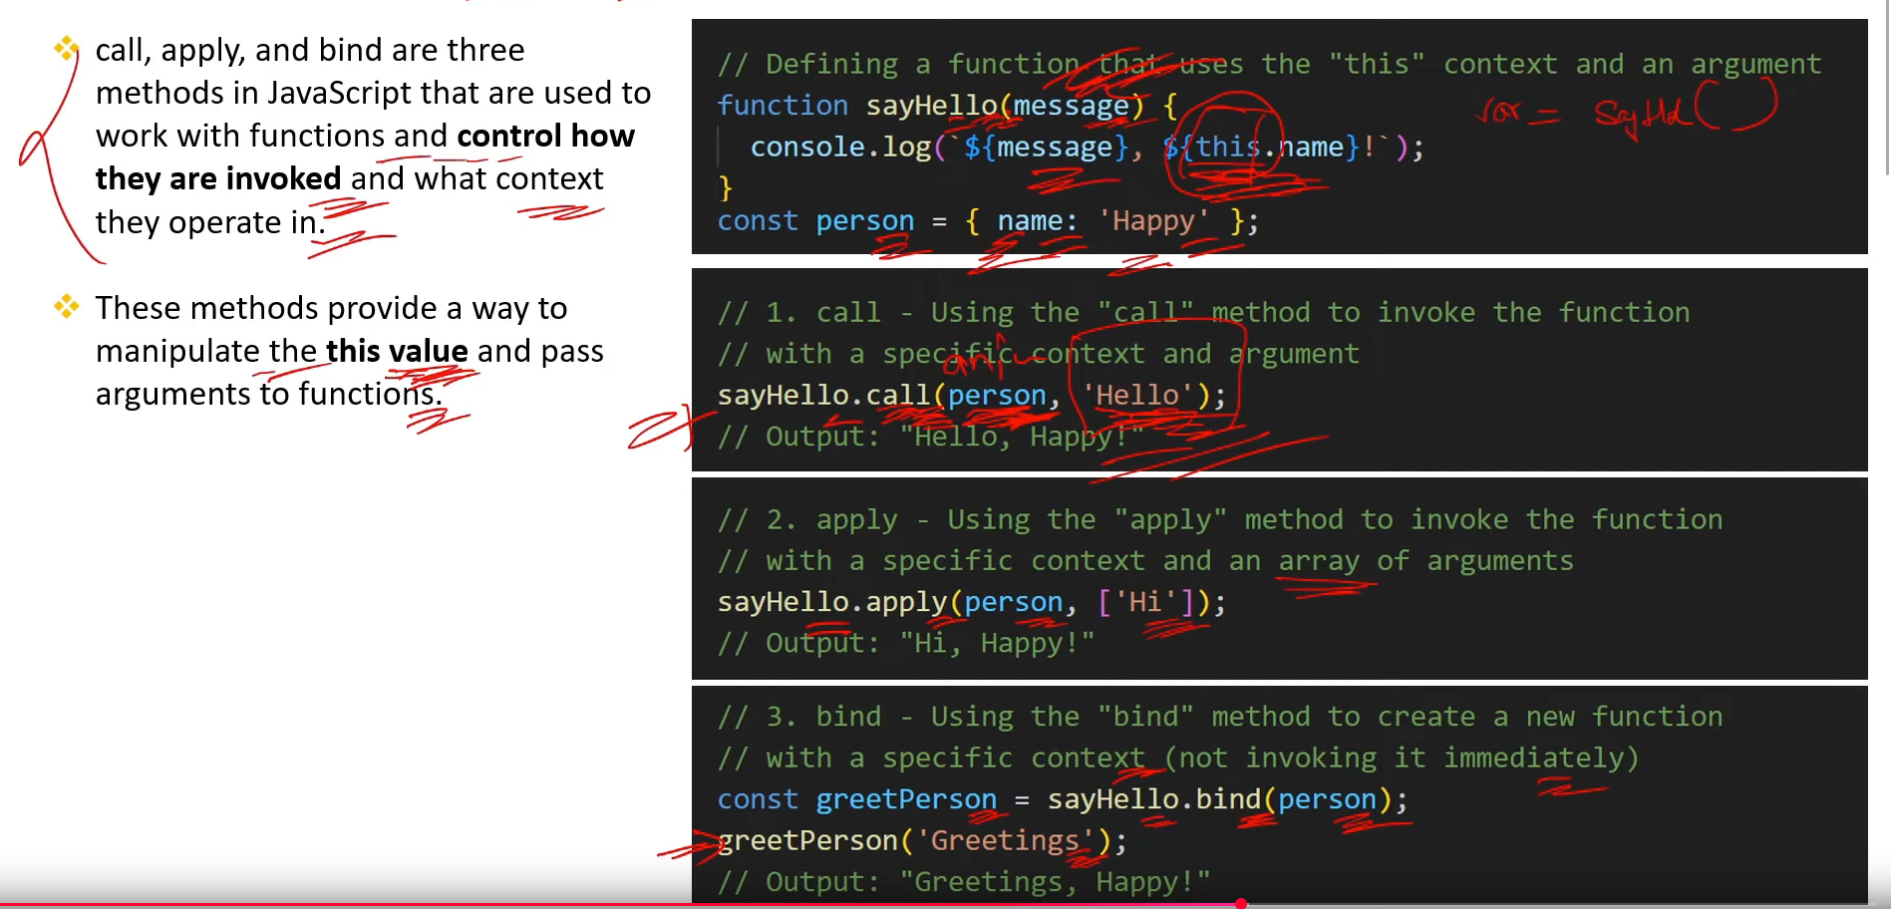

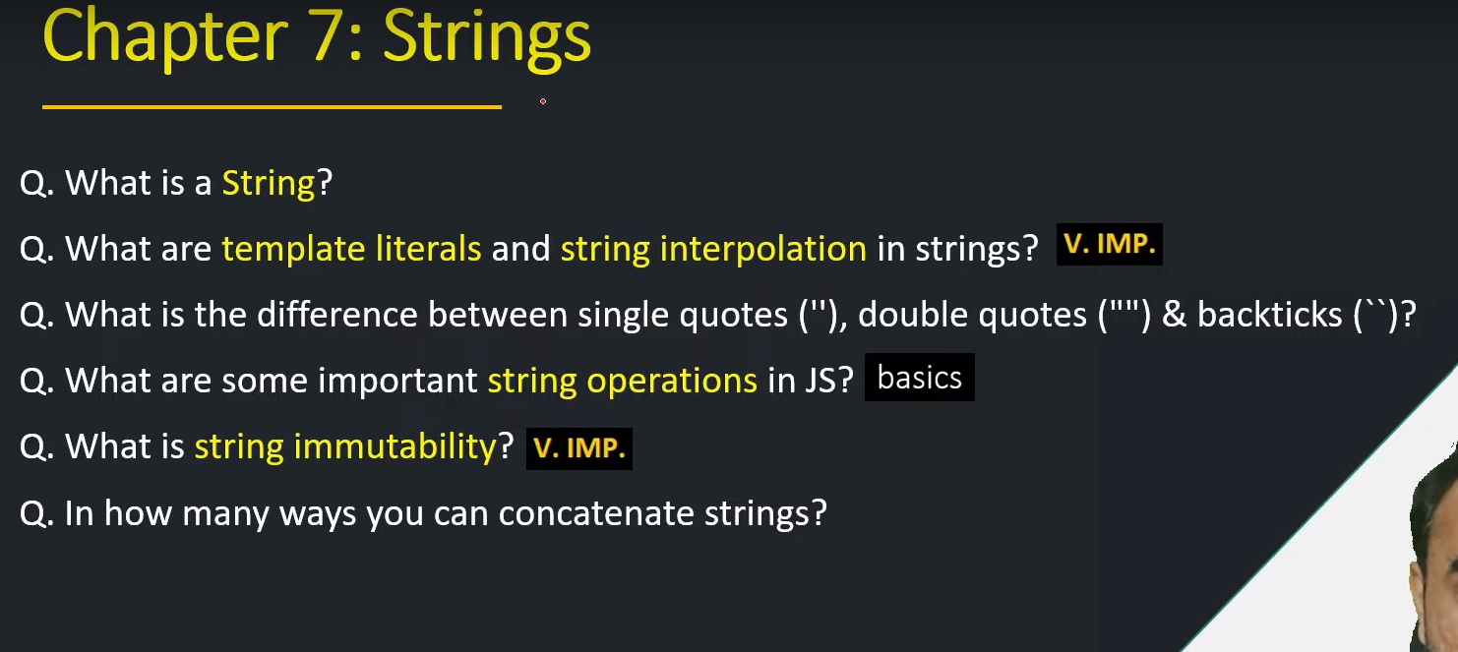

1. **What is a String?**

* **String is a Data type where we store the word or sequence of character.**
* **Strings are immutable in JS**

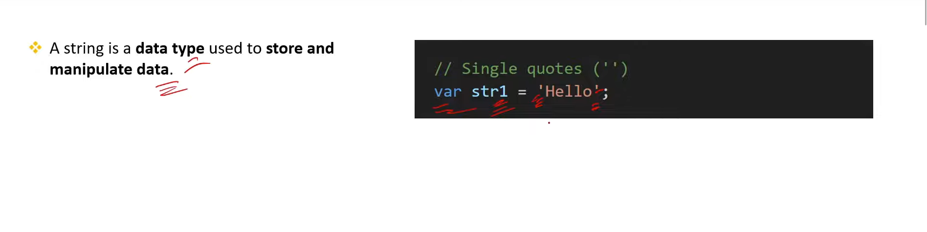

1. **What are template literals and string interpolation in strings? [V.MP.]**

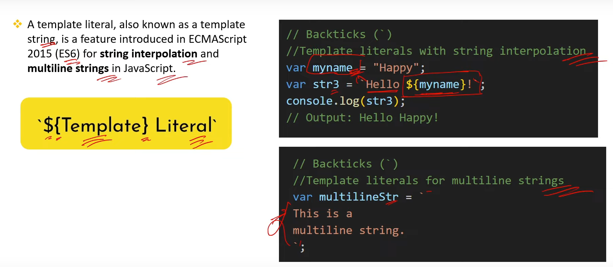

1. **What is the difference between single quotes ("), double quotes ("")& backticks ()?**

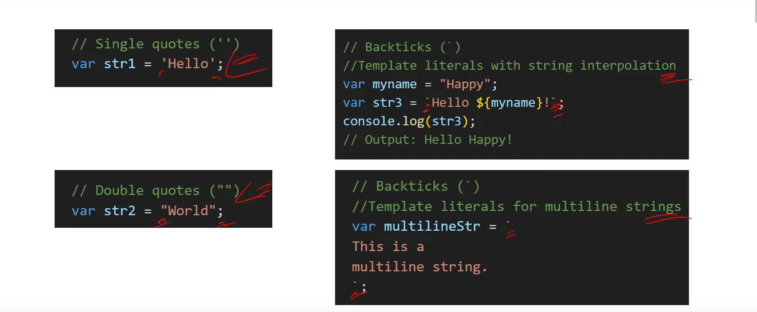

1. **What are some important string operations in JS? [basics]**
2. **What is string immutability? [V.IMP.]**

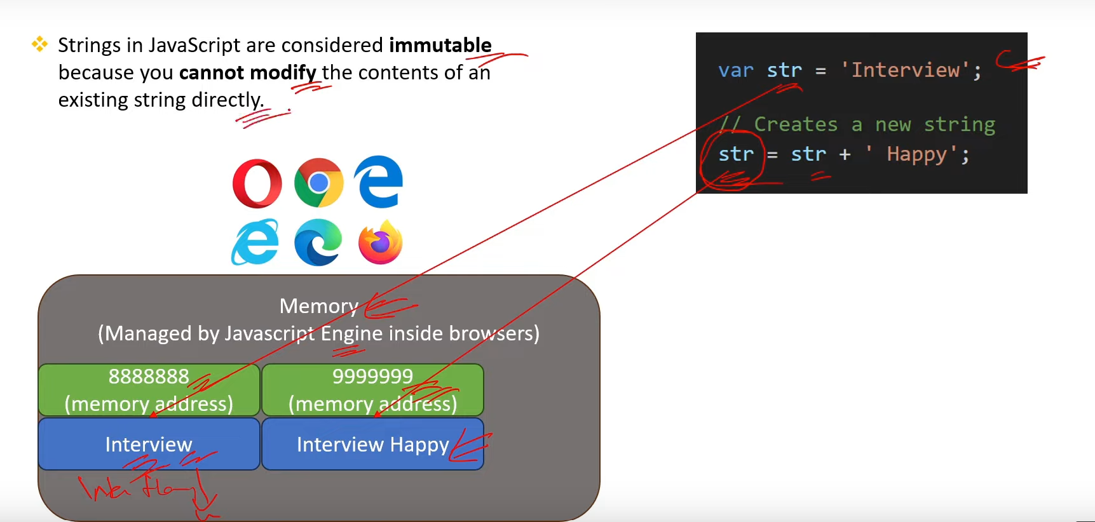

1. **In how many ways you can concatenate strings?**

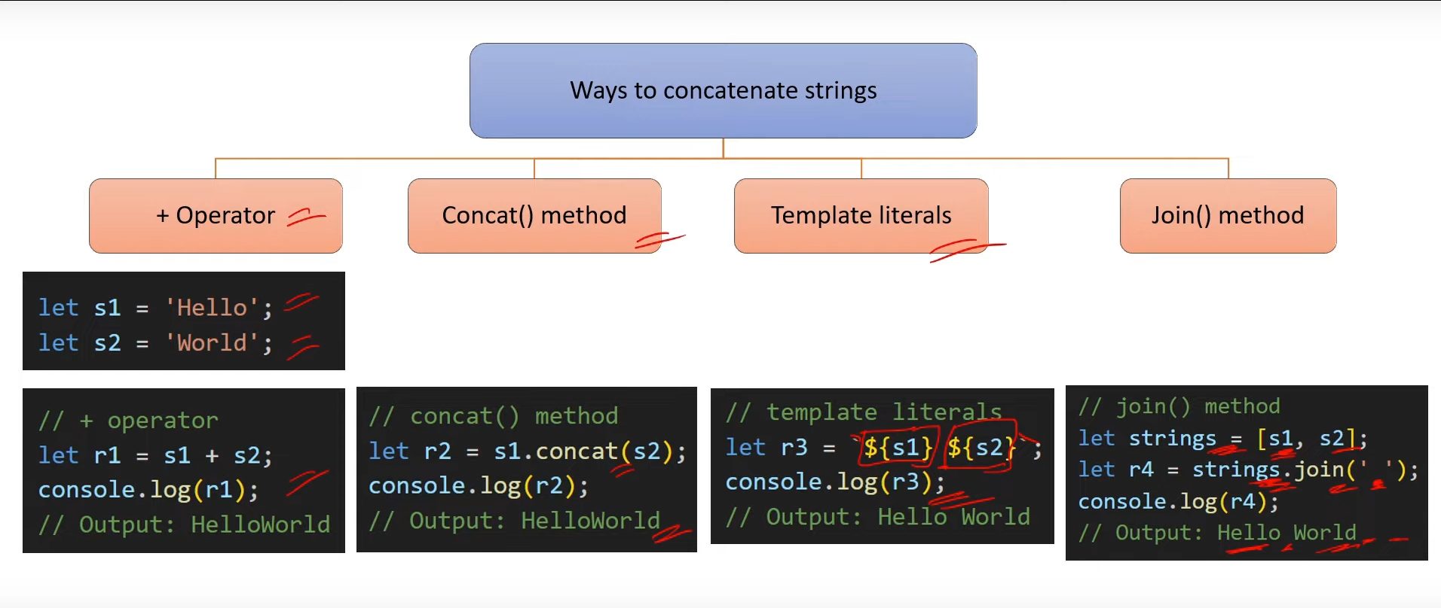

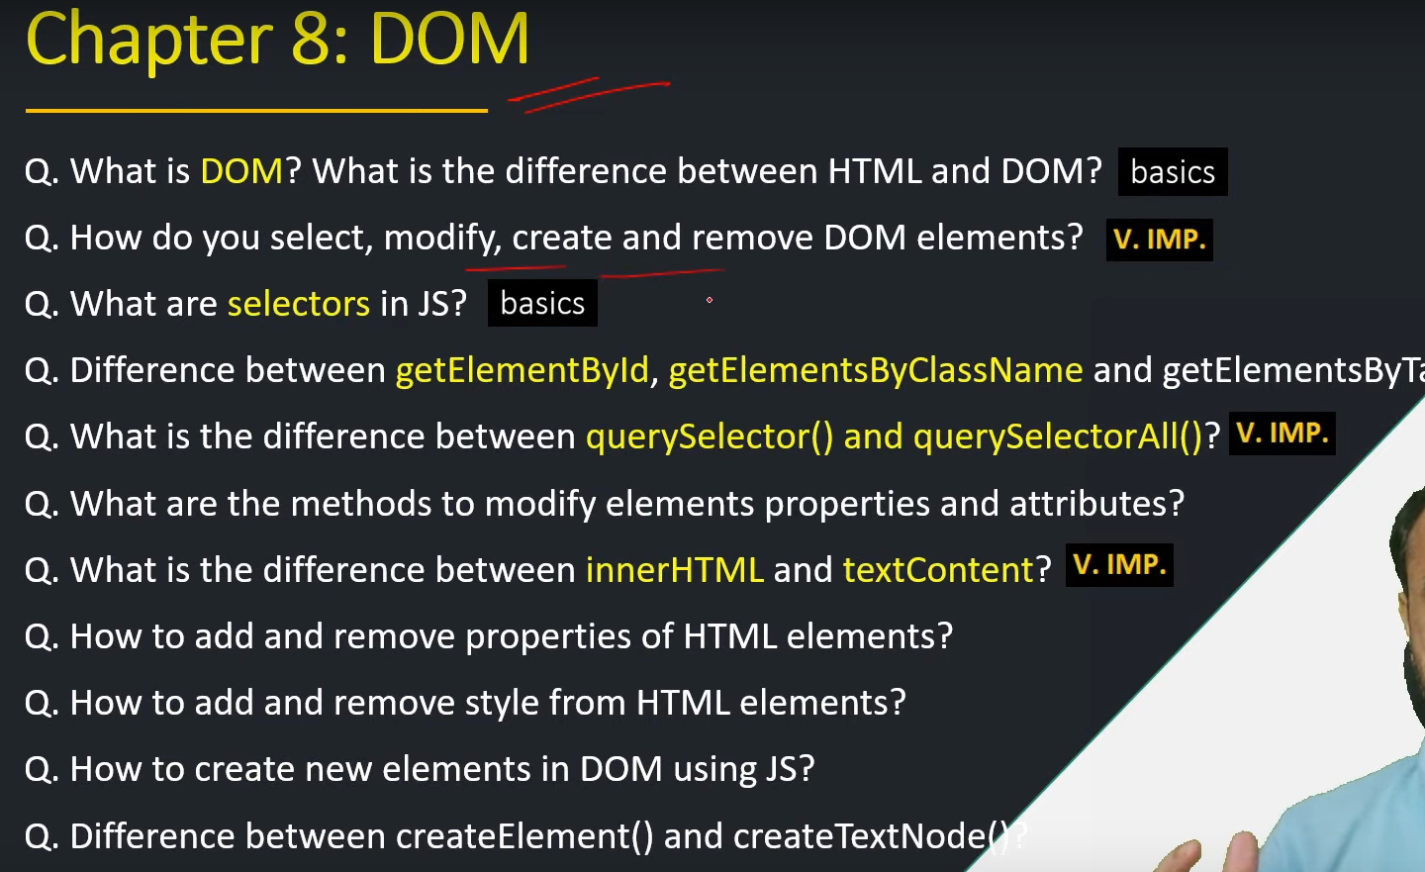

1. **What is DOM?What is the difference between HTML and DOM? [Basics]**
2. **How do you select, modify, create and remove DOM elements? [V.IMP.]**

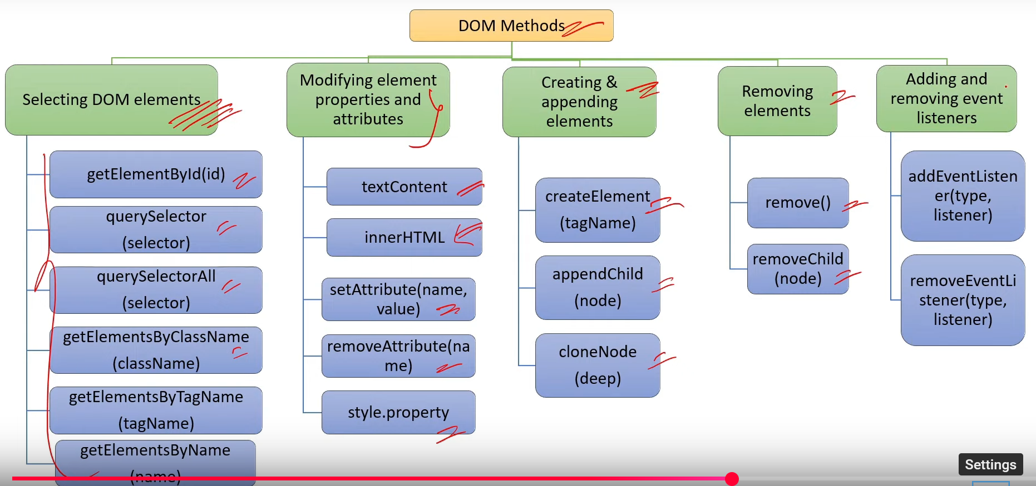

1. **What are selectors in JS? [basics]**
2. **Difference between getElementByld, getElementsByClassName and getElementsByTagName?**
3. **What is the diference between querySelector() and querySelectorAl()? [V.IMP.]**

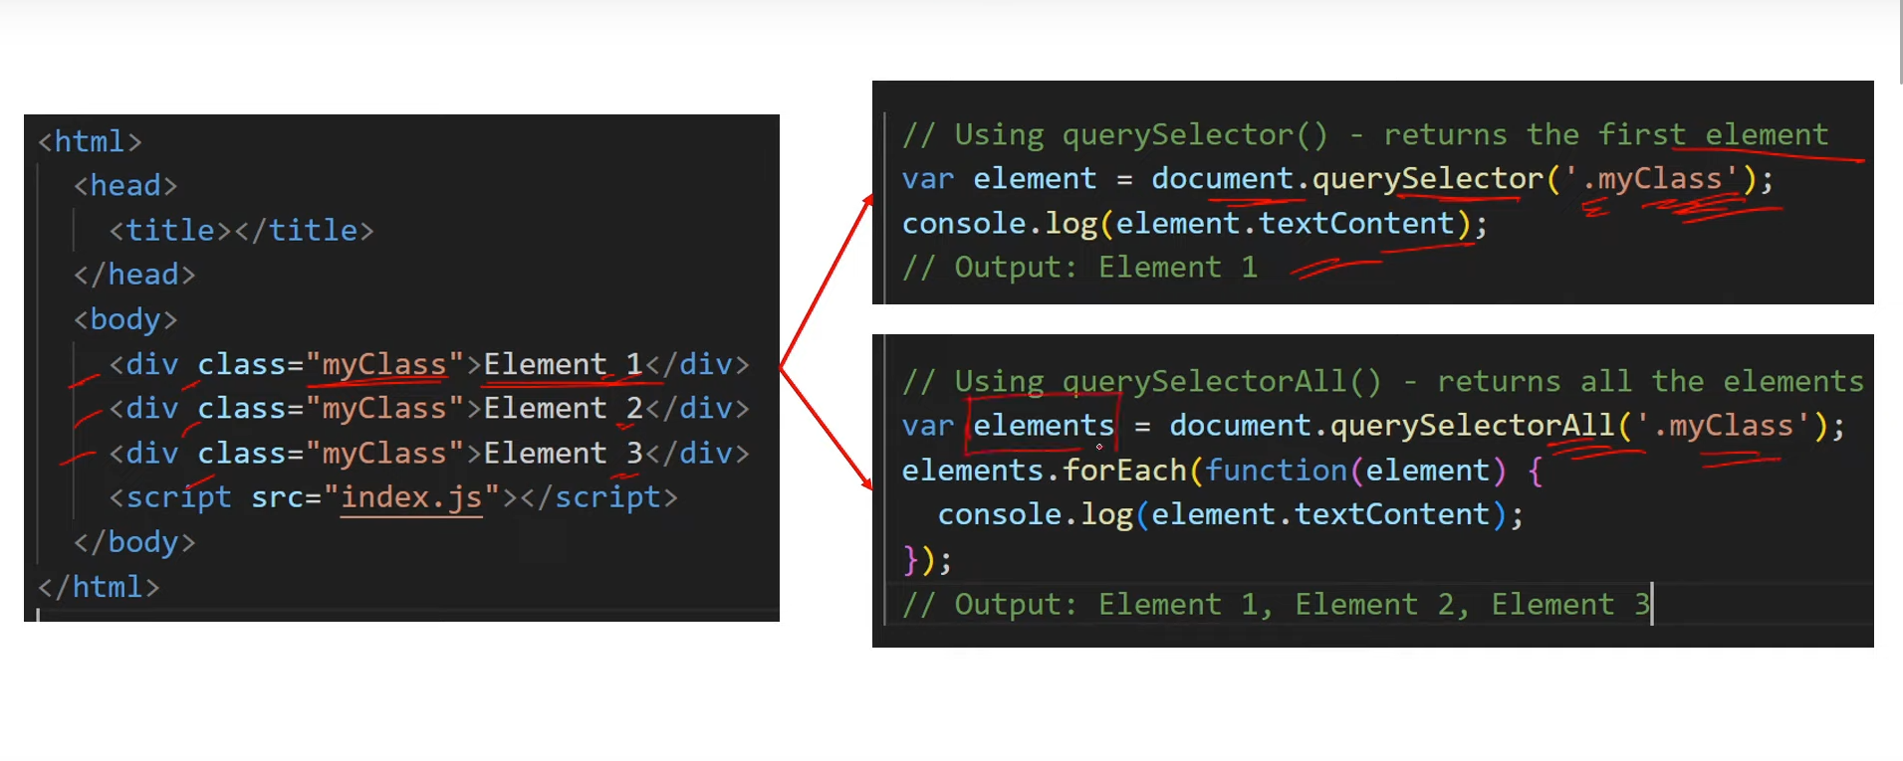

1. **What are the methods to modify elements properties and attributes?**

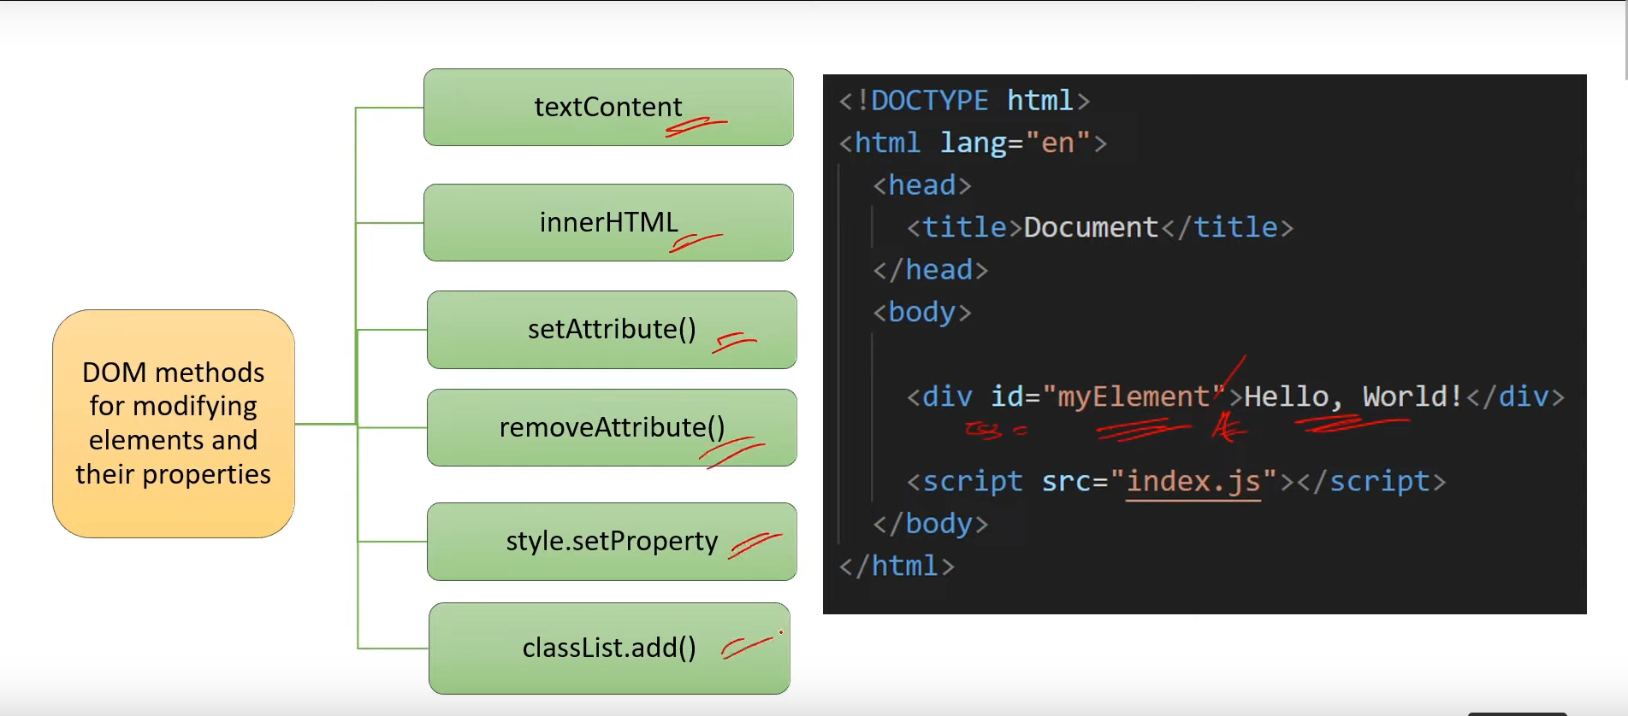

1. **What is the difference between innerHTML and textContent? [V.IMP.]**

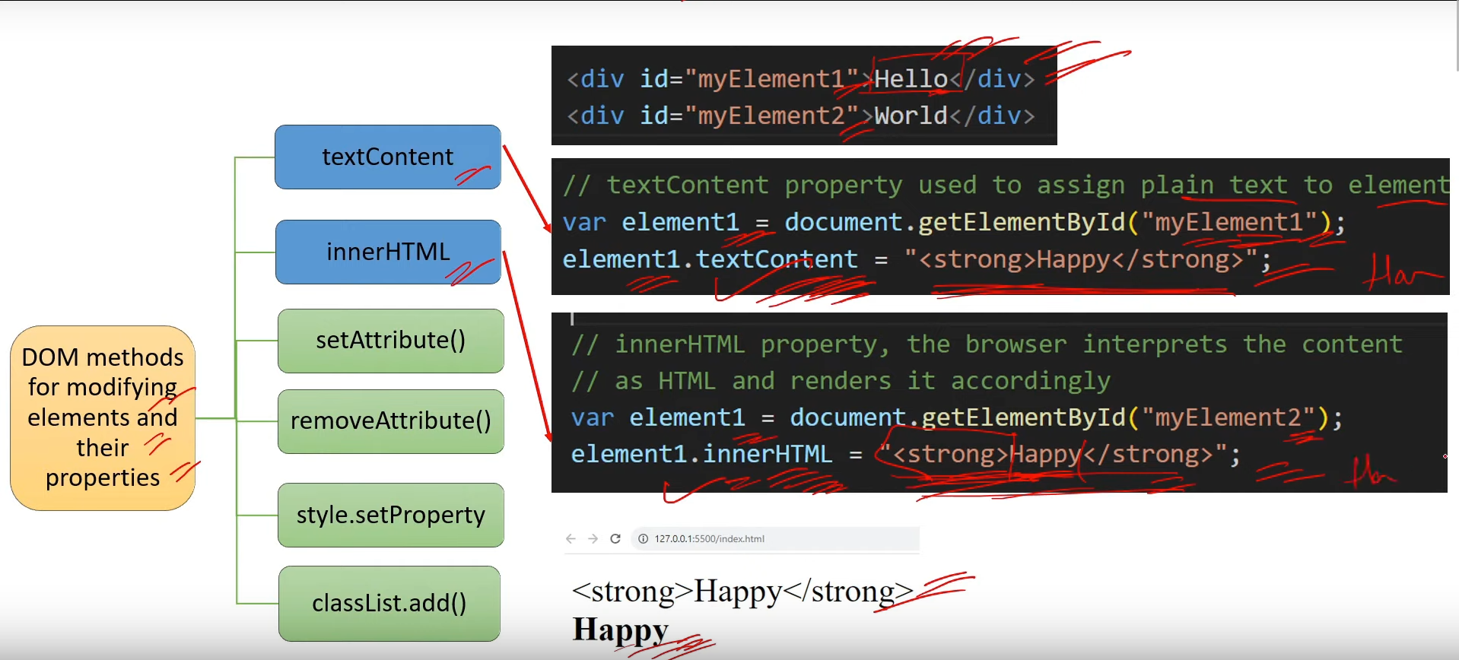

1. **How to add and remove properties of HTML elements**

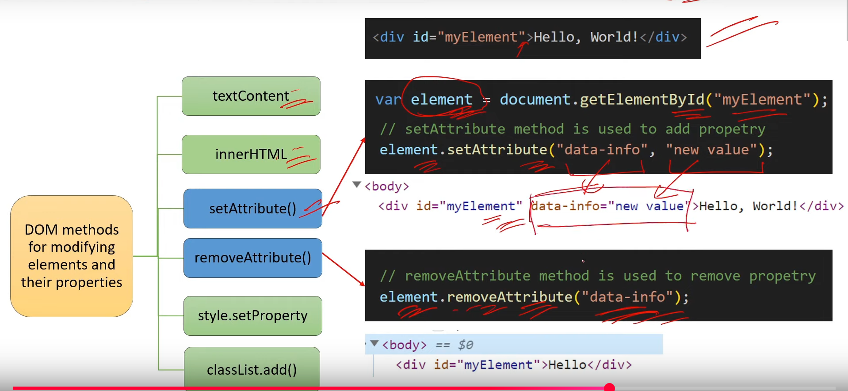

1. **How to add and remove style from HTML elements?**

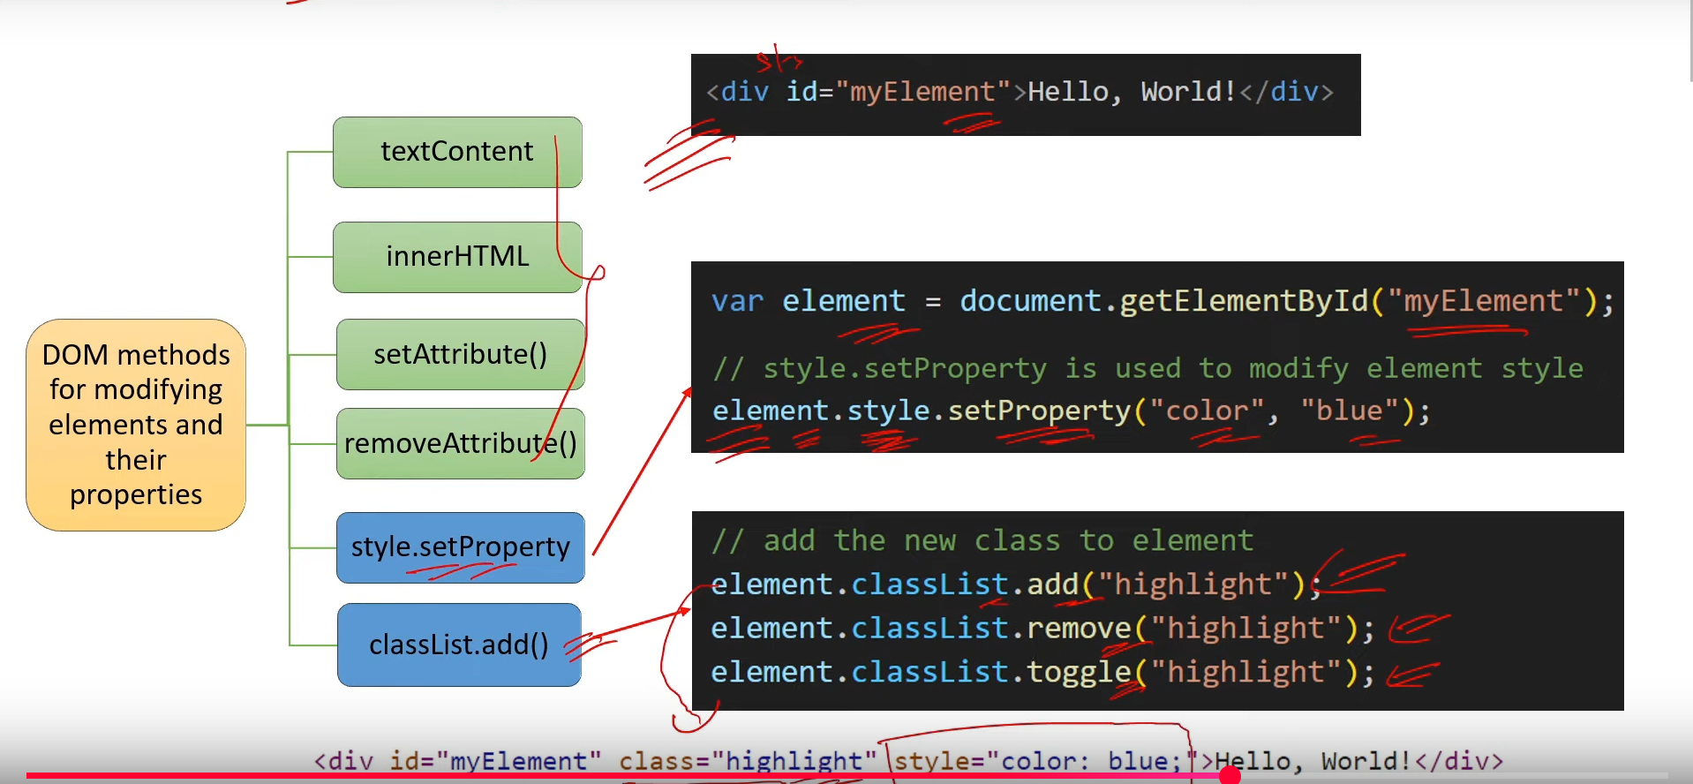

1. **How to create new elements in DOM using JS? Difference between createElement() and cloneNode()?**

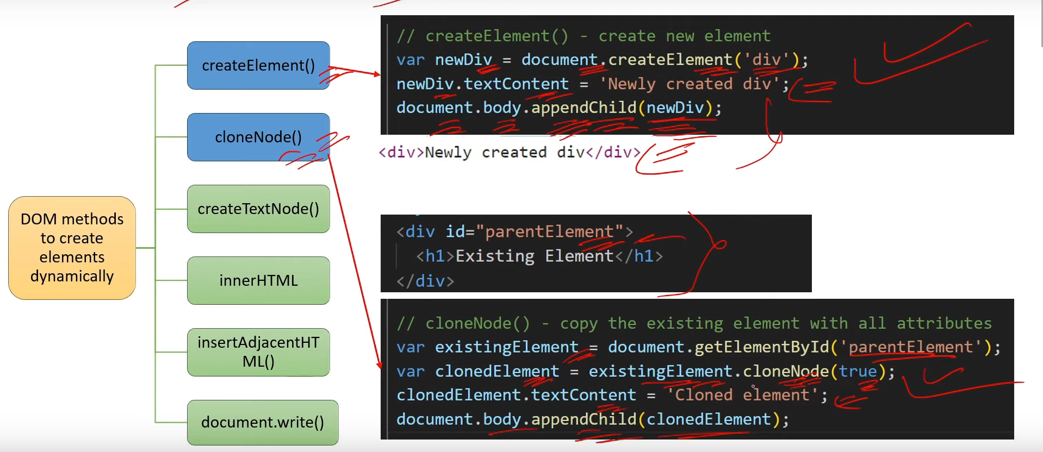

1. **Difference between createElement() and createTextNode()?**

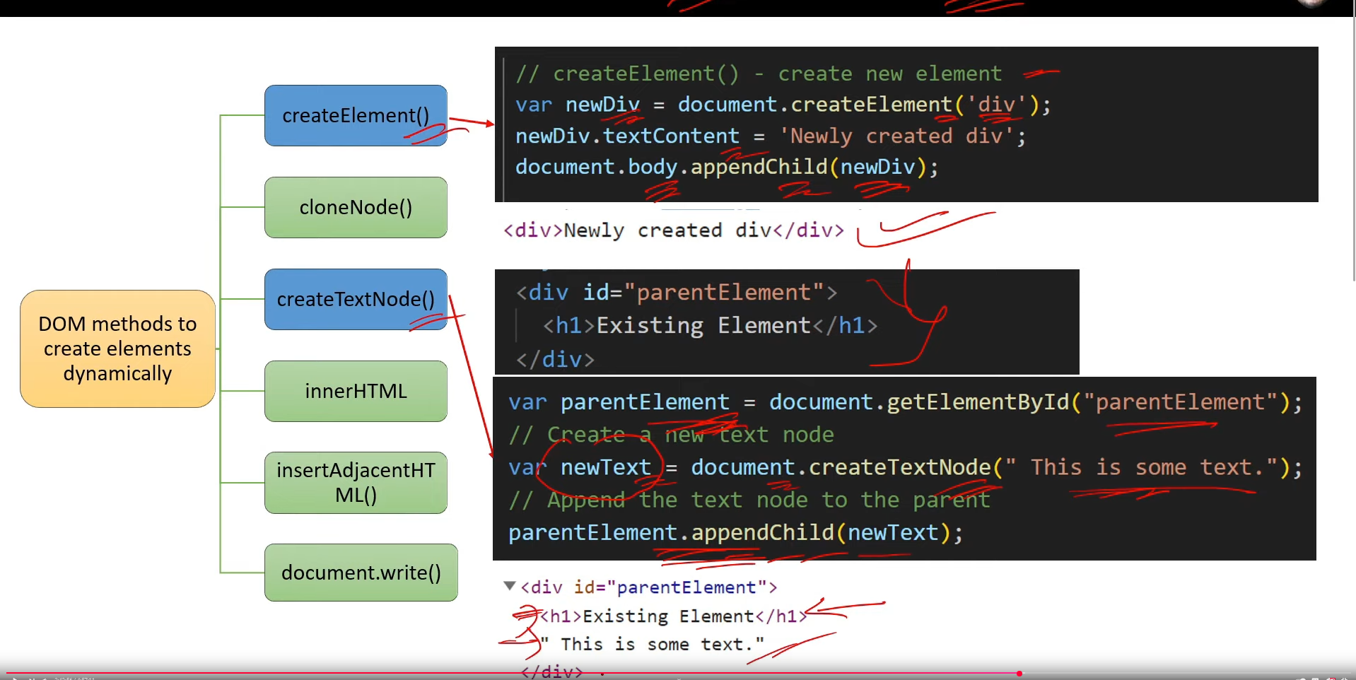

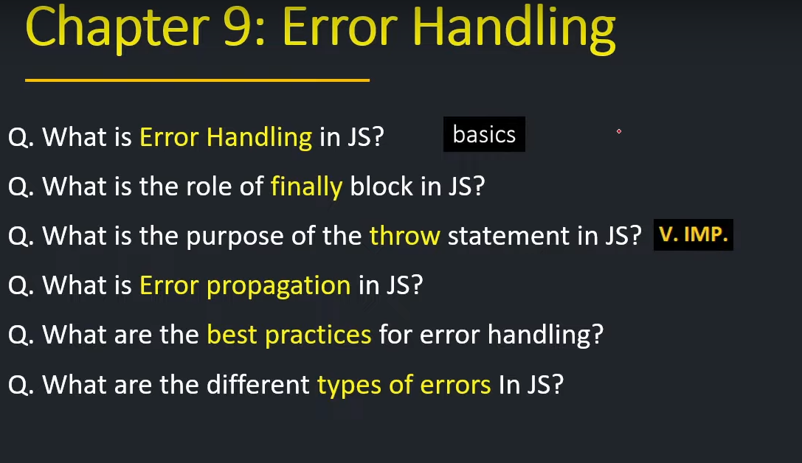

1. **What is Error Handling in JS? [Basic]**
2. **What is the role of finally block in JS?**

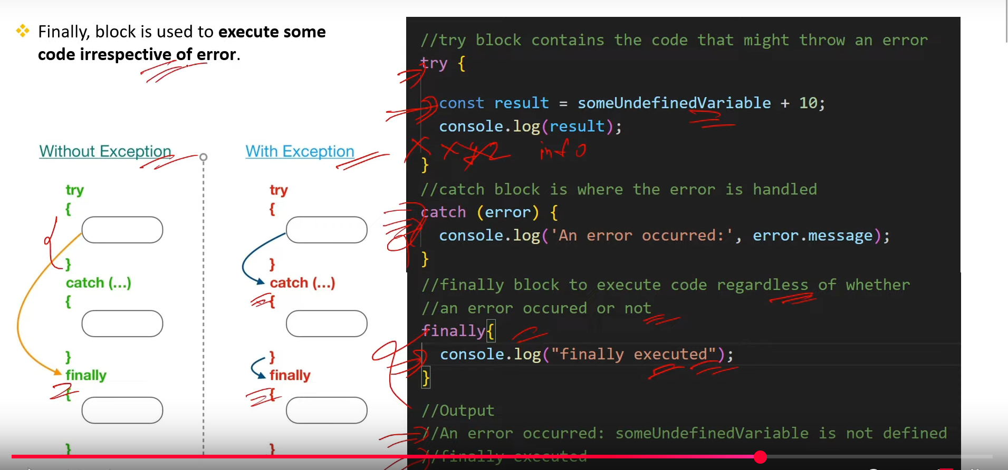

1. **What is the purpose of the throw statement in JS? [V.Imp.]**

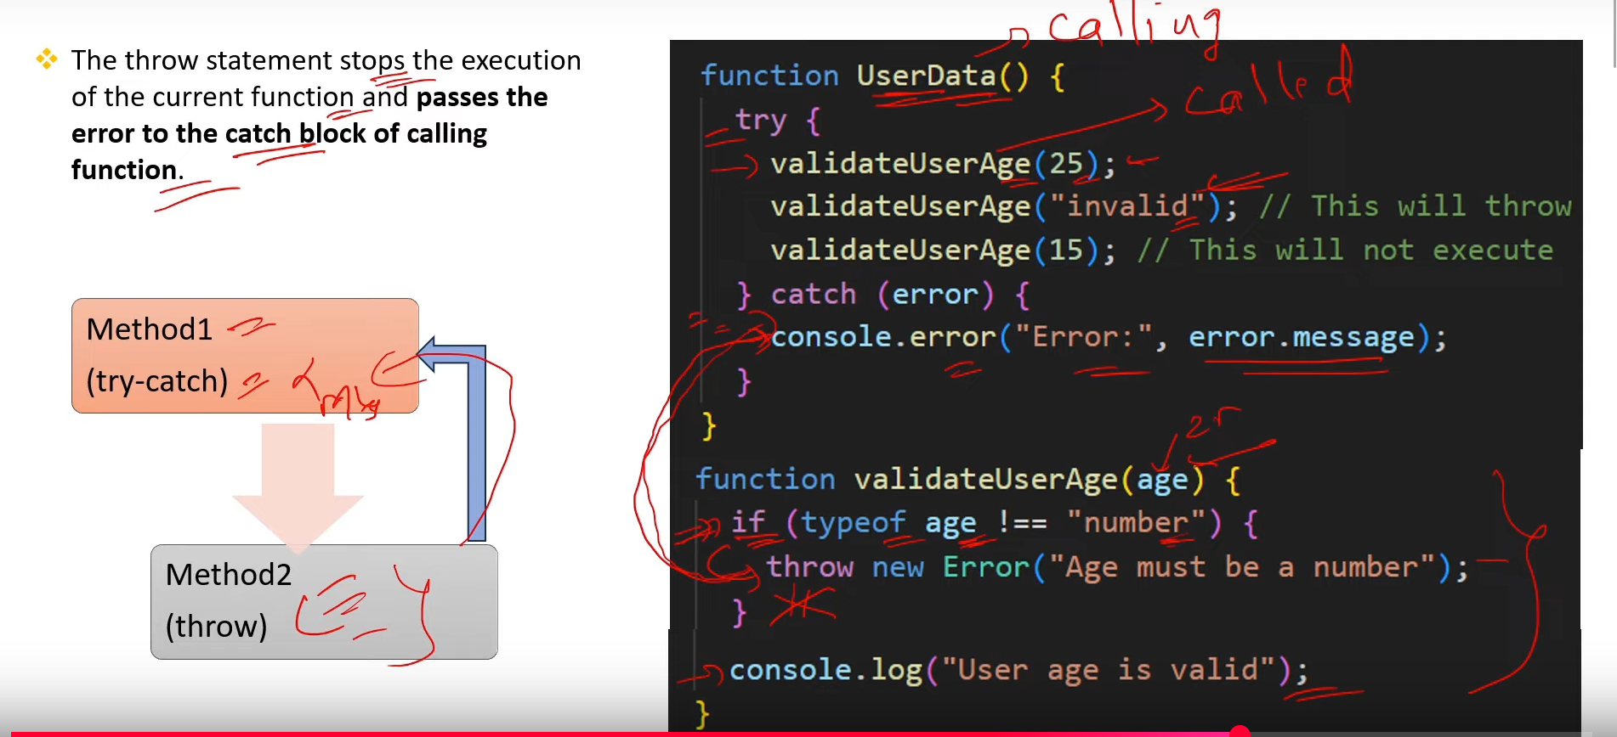

1. **What is error propagation in JS?**

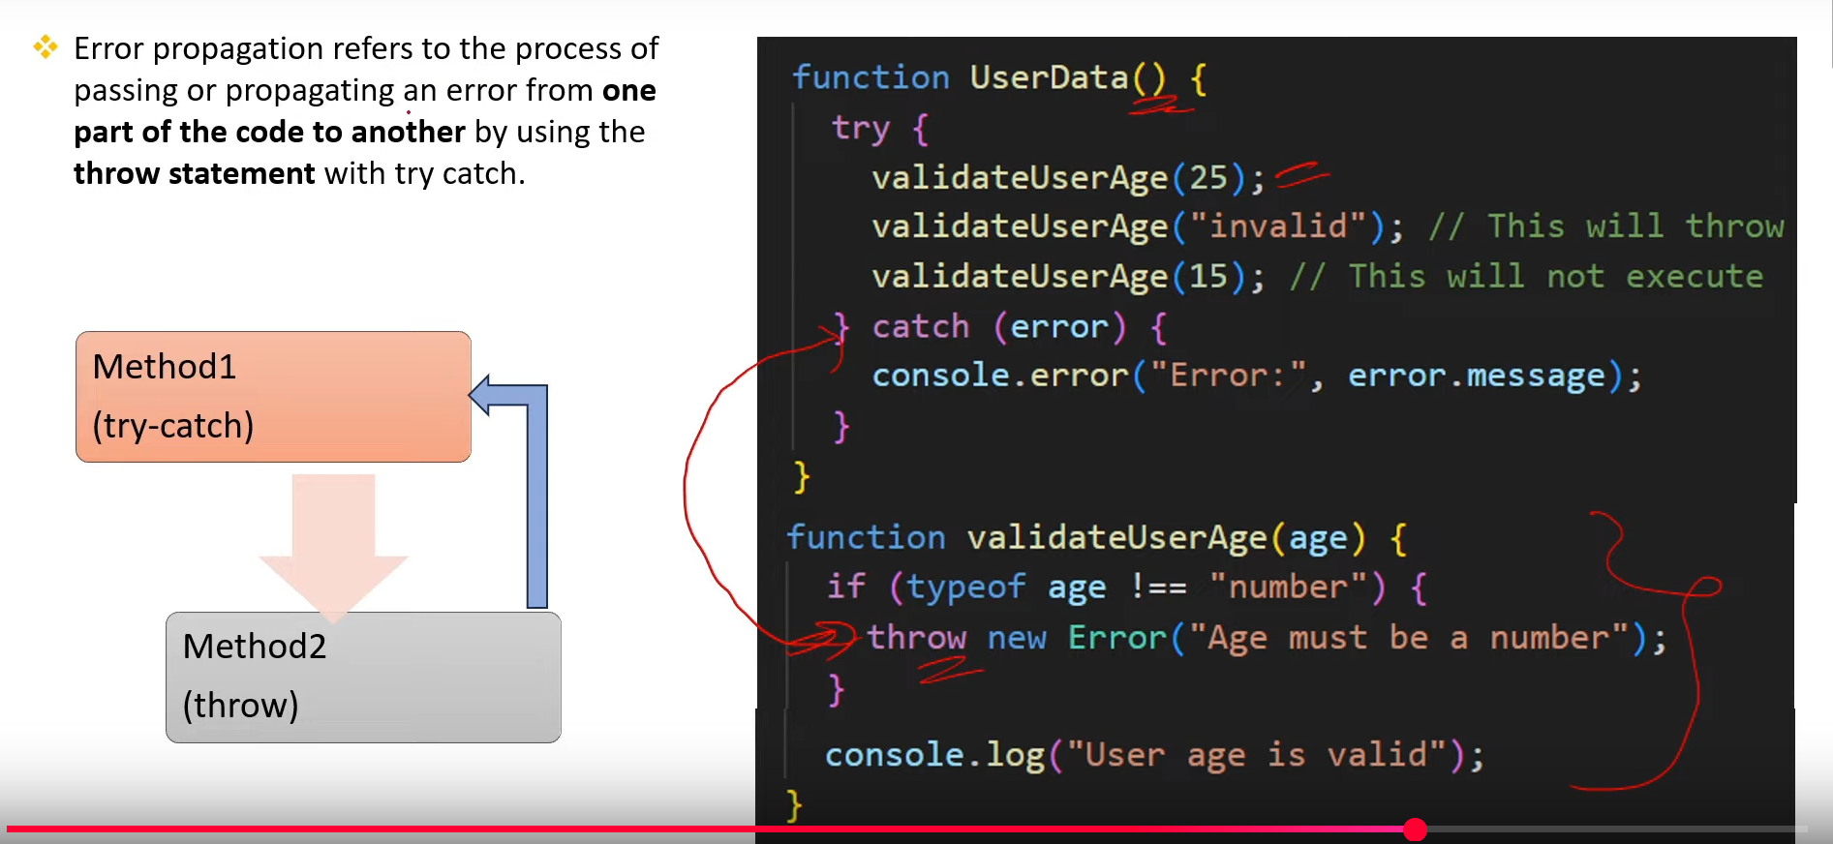

1. **What are the best practices for error handling?**

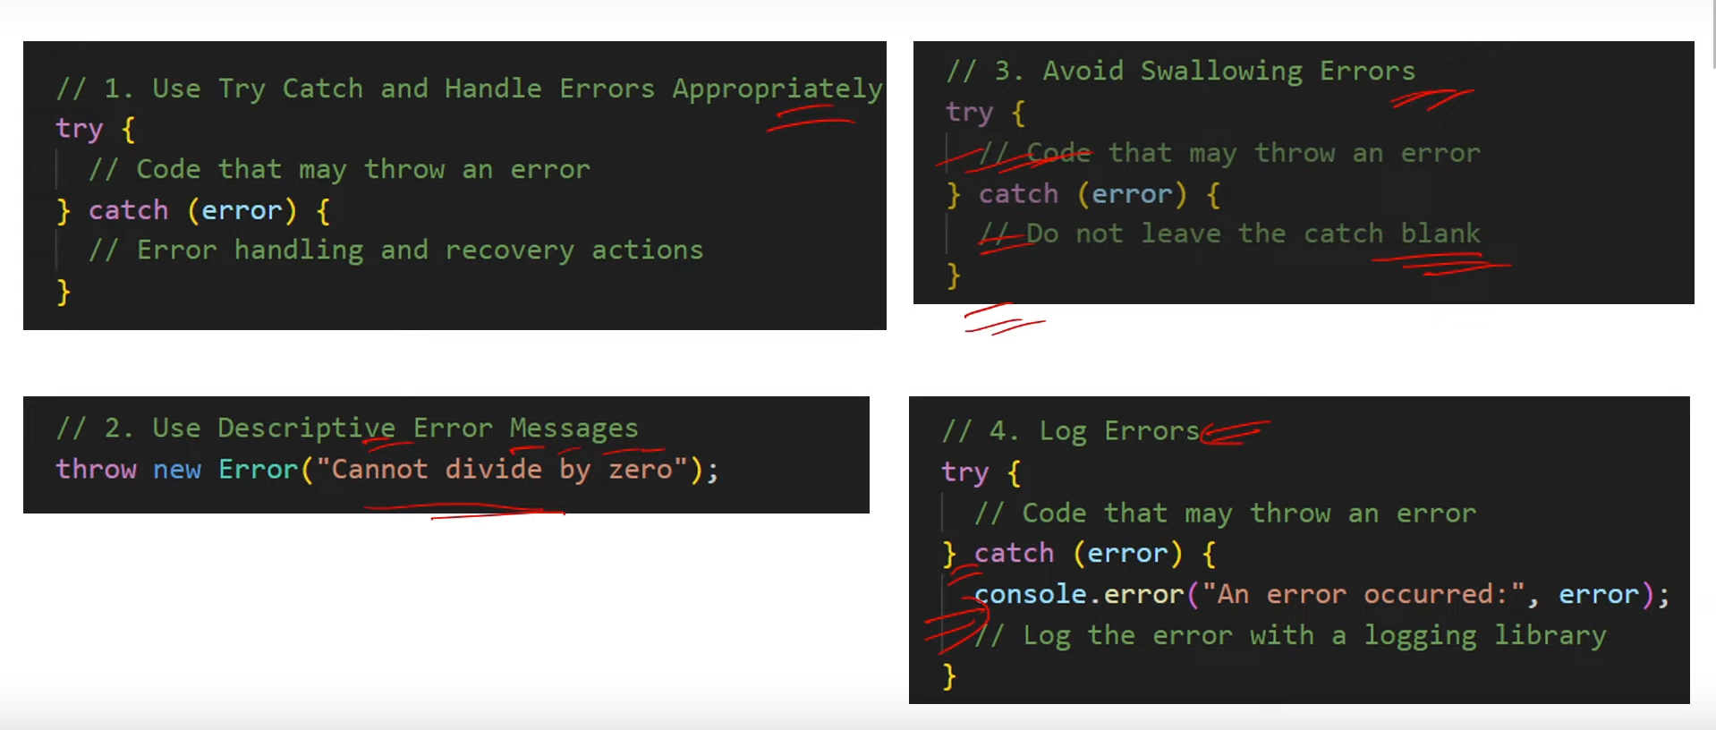

1. **What are the diff types of error in JS?**

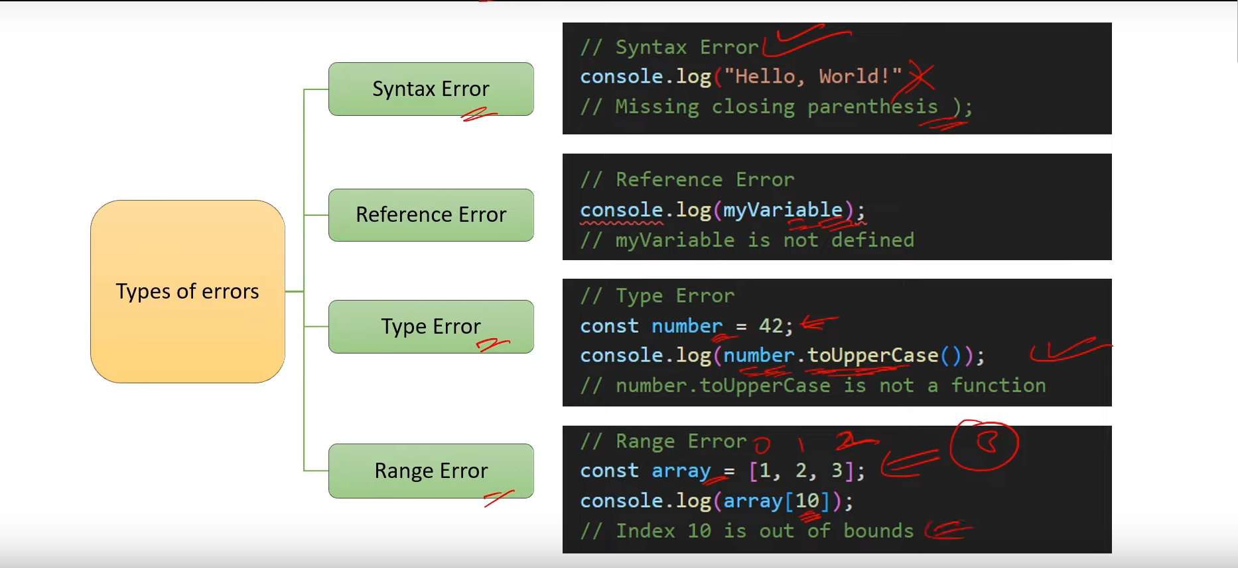

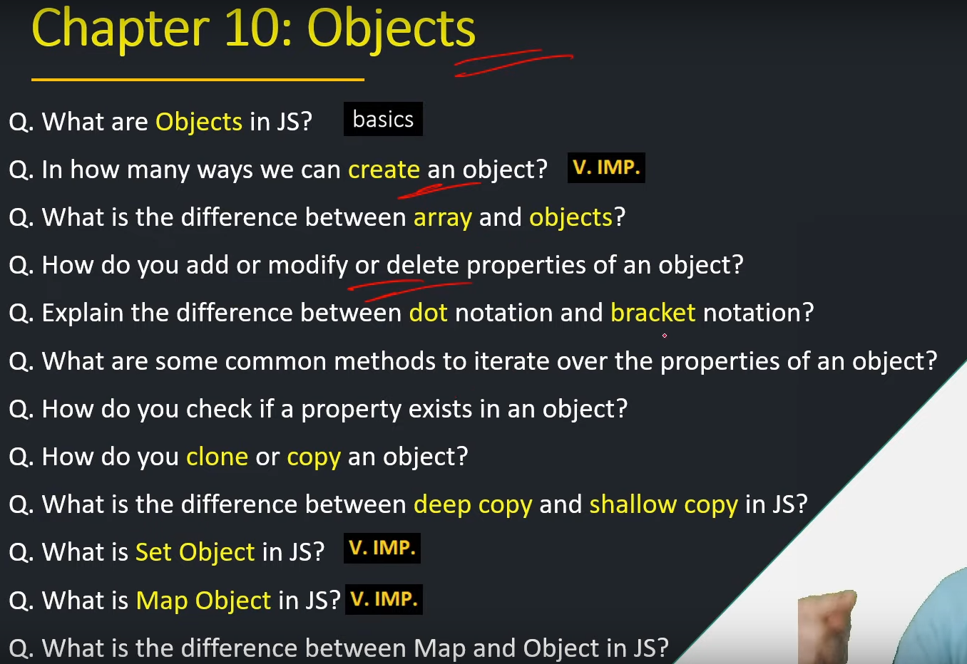

1. **What are Objects in JS? [basics]**
2. **In how many ways we can create an object? [V.IMP.]**

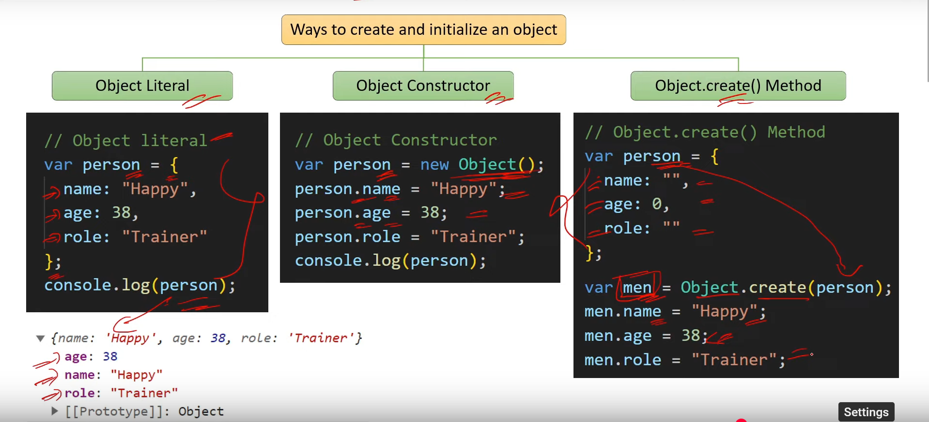

1. **What is the difference between array and objects?**

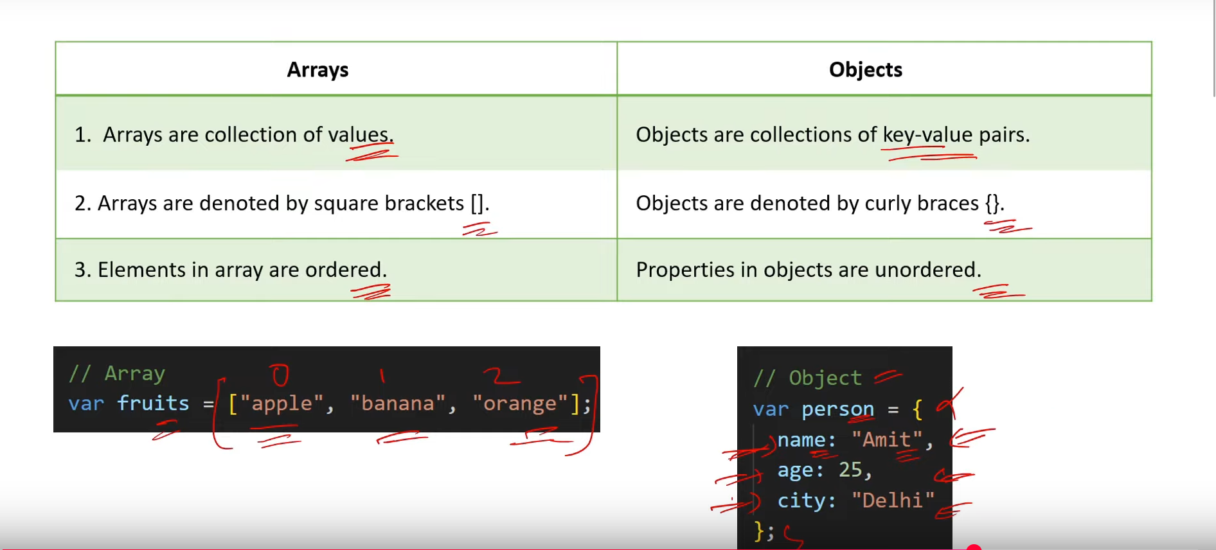

1. **How do you add or modify or delete properties of an object?**

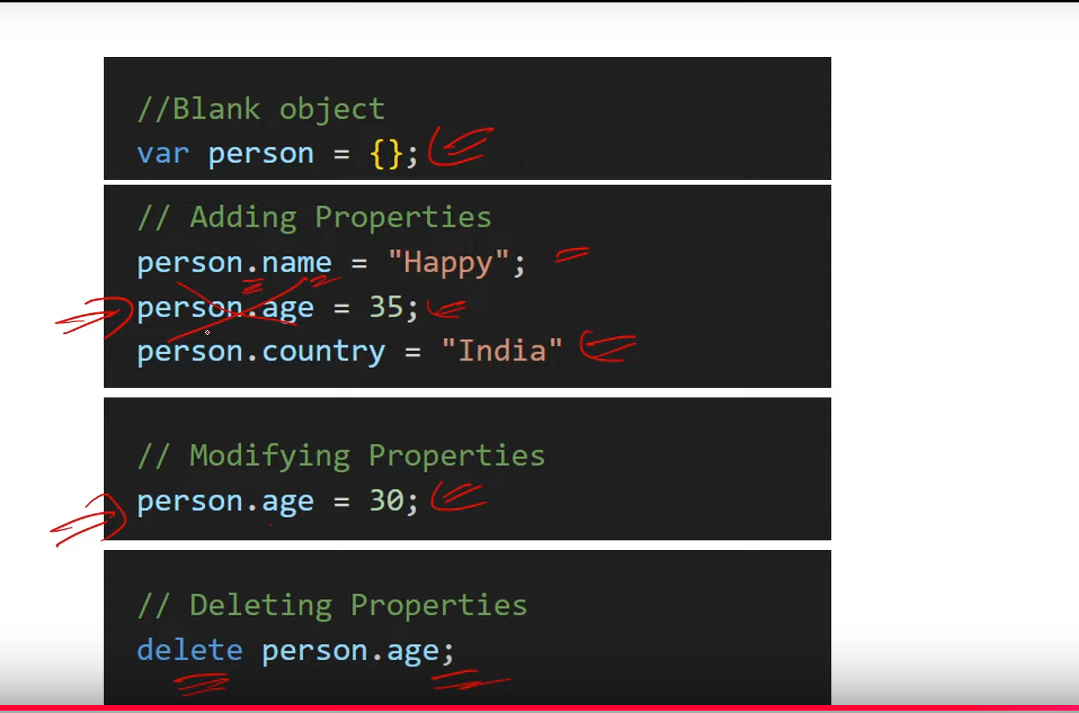

1. **Explain the difference between dot notation and bracket notation?**

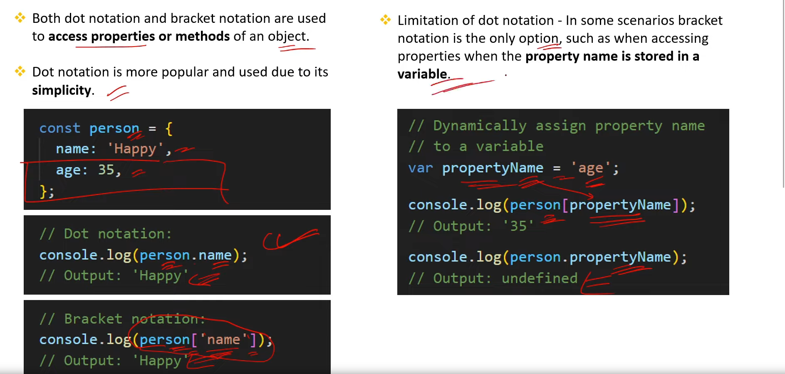

1. **What are some common methods to iterate over the properties of an object?**

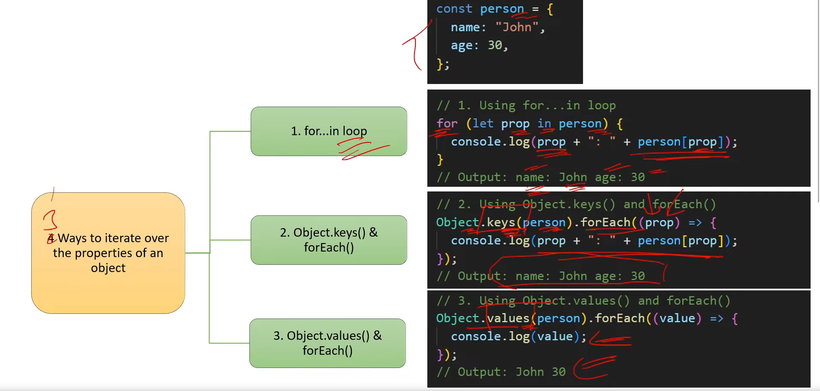

1. **How do you check if a property exists in an object?**

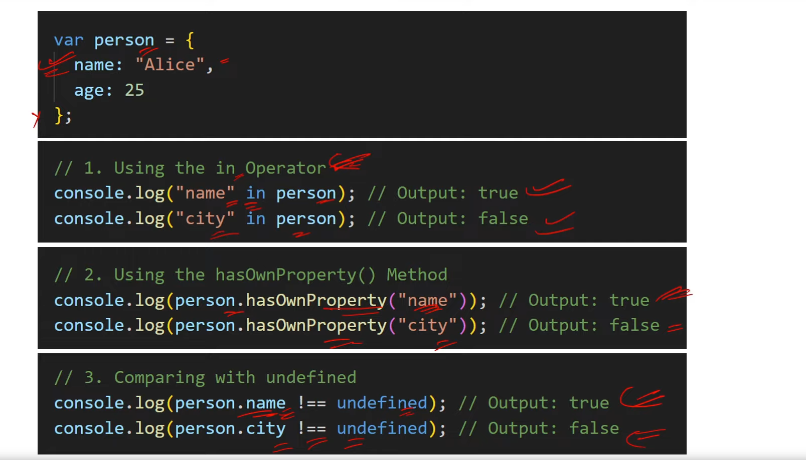

**100. How do you clone or copy?**

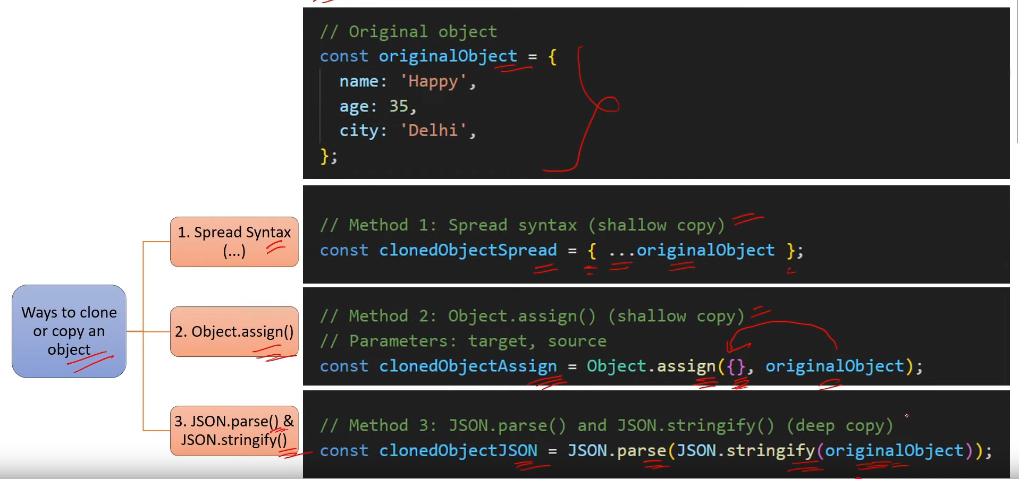

1. **. What is the difference between deep copy and shallow copy in JS?**

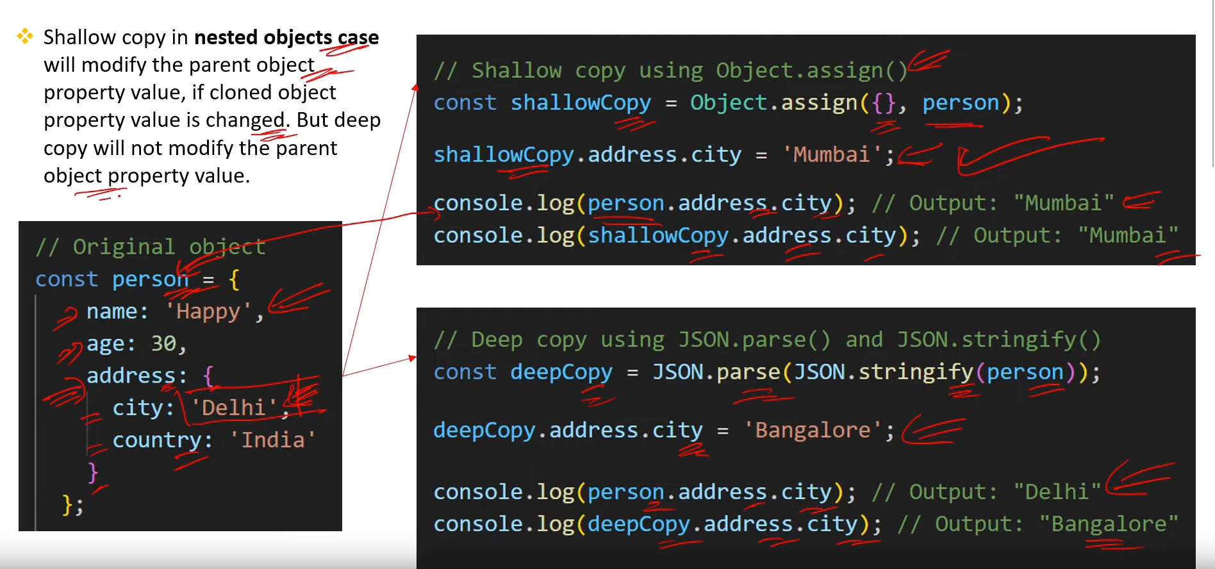

**102. What is Set Object in JS? [V.IMP.]**

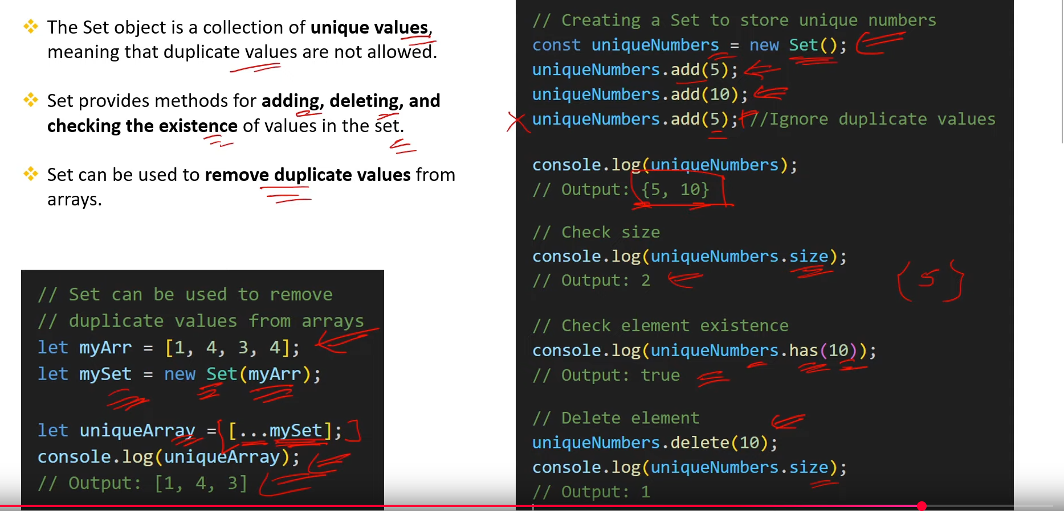

**103. What is Map Object in JS? [V.IMP.]**

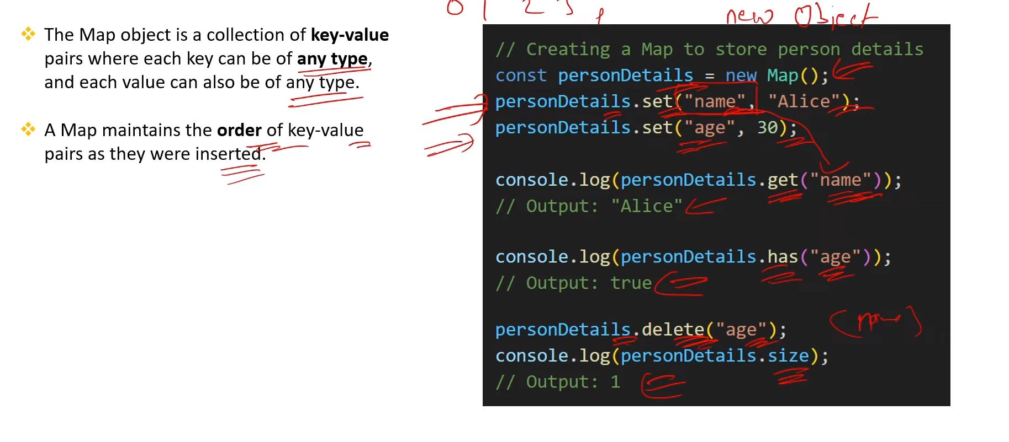

**104. What is the difference between Map and Object in JS?**

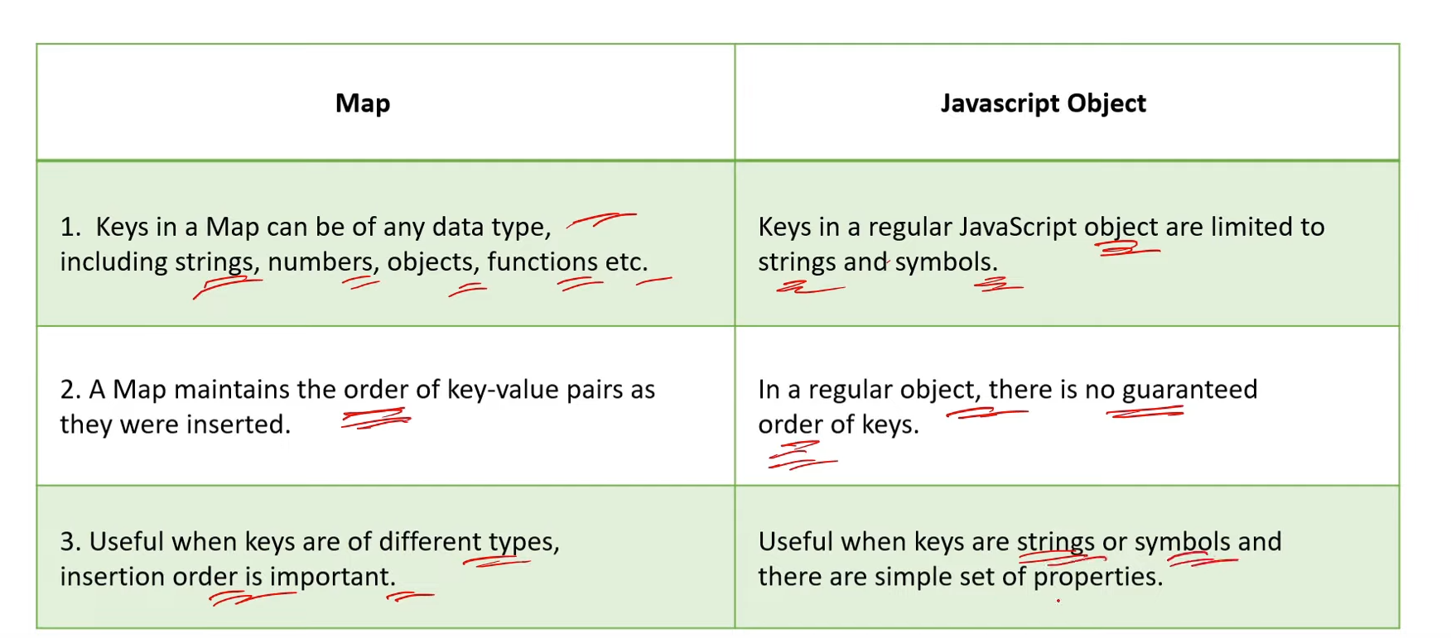

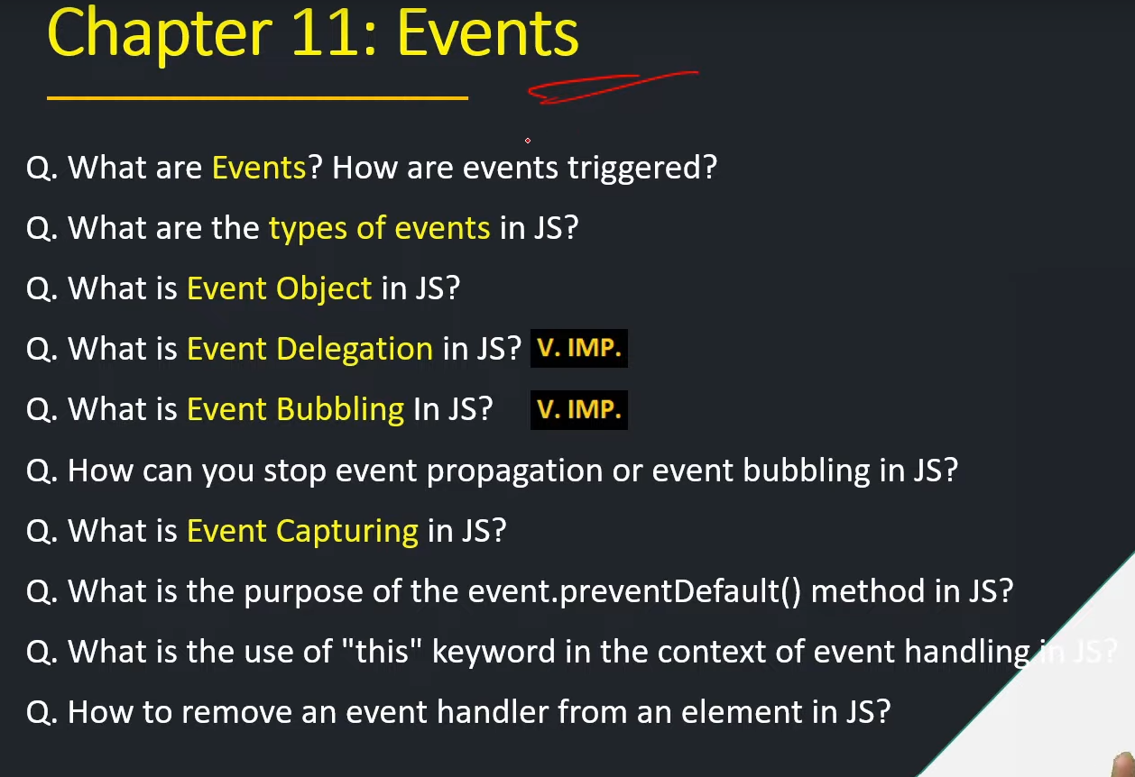

**105. What are Events ? How are events triggered?**

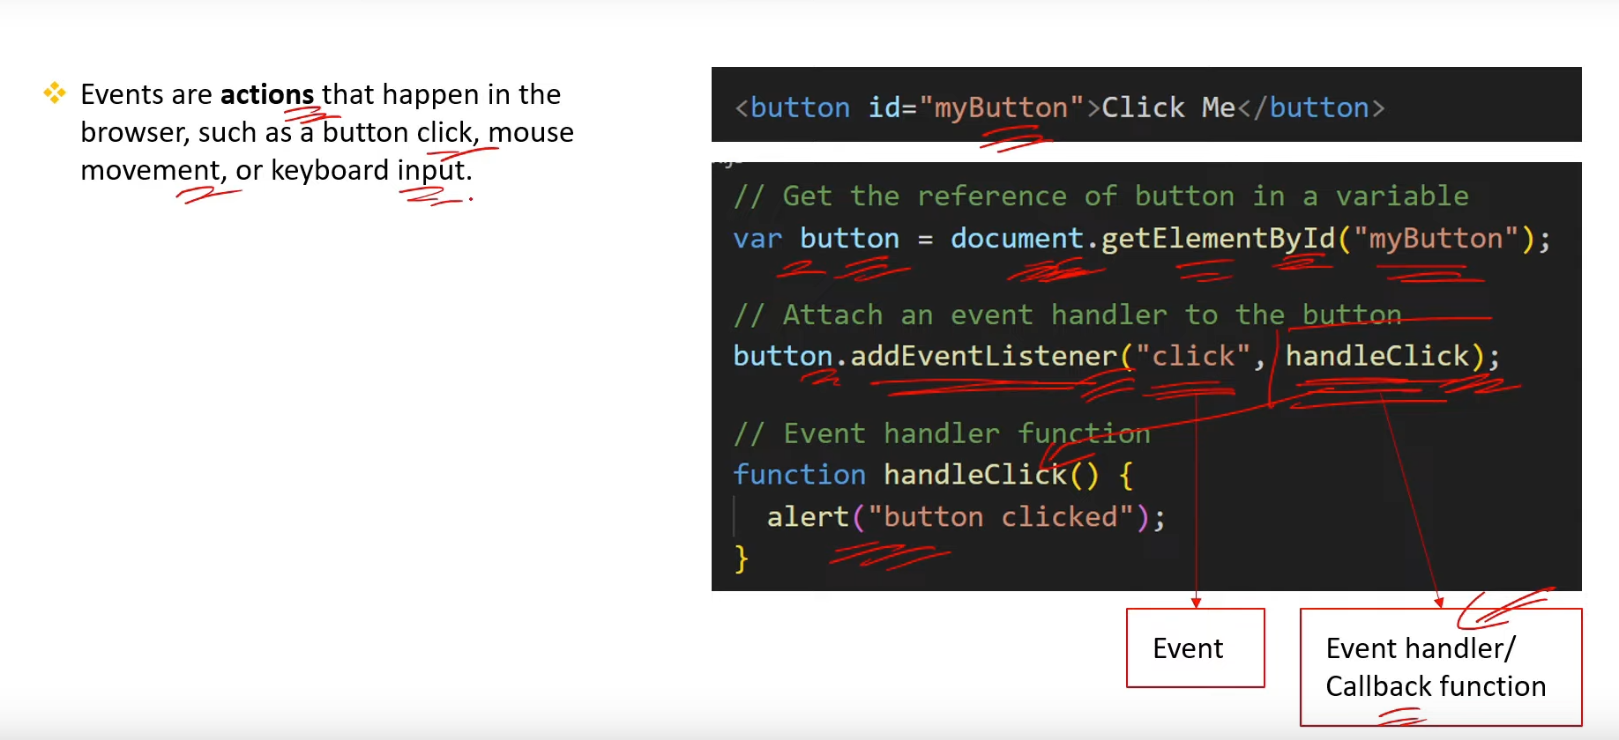

**106. What are the type of Events in JS? [v. imp.]**

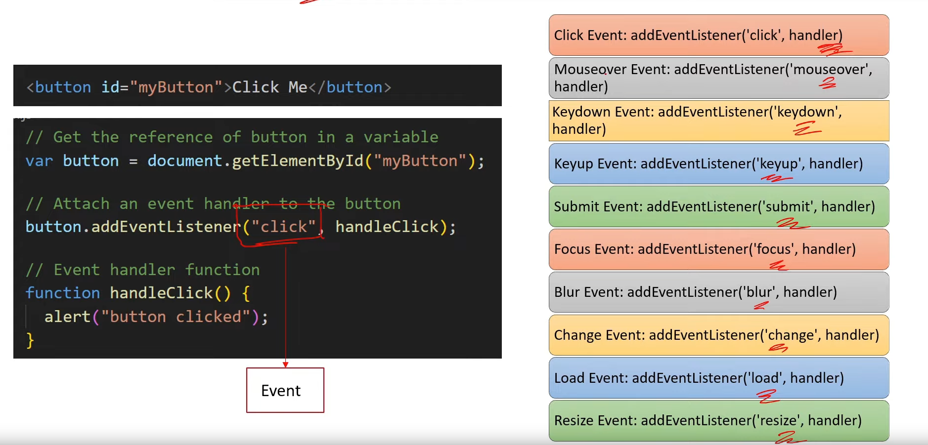

**107. What is event object in JS?**

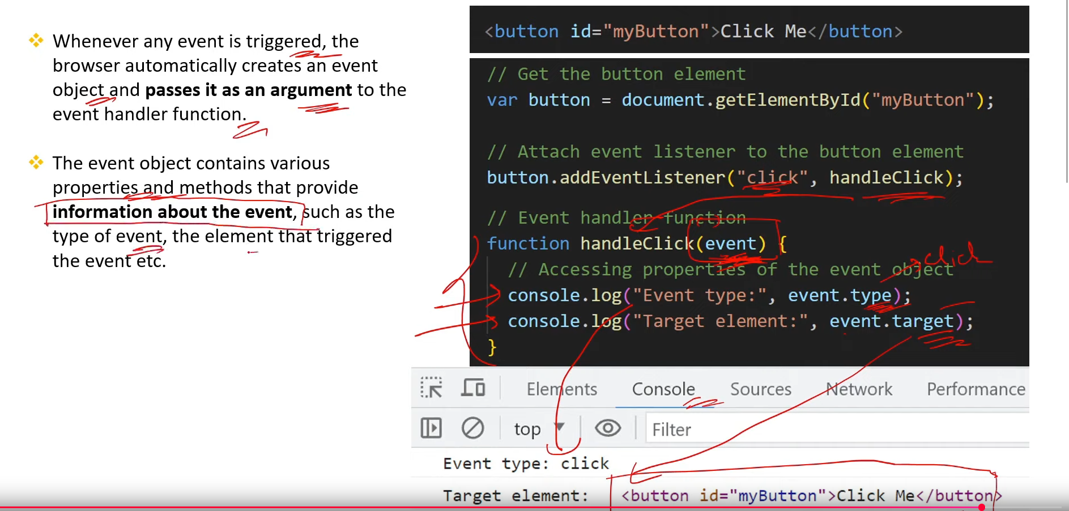

**108. What is event Delegation in JS? [v. imp.]**

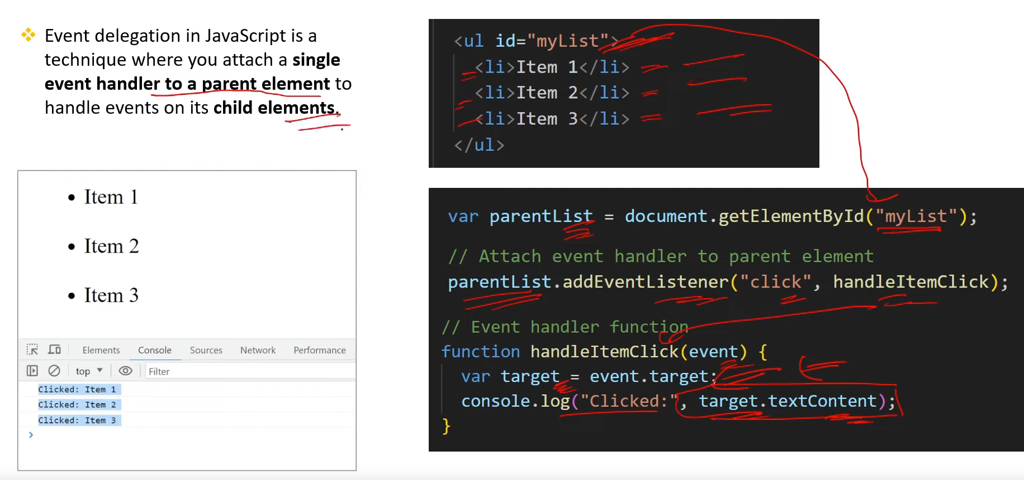

**109. What is event Bubbling in JS? [v. imp.]**

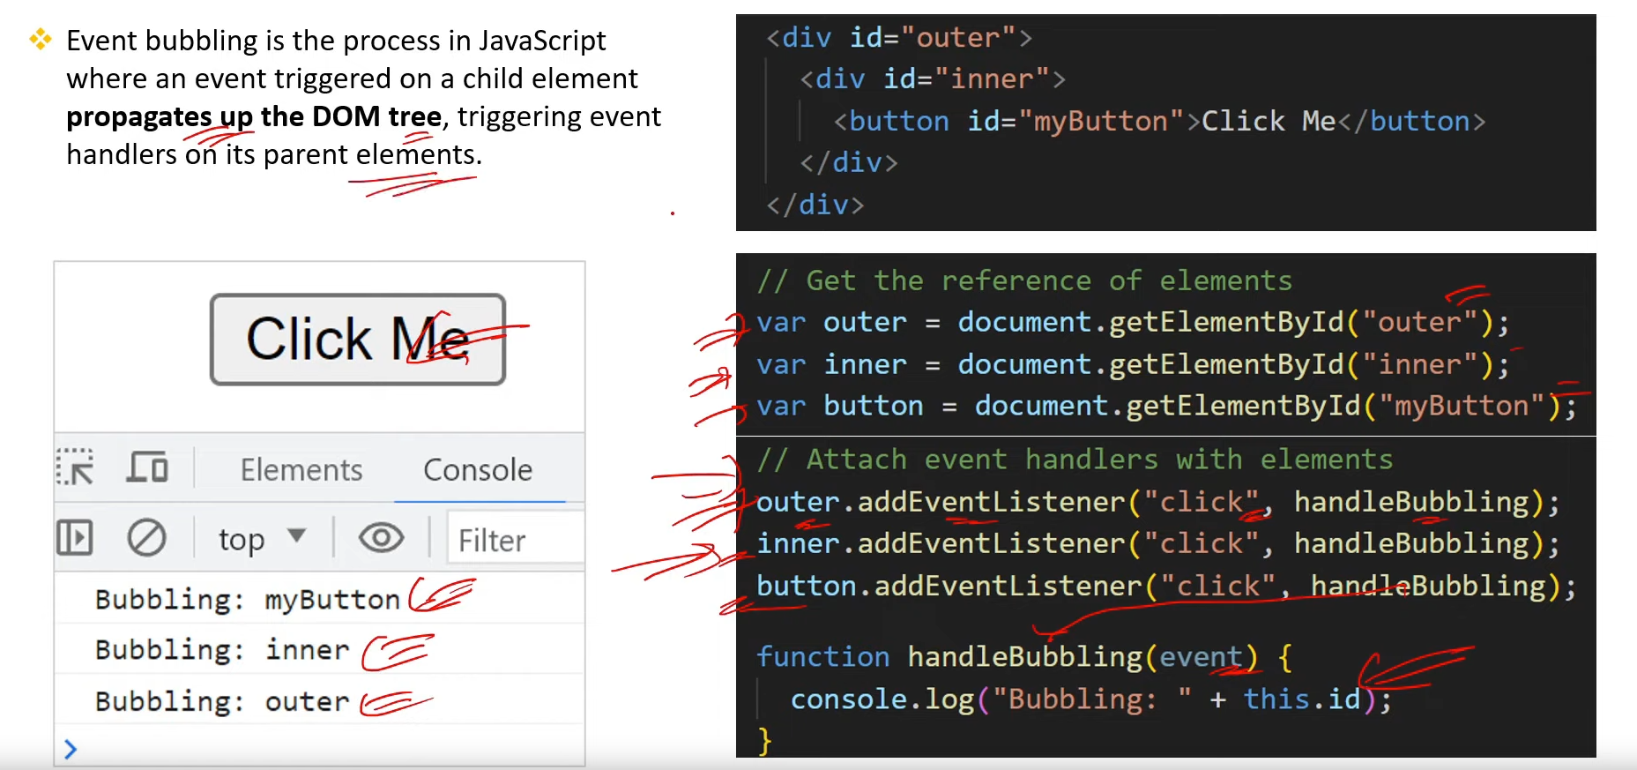

**110. How can you stop event propagation or event bubbling in JS?**

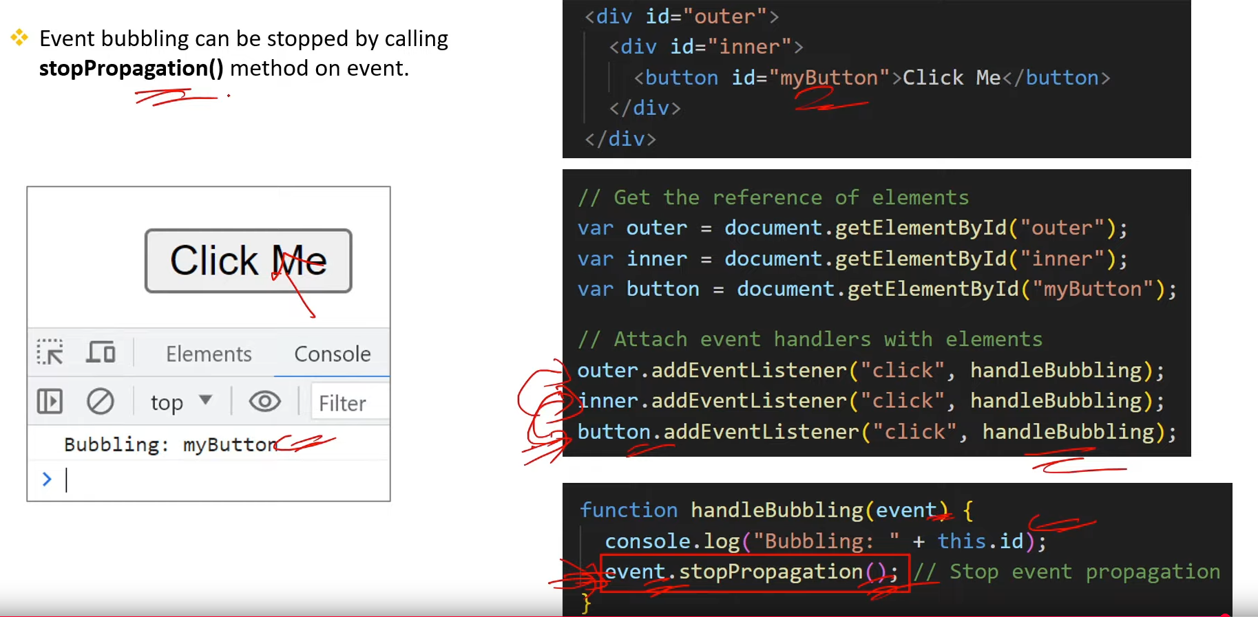

**111. What is event Capturing in JS?**

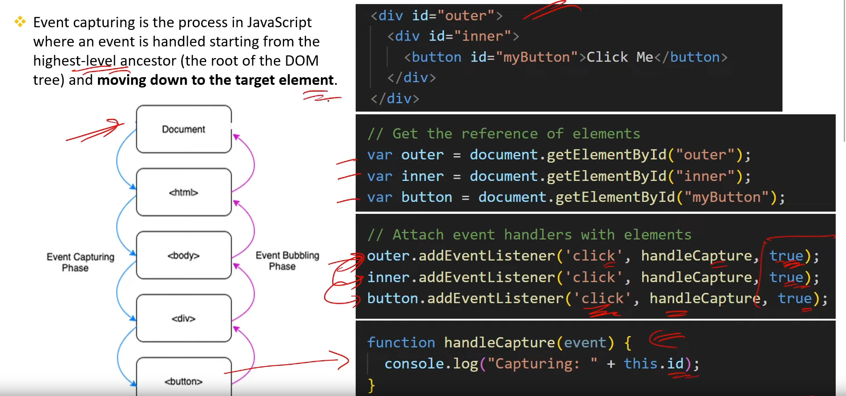

**112. What is the purpose of the event.preventDefault() method in JS?**

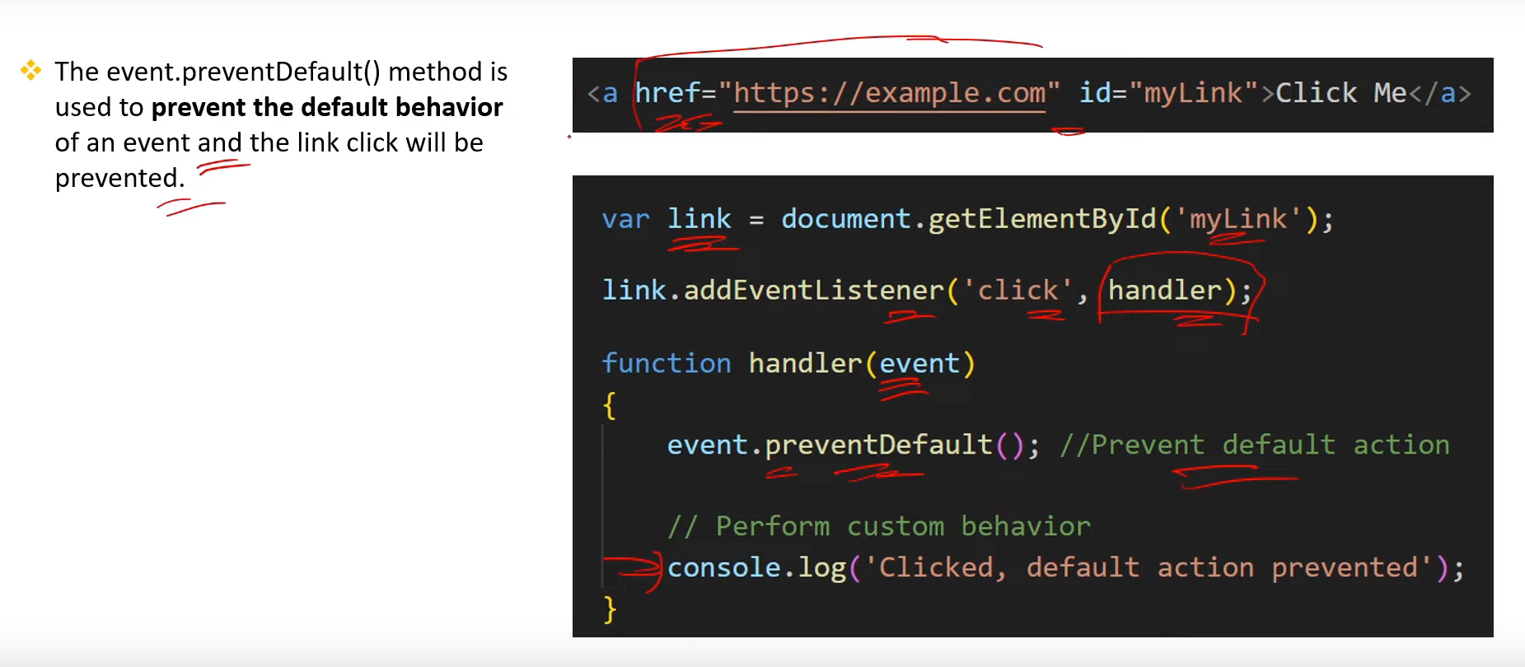

**113. What is the use of “this” keyword in the context of event handling in JS?**

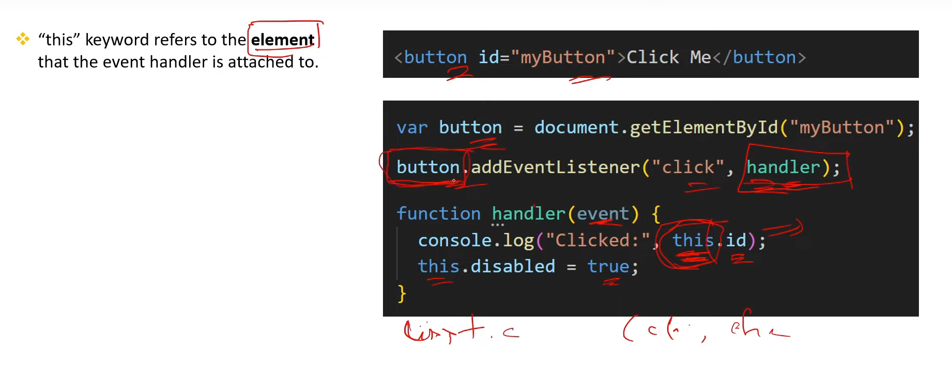

**114. How to remove an event handler from an element in JS?**

